Table of Contents

Unit 1 Introduction 4

AGENDA 4

1.1 Describing the EC Value Add of an Integrated and Strategic Human Resource Information System (HRIS) 4

1.2 Understanding EC Fundamental Data Structure: 6

1.3 EC Environment: 12

1.4 Setting Up the EC Environment: 20

1.5 People Profile, Action Search and the Check Tool: 21

Unit 2 Security- Role Based Permissions 29

AGENDA 29

2.1 Managing User Access: 29

2.2 Managing Security Using Role-Based Permissions (RBP): 31

2.3 Implementing Data Changes and Reviewing Audit Trails: 33

Unit 3 Foundation Object Management 37

AGENDA 37

3.1 Employee Central (EC) Structure and FO: 37

3.2 Populating a Foundation Object (FO) Records: 52

3.2 Customize Foundation Objects: 54

3.3 Configuring the Country-Specific Fields (CSF) for Foundation Objects: 56

Unit 4: Employee Data 59

AGENDA 59

4.1 Storing Employee Data: 59

4.2 Importing Users and Data and Implementing Mass Changes: 69

4.3 Configuring the Succession Data Model: 75

4.4 Configuring the Succession Data Model with Manage Business Configuration: 78

4.5 Configuring the Country-Specific Field (CSF) Succession Data Model: 82

Unit 5: Advanced Foundation Object and Employee Data Management 87

5.1 HRIS Propagation 87

5.2 Foundation Object Associations 93

5.3 Creating Internal Integration using HRIS Synchronization 101

5.4 Translating Foundation Object Data 105

Unit 6: SAP SuccessFactors Employee Central - Self-Service and Workflows 116

6.1 Managing Role-Based Permissions (RBP) for Self-Service Access 116

6.2 Customizing Self-Service Transactions Using Workflows: 120

6.3  Event Reason Derivation: 134

Unit 7: Object and Rule Management in the Instance 143

Agenda 143

7.1 Building Meta Data Framework (MDF) Objects for Employee Central (EC): 143

7.2 Customizing an MDF Object Using Configurable UI: 147

5.3 Creating a Configurable Rule Using the Rules Engine: 162

Unit 8: Position Management 172

AGENDA 172

8.1 Setting Up Position Management: 172

8.3 Leave of Absence: (nghỉ mà định kỳ, period) 193

5.4 Contingent Workers (nhân viên làm việc ngẫu nhiên): 194

5.5 Dependents Management: 202

# Unit 1 Introduction

## AGENDA

1. Describing the EC Value Add of an Integrated and Strategic Human Resource Information System (HRIS)
2. Understanding EC Fundamental Data Structure
3. EC Environment
4. Setting Up the EC Environment
5. People Profile, Action Search and the Check Tool

## 1.1 Describing the EC Value Add of an Integrated and Strategic Human Resource Information System (HRIS)

**Giải pháp HR cũ**

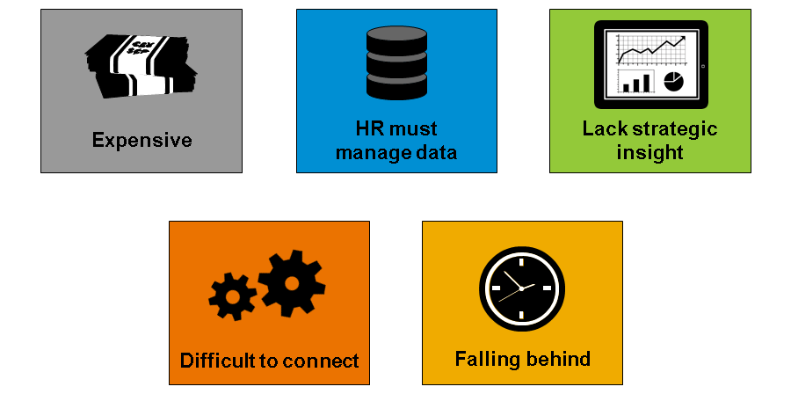

**Data Protection and Privacy Features**

Bản cập nhật Q1 2018, nhiều tính năng bảo mật và riêng tư được ra mắt, cải thiện nhiều tính năng có sẵn.

Bảo mật dữ liệu bao gồm, ví dụ là, khả năng báo lại những thay đổi dữ liệu cá nhân và các mục dự liệu cá nhân đang có mặt trên hệ thống. Khách hàng có lựa chọn cấu hình “data retention rules” ở level country cho nhân viên active, inactive, cấu hình này sẽ xóa vĩnh viên dữ liệu cá nhân.

Nghĩa vụ khách hàng là tìm tính năng phù hợp. More information can be found on the SAP Help Portal: <http://help.sap.com/cloud4hr>.

**Traditional HR Features**

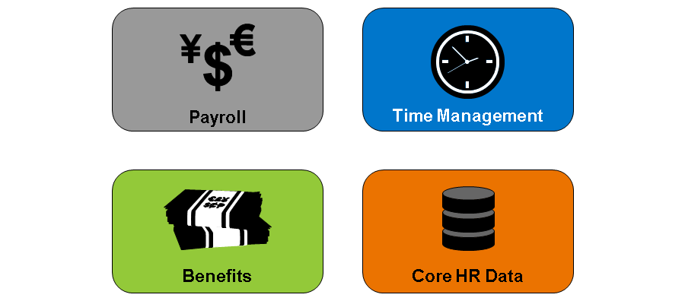

**Khả năng tương tích Integration**

EC có hai kiểu tương thích: Internal & External. Internal là tương thích của EC với các sản phẩm khác của SAP SFs thông qua HRIS Synchronization.

External Integration: thử thách, phức tạp, tốn tgian và nhiều consultants, tương thích EC với các hệ thống khác. EC đồng bộ HR data đến các hệ thống khác. Được thực hiện thông qua ***Cấu hình***, không phải lập trình.

**Tương thích:**

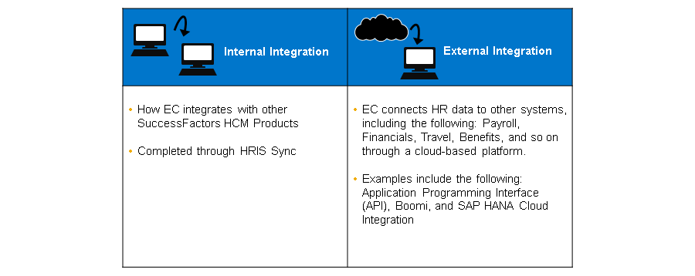

**Intergration Flatform**

The Integration platform has visual data mapping and transformation, and it allows for workflow scheduling. EC also incorporates Application Programming Interfaces (APIs).

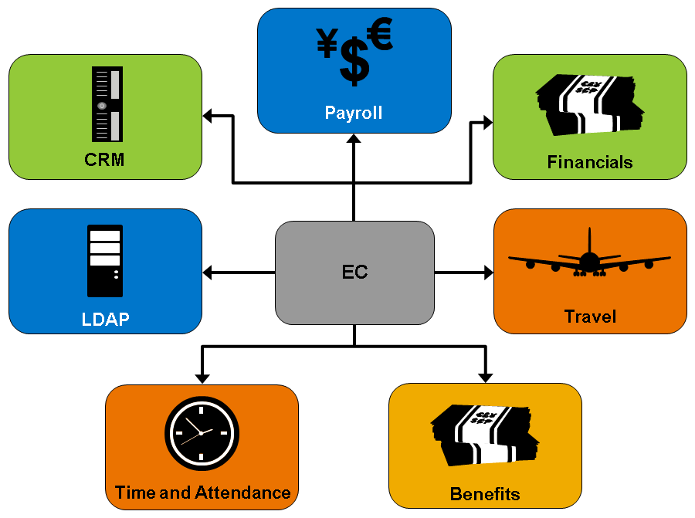

**Implementation Scenarios**

Instance của EC Demo đã được cấu hình sẵn. Tuy nhiên out-of-box instance của khách hàng yêu cầu setup sơ bộ và cấu hình.

-Đồng bộ EC instance -> implementation guide ở SAP Help Portal

-Q&A -> Forum section in the Learning Room

## 1.2 Understanding EC Fundamental Data Structure:

**EC Structure**

EC là một phần của SAP SFs:

-Đầu tiên, EC quản lý HR data nhân viên: thông tin cá nhân, thông tin tuyển dụng (vị trí & lương)

-Phần 2, ***Foundation Objects (FO)***, định nghĩa corporate structure (cấu trúc vận hành), giúp sắp xếp thông tin nhân viên. Dùng Corporate Data Model để định nghĩa các trường thôn tin trong file XML Foundation Objects. Mội vài Fos được quản lý thông qua MDF.

-Tính năng quan trọng của EC là giảm khối lượng công việc maintain data. EC được offer cho employee và manager self-service (kiểm soát thông qua RBP).

RBP kiểm soát ai xem và edit data nào. Em & Man có thể thay đổi data của bản thân, của cấp dưới, người dưới thẩm quyền, công việc mà trước kia chỉ do HR làm.

**EC Components**

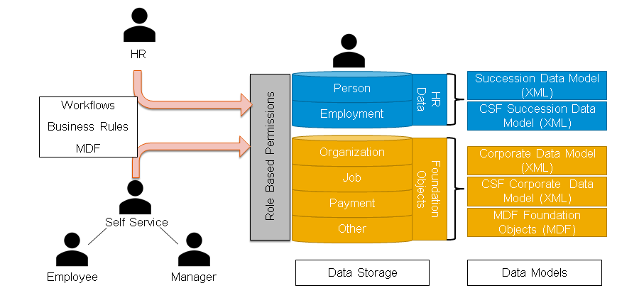

**XML Vocabulary**

In the figure, XML Vocabulary, you can see vocabulary commonly used in SAP SuccessFactors XML.

XML is a flexible language that is designed to carry, not display, data. The flexibility of XML enables authors to define their own tags and document structure. The structure in the figure, XML Vocabulary, is common in the Succession and Corporate Data Models.

XML là một ngôn ngữ lập trình linh động, để chứa, không hiển thị data. Định nghĩa tag, cấu trúc tài liệu -> flexible -> ***Succession Data & Corporate Data Models***.

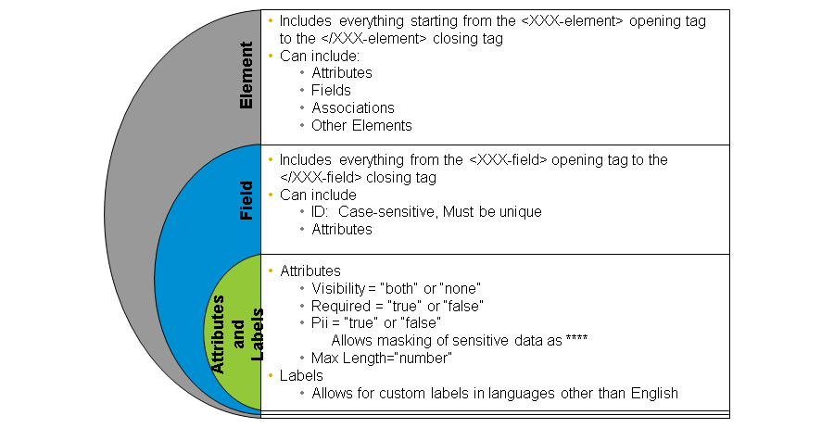

**XML Vocabulary: DTD**

XML uses a ***Document Type Definition (DTD)*** để định nghĩa cấu trúc. The DTD định nghĩaXML bao gồm những gì. In the figure, XML Vocabulary: DTD, in line 5132, you can see that the visibility is set to false. When the Data Model is validated, the DTD tells you that the visibility value is incorrect. ***Visibility requires edit, view, none, or both.***

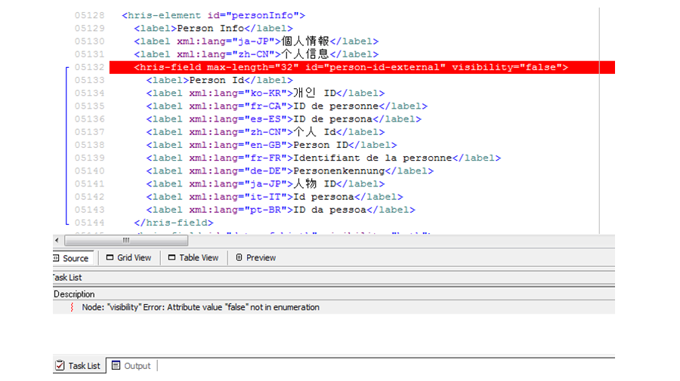

**Data Models and XML Files**

What do the Data Models do in EC?

***Succession Data Model vs XML Files***

What fields are part of the element?

How long can a Person ID be?

How many languages are currently supported?

Why does Date of Birth have a red star?

Why is Date of Death not visible on Marcus Hoff’s profile?

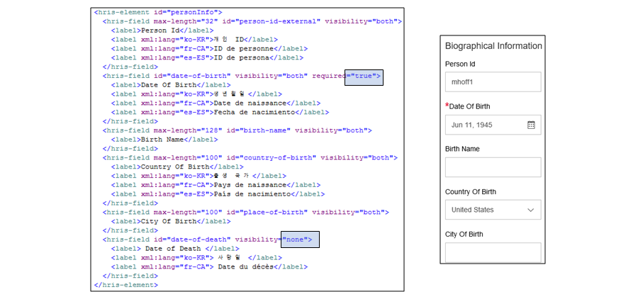

**Functions that Data Models Control**

***The four data models in EC*** play a critical role in configuration. In the figure, Functions that Data Models Control, you can see a list of the functions that the Data Models control in our instance. You have already seen an example of visibility and custom labels in the figure, Data Models and XML Files. Remember that you could not see the Date of Death field and that the Place of Birth field was re-labeled City of Birth.

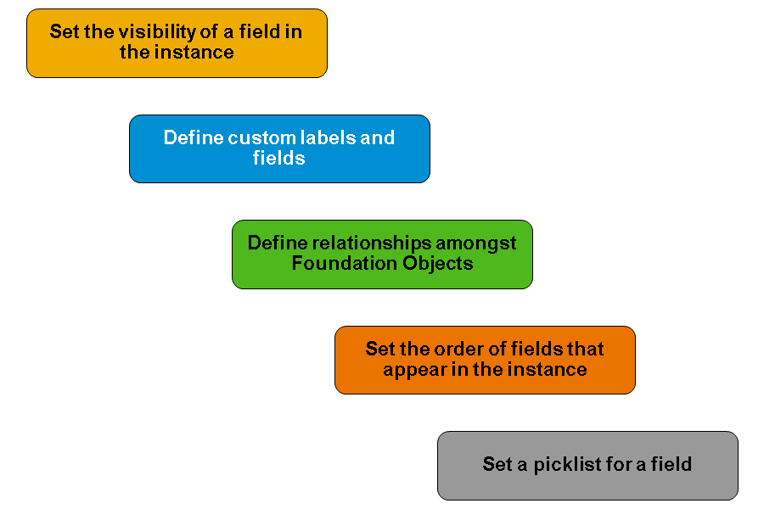

**EC XML**

The figure, EC Data Models, details the high-level functions of each of the data models and XML files.

**EC Data Models**

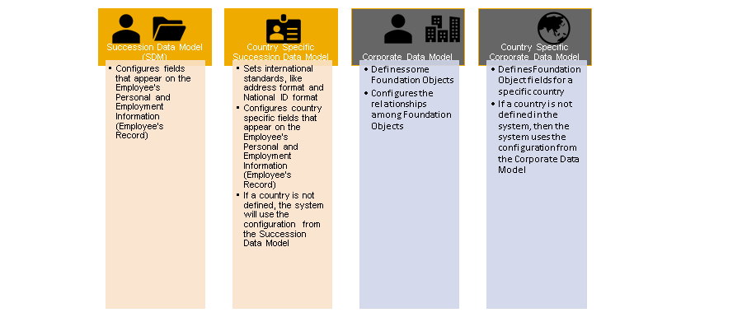

**Employee Records**

***Succession Data Model*** kiểm soát Employee Record (bản lưu nhân viên), được chia làm 2 phần:

-Employment: Bản lưu về ***công việc***, bao gồm job info, lương, bla bla

-Personal Information: Bản lưu thông tin ***bên ngoài công việc***, bao gồm: địa chỉ nhà, ID nước, thông tin liên lạc, bla bla

Both the Employment and Personal Information Records can store ***country-specific information***. For example, a company might record Equal Employment Opportunity (EEO) or Fair Labor Standards Act (FLSA) information in the USA or different kinds of national IDs.

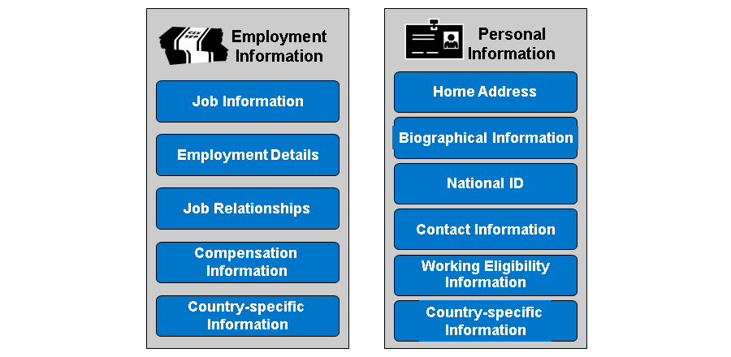

**Corporate Data Model**

Corporate Data Model kiểm soát data công ty (địa điểm, nhóm địa điểm…). Phần còn lại thuộc cơ cấu của tổ chức (legal entity, BU, devision, department) chuyển qua MDF, ở đó, admin quản lý trực tiếp qua Admin Center.

The Corporate Data Model is divided into ***four main areas***: ***Organization Structures, Pay Related, Job Related, and other***.

Additionally, the Corporate Data Model can contain ***country-specific information***. For example, your Location object may contain different address formats depending on the country.

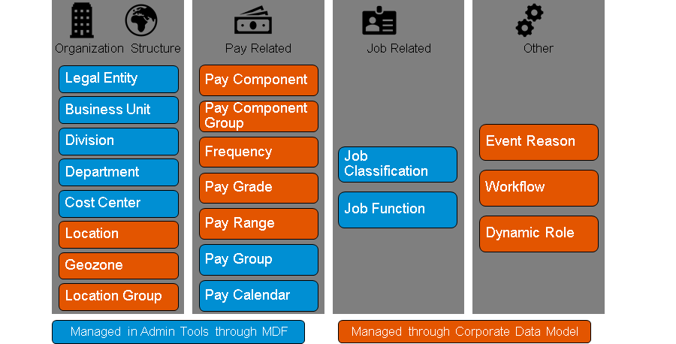

**XML Management**

Best Practices cho quản lý file XML của EC. Trong bài học, XML files, data models found in the Master Configuration Files download on the Learning Hub.

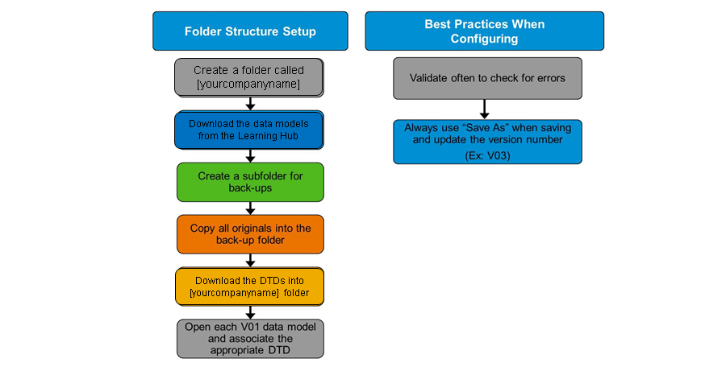

**DTD Associations**

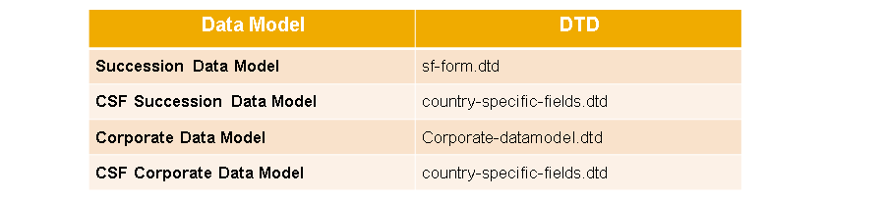

## 1.3 EC Environment:

**EC Functions and Features**

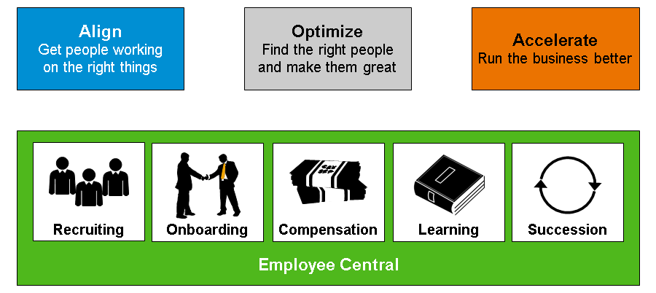

**EC Functions and Features**

EC is an ***innovative cloud-based, software-as-a-service model***, which addresses many of the problems of traditional HR solutions.

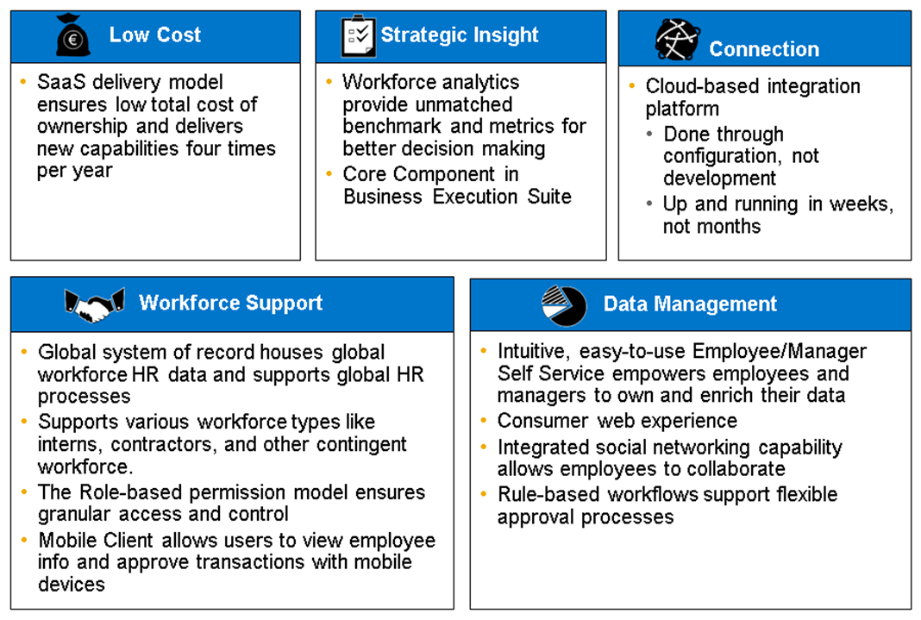

**EC Functions**

EC integrates several functions, including the following:

Houses HR records for all employees

Records transactions or corrections to keep HR information up-to-date

Provides analytics on HR information to meet compliance or business analysis

Provides integrated HR and Talent Management with SAP SuccessFactors HCM Suite

Feeds the downstream system with HR information

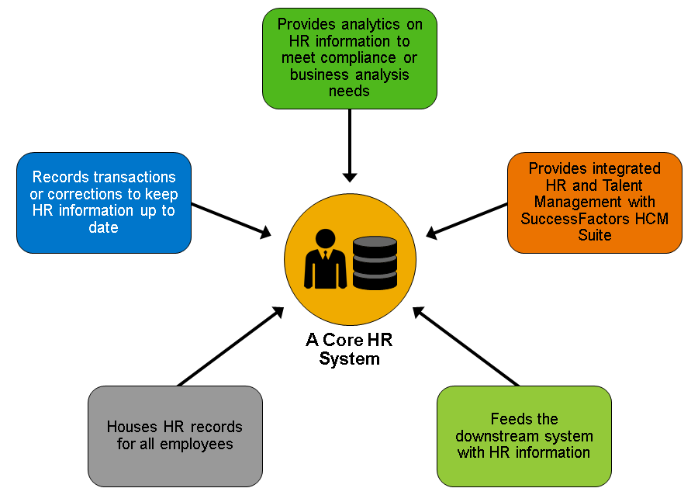

**Transaction Fundamentals**

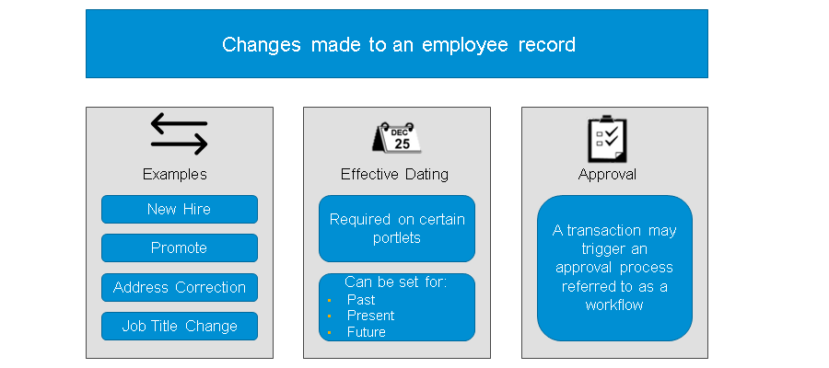

**Administrative or HR Edits**

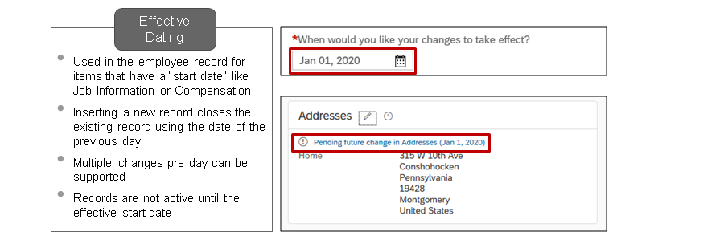

Many of the records in EC are effective-dated. Each time you insert a new record for one of these items, the system prompts you to provide the effective start date. It is important to understand and to maintain accurately effective dates because they enable you to create historical, present, and future records. For example, if Marcus is moving in January, you can add his new address with an effective date in the future. However, Marcus will not see that change in effect until January.

In the application, the fields start-date and end-date are used for effective dating. The start-date is usually displayed in the UI. The field end-date does NOT typically appear in the UI.

When you create the first record for an entity, the start date is supplied by the user creating the record and the end date will be set to December 31, 9999.

When you add a new record for an effective dated portlet, the system does not change the stored data. Instead, it creates a new row of data to track the new values from the effective start date of the change and continues to store the values that were effective before the change. The end date of the previous record is updated to 1 day before the new record’s start date.

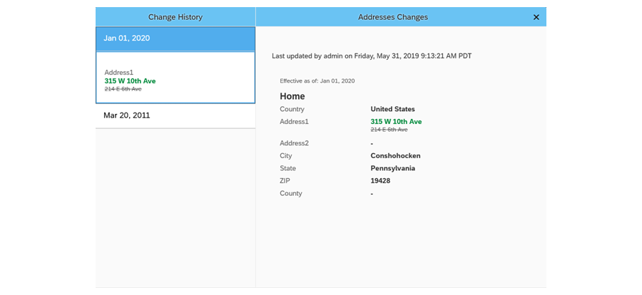

|  |  |  |  |  |  |  |
| --- | --- | --- | --- | --- | --- | --- |
| **Person-id-external** | **Address1** | **City** | **State** | **ZipCode** | **Start-Date** | **End-Date** |
| mhoff1 | 214 E 6th Ave | Conshohocken | Pennsylvania | 19428 | 3/20/2011 | 12/31/9999 |

|  |  |  |  |  |  |  |
| --- | --- | --- | --- | --- | --- | --- |
| **Person-id-external** | **Address1** | **City** | **State** | **Zip-Code** | **Start-Date** | **End-Date** |
| mhoff1 | 214 E 6th Ave | Conshohocken | Pennsylvania | 19428 | 3/20/2011 | 12/31/2019 |
| mhoff1 | 315 W 10th Ave | Conshohocken | Pennsylvania | 19428 | 1/1/2020 | 12/31/9999 |

**Forward Propagation (Thông tin chuyển tiếp)**

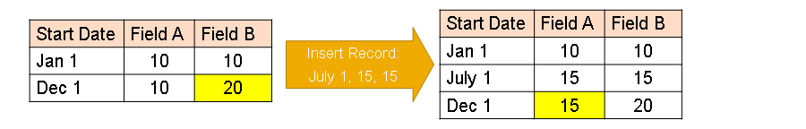

You may need to insert data that is between 2 records of an effective dated portlet. In this case, it is important to understand the concept of forward propagation.

***Forward propagation*** means that a change in the value of a field in an entity (đối tượng) is also made (propagated) (lan ra) to ***future records for the same entity***. The forward propagation of this field change stops as soon as one of the future records has a field value maintained that is different than the original field value.

Thông tin chuyển tiếp nghĩa là khi thay đổi thông tin cho một trường thông tin của một đối tượng, thay đổi sẽ được cập nhật cho đối tượng đó trong cả những bản lưu tương lai của đối tượng đó. Sự cập nhật (lan ra) của trường này dừng khi nào một bản lưu có ***giá trị khác*** với trường quy chiếu ban đầu.

For example, imagine the initial record has a start date of Jan 1 and the values of Fields A and B are set to 10. A second record has already been entered into the system with a start date of Dec 1. The value of field B was changed to 20. In this example the value of field A has not changed.

You want to go back to insert a change that occurred on July 1, where the values of field A and field B were both 15. IF forward propagation is enforced, the value of Field A will be updated on the Dec 1 record, while the value of Field B on the Dec 1 record will remain unchanged. ***This is because forward propagation continues until the field value of the record is different then the original***. In this case Field B had a different value than the original record (Jan 1).

Forward propagation in only supported on certain objects:

• MDF Objects

• Job Information

• Job Relationships

• Compensation Information

Also forward propagation only occurs under certain methods of making the changes, for example importing a change versus changing directly in the employee file portlet.

Forward propagation chỉ xảy ra với những phương thức thay đổi nhất định, ví dụ importing vs thay đổi trực tiếp qua employee file portlet.

*For full details on Forward Propagation support, please review the Employee Central Master Implementation Guide.*

**Special Transactions**

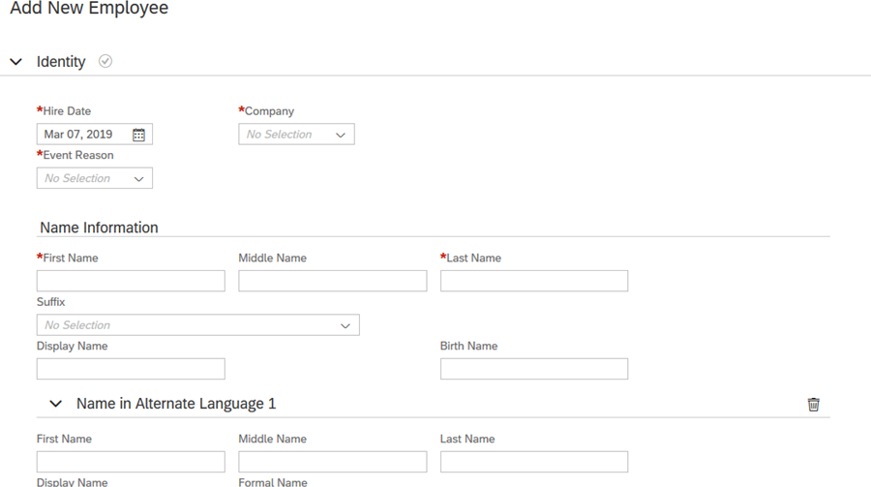

**Rehire Check**

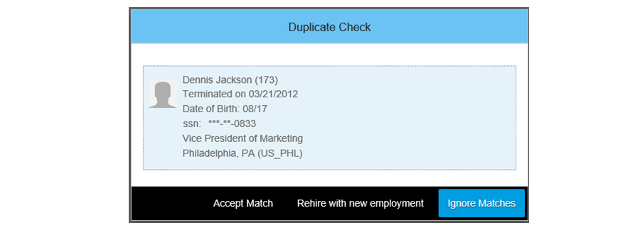

Sau nhập thông tin tuyển mới -> next/ continue -> EC check hệ thống với bản lưu current & inactive records để kiểm tra trùng, nếu có:

-Chọn bản lưu có sẵn để update thông tin hoặc ignore bản trùng.

Có thể dùng kết hợp các trường Fist name, Last name, Date of Birth, National ID để KT trùng.

Chọn “accept match”, tất cả thông tin ngày nghỉ việc sẽ được copy vào màn hình “add new employee”.

Nếu chọn “Rehire with new employment”, những thông tin cũ trước khi nhận lại sẽ không nhìn thấy được trên hệ thống -> hoàn thành tuyển dụng ở màn hìn”h Add New Employee”.

**RBP for Adding New Employee Screen**

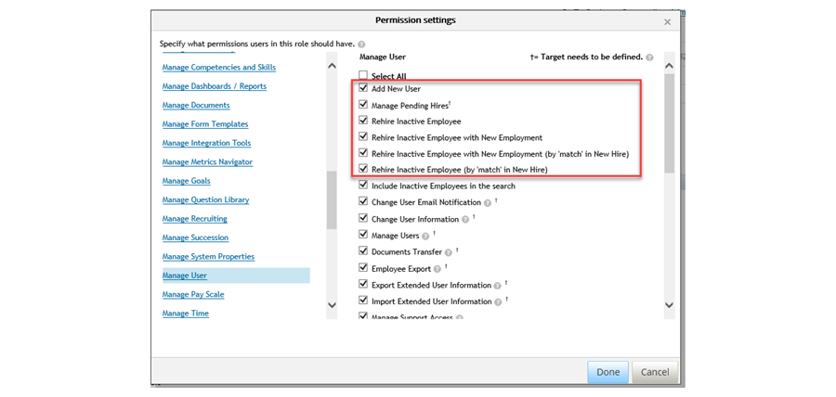

Here are the available Role Based Permission options around the Add New Employee screen. You can control

***who can hire*** employees, ***who can rehire*** inactive employees, and ***who sees the option to match or rehire*** as a new employee.

**Manage Pending Hires**

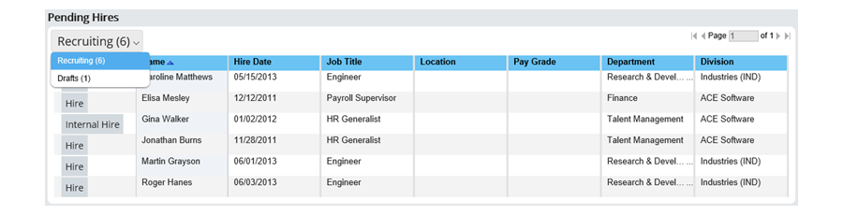

Cầu nối giữa Recruitment mudule và EC. Hiển thị những ai đã qua R process và sẵn sàng được thuê mướn. Nếu quá trình thuê mướn bị gián đoạn và được lưu, sẽ hiện thị ở Drafts.

**New Hire Additional Configuration**

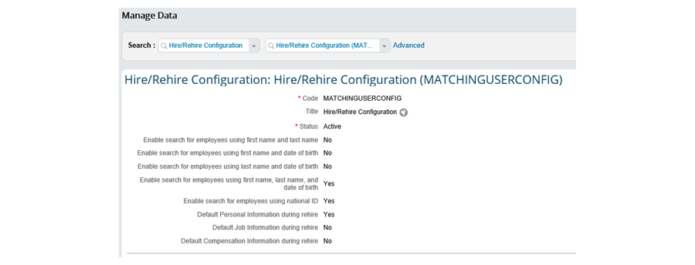

Some of the optional configuration include:

• Enabled / Disable ***search for employee match*** options: Configure support for search fields of employees, such as Names, Date of Birth, or National ID to match an inactive employee

• Enable ***Default Information for Rehires***: Include or exclude Personal, Job and Compensation Information data from a previous employment

• ***Select Rule to Generate employee ID***: Create user IDs using business rules, for example, if you want specific ranges for specific regions or countries

• ***Allowing Rehires to Keep Existing Logon***: Allow existing employees rehired in the company to keep their existing logon to avoid confusion and disruption

• ***Prohibiting Change of Legal Entity*** in Any Employment: Set the system up so that it doesn’t tolerate a change of legal entity within one employment. ***For an active employee, you must first terminate the employee in the system from the old legal entity and then rehire them with new employment on the new legal entity.***

• ***New Hires with Fixed Term Contracts***: Enter the hire information and future termination in a single tool New Hire for Fixed Term.

• Accessing Future Transfers and Hires: Configure managers and admins to see a ***pending transfer*** or ***hire prior*** to the transfer date ***to add employee data and complete the hire process.***

**Terminations**

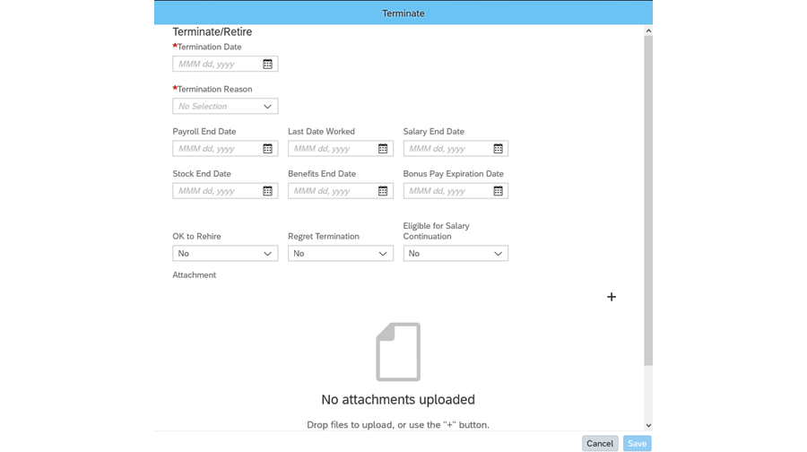

***You terminate an employment in Employee Central when an employee leaves the company***. You will need to include a ***termination date and termination reason***. Additional fields are available on the termination screen that do not normally appear in the Employment Information portlet. If the employee is a manager with direct reports, then the Transfer Direct Reports section will appear on the screen. You can select from the list about who the direct reports will then report to.

## 1.4 Setting Up the EC Environment:

Provisioning and Admin Center

Both ***Provisioning and Admin Center*** are necessary to configure and maintain EC. The figure, Provisioning and Admin Center, lists some of the key roles of each tool.

When working with EC, we recommend that you choose a different browser when using each tool. For example, you might use Google Chrome for Provisioning and Mozilla Firefox for the EC instance. Choosing different browsers enables you to work in both areas without logging out and on again.

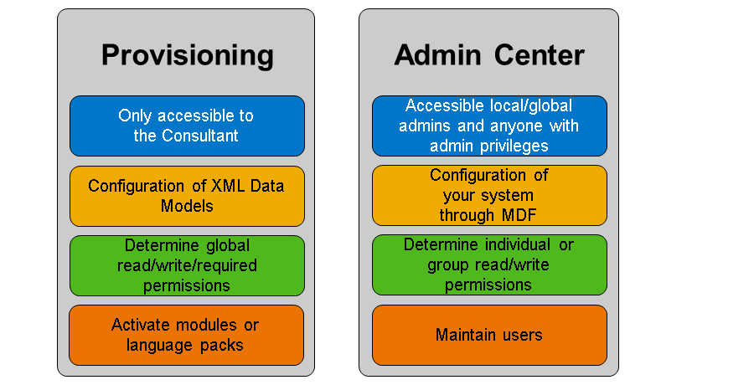

**Instance Preparation to Receive Notifications**

To prepare your test instance, you need to ***update all employees email addresses so that you receive system notifications***. In the figure, Test Instance Preparation, you can see the updated Email Information import file and the attached screenshot showing how to load the information.

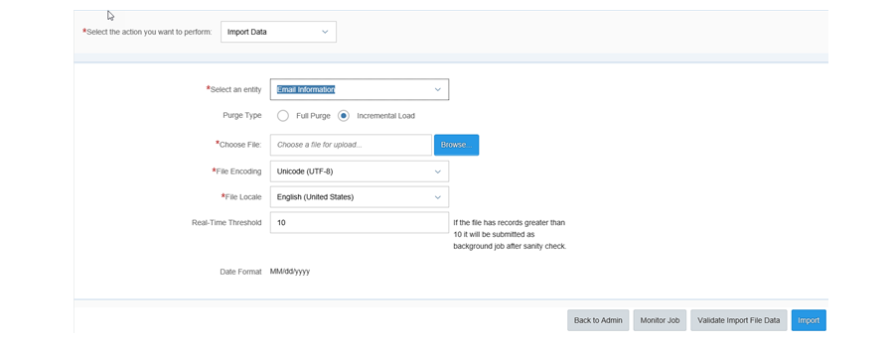

## 1.5 People Profile, Action Search and the Check Tool:

**People Profile**

With the People Profile, you can view the entire profile and take immediate action on one simple, unified page. People Profile comes with a drag-and-drop configuration tool to set up the employee profile for your company. You can select ***which data fields to display in the profile page header*** and ***control visibility of all employee data with role-based permissions.***

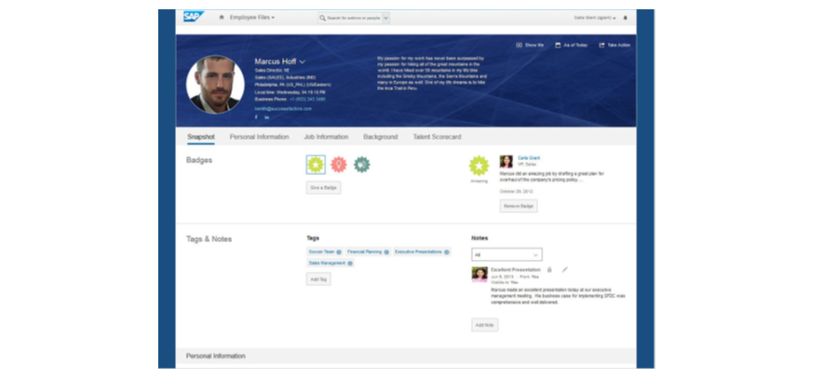

**People Profile - Employee Central Functionality**

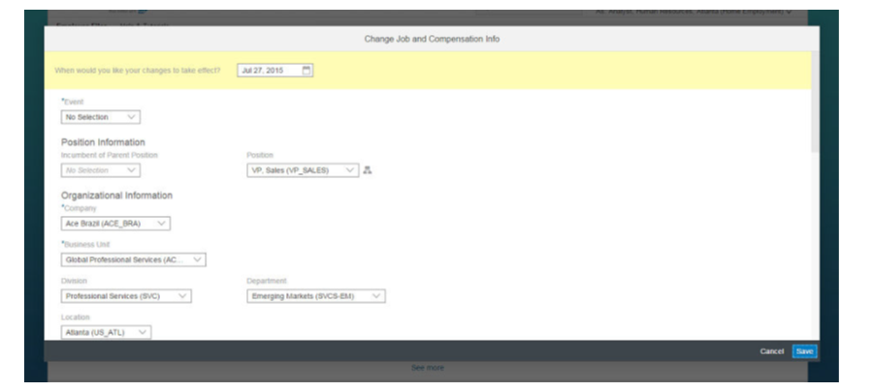

With People Profile, you can access ***Employee Central functionality***, such as employee self-service (ESS), manager self-service (MSS), and spot bonus. You can add and edit an employee's personal, employment, and compensation information, or view the effective-dated change history.

**Employee Central Information in People Profile**

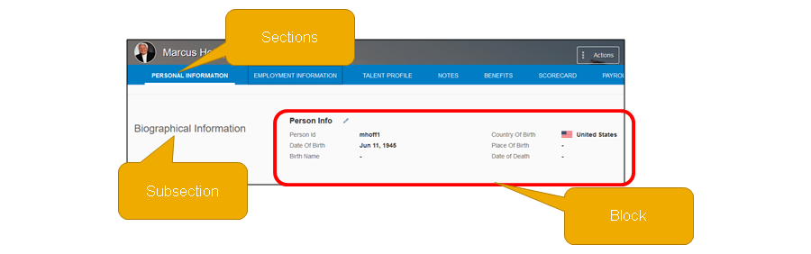

Thông tin trong People Profile được nhóm lại thành các Block, thêm vào bất cứ section hoặc subsection nào.

***In most cases, information blocks on the People Profile correspond to "portlets" used in previous versions and display exactly the same data.***

Portlet: an application used by a portal website to receive requests from clients and return information.

In some cases, information blocks do not correspond to portlets, but to entirely separate pages, or "employee views," used in earlier, versions. For example Employee Profile information such as notes, performance history, or compensation statements were previously displayed as separate pages, but on the People Profile, they are all displayed as blocks. Likewise, some Employee Central features, such as Time Off and Payroll, were previously displayed as separate pages and are now displayed as blocks.

Employee Central defines data from the data models to be displayed in portlets as well. Most HRIS elements in the succession data model were defined to ***display as a portlet***, with a few exceptions. When you enable EC with People Profile, People Profile will be configured with ***2 section for the EC Core Data (Person and Employment Objects)***. Those by default are labeled ***Personal Information and Employment Information***. Each section in PP will have several subsections. Each subsection may have 1 or 2 PP blocks that represent a portlet for EC.

**Configure People Profile**

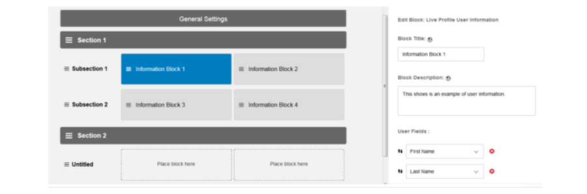

You can manage the content and layout of People Profile using a ***Configure People Profile*** tool.

The Configure People Profile admin tool supports all of the functionality available in the previous ***profile configuration*** tool, but with a much improved user experience. You can now use an ***easy, drag-and-drop interface to add sections, subsections, and information blocks to the profile***.

You can also use it to ***configure other "general settings"*** that were available in the previous admin tool, such as the ability to add introductory text or video, manage background images, add profile completion reminders, and configure ratings data settings.

**People Profile Field Configuration**

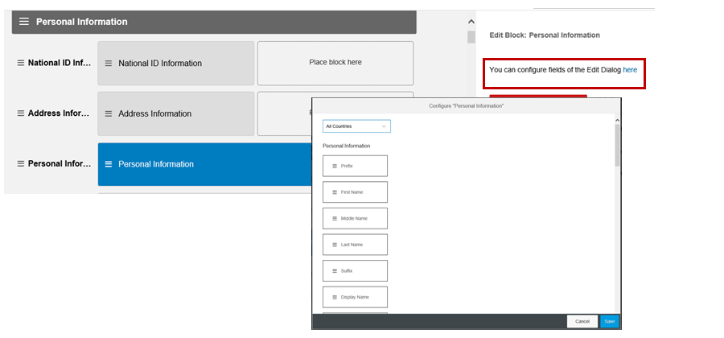

Within the Configure People Profile tool, you now have the ability to **rearrange fields** within certain sections, like Personal Information and Job Information, when viewing the edit screen. ***You can also choose a country to then re-arrange country-specific fields within that portlet.***

**Action Search**

Action search facilitates navigation of the SAP SuccessFactors HCM Suite by enabling you to find common actions and pages in the search box at the top of every page. You can use natural language to describe what you want to do, in your own words, and then select from a list of suggested actions.

You can type search terms that describe the desired action. For example, you might type add an employee or view my performance review or request time off. If the entered text matches any of the search terms associated with any of the available actions, those actions are listed in the search results.

***Action search results respect both system configuration and system permissions***, so you do not see actions that are not available to you or that you do not have permission to perform.

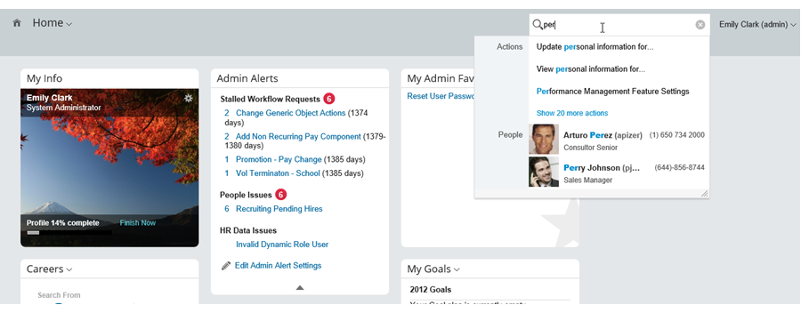

**Search Terminology**

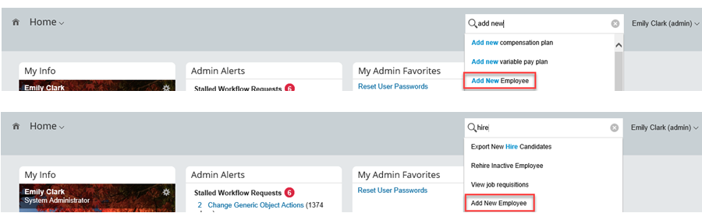

***Search terms do not need to exactly match the labels displayed in the user interface. You can natural language to describe actions in your own words***. For example, to add a new user to the system, you might type “add employee” or “add user” or “hire”. All of these search terms return the action Add new employee.

Similarly, in order to request a day off, you might type “take day off” or “request leave” or “PTO”. Any of these terms will return the Request time off action and navigate you to the appropriate page.

**Manage Action Search**

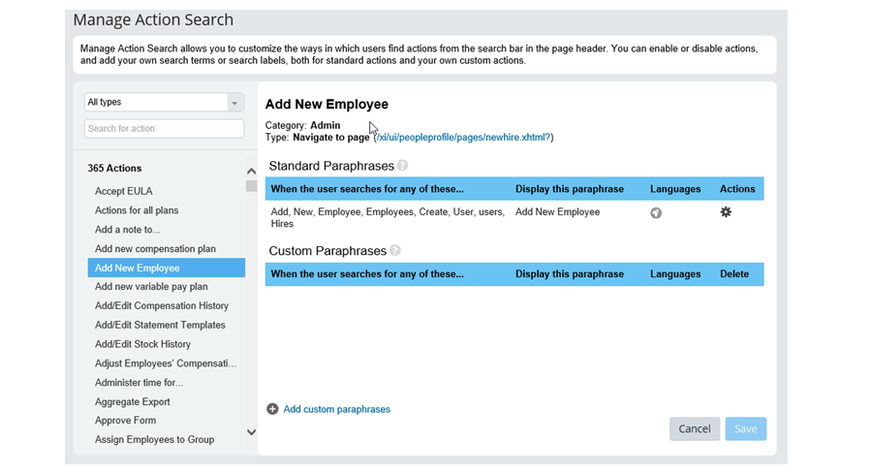

No configuration steps are required after action search is enabled. You can immediately start using it to find and complete a large number of actions that are available by default.

However, as an administrator, you can also use the new Manage Action Search admin tool to modify the default search behavior. This allows you to optimize action search results for people in your company and facilitate access to additional frequently-used actions.

You can also add custom actions to your instance. You can create custom navigation actions using the Configure Custom Navigation tool. Also, when you create new reports or dashboards, they are automatically made available in action search as well.

**Check Tool**

The Check Tool can be used to identify data and configuration issues.

Sometimes, you might find that your system doesn’t work as you expect. There can be different reasons for this, such as:

Some data is inconsistent

The system is not configured correctly

With the check tool, you can identify what's wrong, rather than simply creating a ticket. The check tool:

1. Finds out what is wrong and how bad the problem is
2. Suggests a solution

To use the check tool:

1. Choose the application, such as Position Management, where you want to carry out checks
2. Click the object you're interested in to list the checks you can run for it.
3. You can run as many checks as you want. Note the 'Run Checks' button at bottom right, which tells you how many you have selected.
4. The result can be any of these:

Success: No issues found.

Warning: One or more issues found, but they are not too serious.

Error: One or more serious issues found. Action is required.

In addition, users who need to create customer tickets can export configuration information.

**Enabling the Check Tool**

To Activate the Check Tool, go to Manage Permission Roles and that will open up the Permission Role List

Select the permission role you want to change. This will open up the Permission Role Detail page

Select Permission button. This will open up the Permission settings box

Go to Administrator Permissions > Check Tool and select All and click Done

Select Save Changes to Finish

**Employee Central Feature Settings**

Customers can now enable/disable certain Employee Central features that previously could only be turned on through Provisioning. This includes the following features we discuss throughout this course:

1. Position Management
2. Company Structure Overview
3. Contingent Workers
4. Global Assignment
5. Concurrent Employment
6. Enabling Employee Central Feature Settings

To Activate Employee Central Feature Settings:

1. Go to Manage Permission Roles that will open up the Permission Role List.
2. Select the permission role you want to change. This will open up the Permission Role Detail page.
3. Select Permission button. This will open up the Permission settings box.
4. Go to Administrator Permissions > Manage System Properties.
5. Select Employee Central Feature Settings and select Done.
6. Select Save Changes to finish.

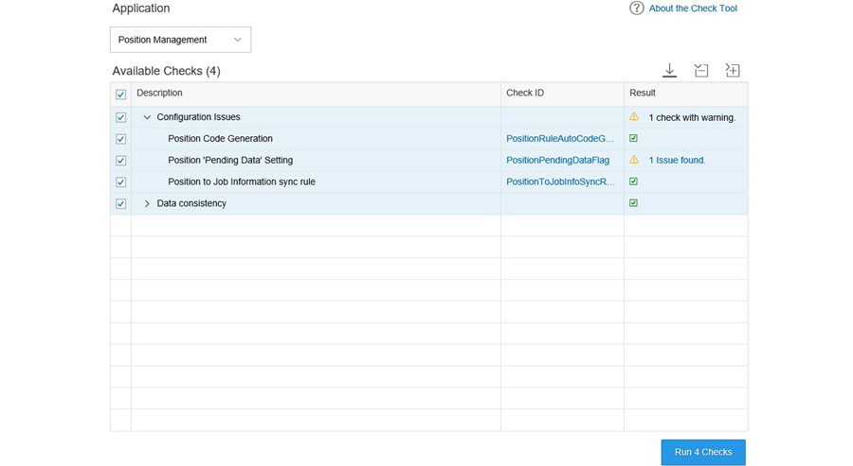

**Enabling the Check Tool**

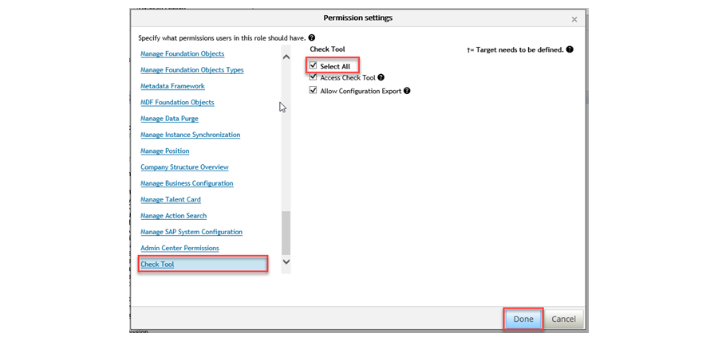

**Enabling Employee Central Feature Settings**

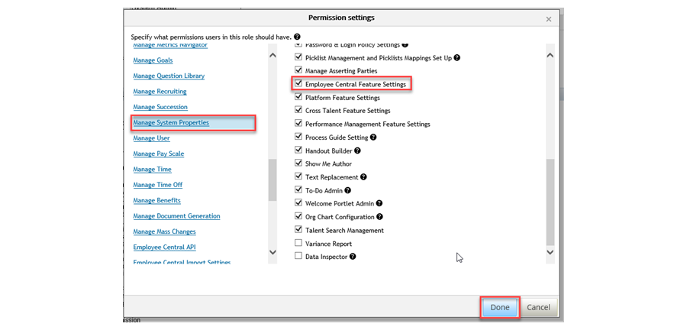

# Unit 2 Security- Role Based Permissions

## AGENDA

Managing User Access

Managing Security Using Role-Based Permissions (RBP)

Implementing Data Changes and Reviewing Audit Trails

## 2.1 Managing User Access:

**Administrator Types**

Employee Central (EC) has several types of administrators as shown in the figure, Administrator Types.

The first level is an ***Admin User***. An Admin User has access to functionality on the Admin page. For example, you can set up an Admin User who manages the performance and goals functionality for a company.

The second level is a ***Security Admin***. A Security Admin is responsible for managing security using roles and permission groups in the ***RBP*** framework. A Security Admin has access to Manage Permission Roles and Manage Permission Groups.

The highest level is a ***Super Admin***. ***The Super Admin is set up using Provisioning or by another Super Admin in Manage Role-Based Permission Access***. A Super Admin can grant an employee the permission to operate at any administrator level. A Super Admin has access to Manage Role-Based Permission Access.

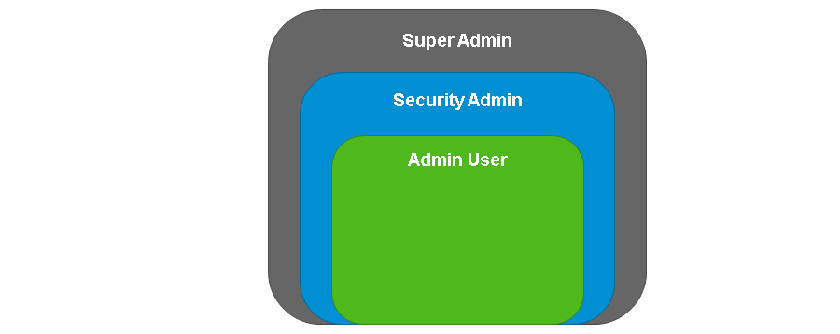

**Proxy Roles**

Proxies are useful in EC. There are typically two roles in proxy. The Account Holder owns the account and has the rights to view and edit information. A user who has Proxy rights for an Account Holder can choose Proxy and open, view, edit, or send any item in the modules for which the user has permissions. In EC, an additional setting is available for Employee Central and Employee Profile data. ***When Private Data for Proxy Account Holder is deselected, the proxy does not have access to potentially sensitive information such as home address or compensation.***

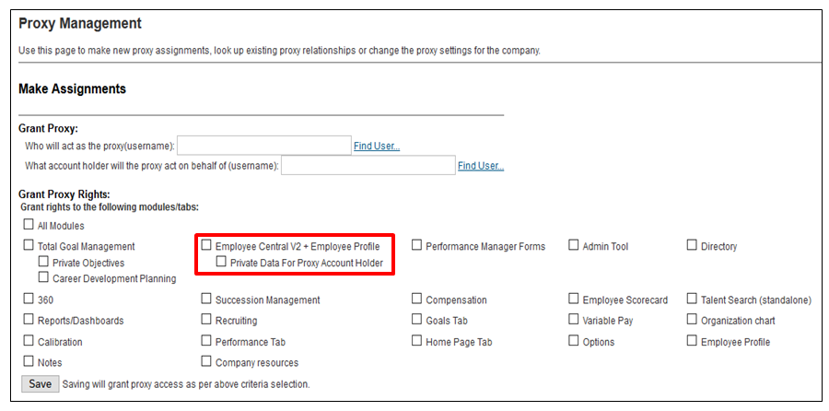

**Delegate Relationships (đại diện người khác)**

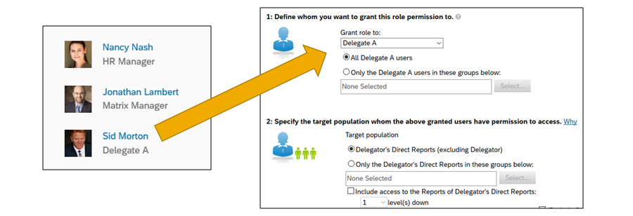

***You can configure delegates to perform actions on another user’s behalf*** that affects other employees in your organization.

Bạn có quyền chọn quan hệ Delegate A và Delegate B để assign quyền đó cho tối đa 2 người (một cho mỗi quyền), cho phép người đó thực thi như một đại diện Delegate. Người đại diện, delegate, có quyền truy cập trực tiếp (gián giếp) report của người ủy nhiệm Delegator và thực hiện task được cấp quyền.

You can assign the two delegates separate tasks or permissions to cover different functional or regional areas.

Delegates differ from proxies in that proxies get the permission of the account holder, while delegates only have the explicit permissions assigned via RBP roles.

**EC Historical Change Tracking**

The EC platform is effective-dated across many of the Foundation Objects (FO) and employee records, which means that EC stores records and changes in a global system. When a new record is inserted, the previous record is closed. How do you know who is making those changes and when? For most effective-dated entities in the system, EC provides a high-level overview of changes in the History section of the instance. Permissioned users can also access Audit Reports for a more in-depth look at changes.

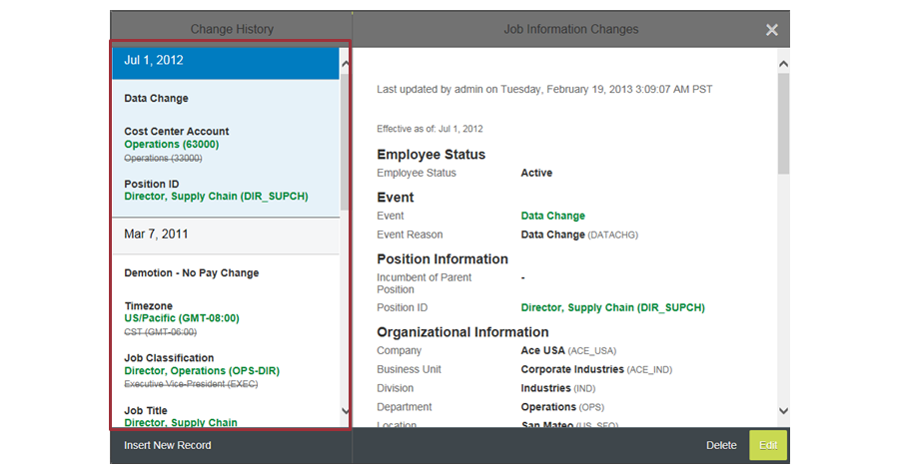

## 2.2 Managing Security Using Role-Based Permissions (RBP):

RBP Overview

RBP is a customizable method of managing permissions in your company. Traditionally, HR managers are assigned the same permissions. However, you can use RBP to grant control at a granular level based on the specific work that a person does. ***You can define roles based on job codes, locations, relationships, and more***. ***This granularity allows the groups to be both targeted and dynamic***. For example, you can create permissions for HR managers in the USA that enable them to view and edit person and employment data for all of their employees in the USA.

***Enabling RBP in provisioning is a required to enable Employee Central.***

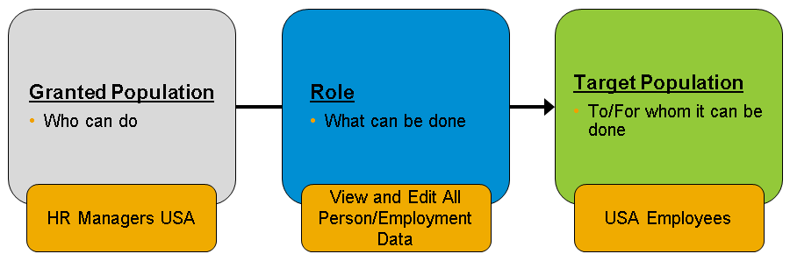

**Permission Groups**

***Permission Groups allow you to define employees in the Granted Population and Target Population roles.*** You can create these groups based on ***single or multiple parameters***. For example, you can create a group of IT managers based on the job code IT-MGR. You can also create a group of IT managers in the USA based on job code and location. Permission Groups are an integral part of RBP. ***However, they might not be necessary if you are working with general conditions such as All Employees or Manager’s Direct Reports, which are predefined roles in the system.***

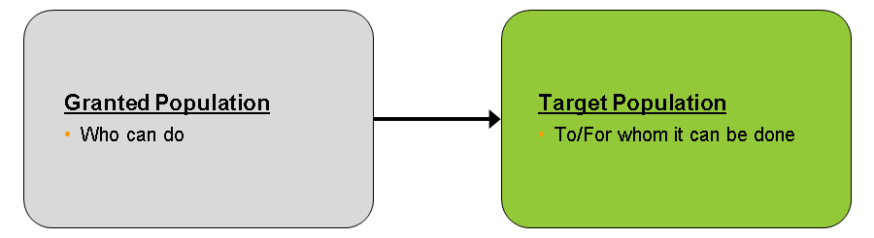

**Best Practices for Naming Permission Groups**

As a best practice, when creating permission groups use a prefix to help you to identify which group to use in your permission role. If you are creating a permission group that is receiving the permissions (a granted group), use the ***prefix Granted***: for the name of the group. For example, if you are creating a permission group for IT managers, use ***the name Granted: IT Managers***. Similarly, if you are creating a target permissions group, use the ***prefix Target***. For example, if you want the IT managers to have access to all employees in the USA, you must create a target permission group based on location and use the name ***Target: Employees in USA.***

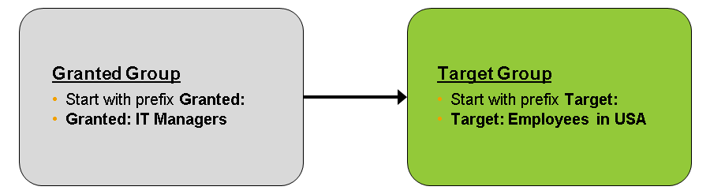

**Permission Roles**

Permission Roles ***control the access rights in the system*** and ***involve the process of defining access to data and application functionality***. ***To create and manage permission roles***, choose ***Manage Permission Roles***. After you add a name and description, choose Permission to go to Permission Settings, as shown in the figure, Permission Roles. You can see permission categories such as Employee Data and Employee Central Effective Dated Entities. When you select one of these categories, the permissions or fields for the category display on the right. ***Managers and employees in EC use the following permission categories: Employee Data, Employee Central Effective Dated Entities, and Employee Views***. Some users also need access to ***Reports Permissions***. If a customer chooses to use customizable fields in any of these categories, they must also receive permissions for the relevant roles.

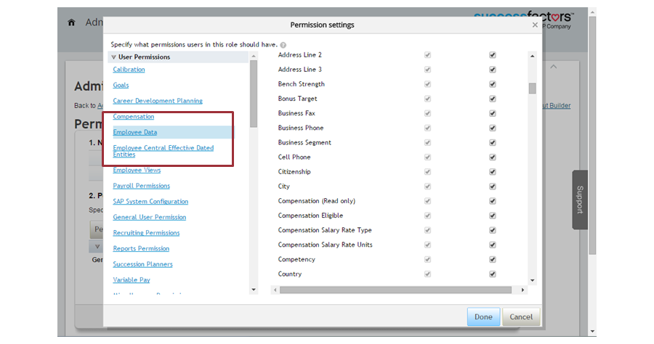

**Additional RBP Resources**

For more information on RBP, download the Role-Based Permissions Handbook and EC Implementation Handbook from the SAP Help Portal (<http://help.sap.com/cloud4hr>).

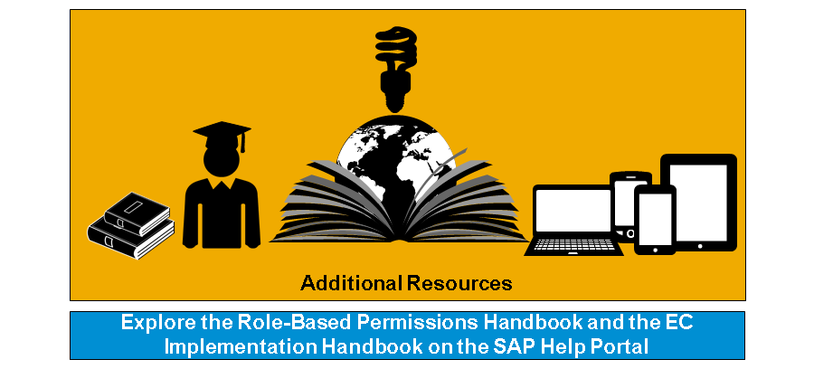

## 2.3 Implementing Data Changes and Reviewing Audit Trails:

**Effective Dating for New Records**

Nhiều lưu trữ (record) trong EC có ngày hiệu lực. Mỗi khi bạn thêm mới một bản lưu cho một trong những item này, hệ thống yêu cầu ngày hiệu lực. Rất quan trọng hiểu và duy trì sự chính xác của ngày hiệu lực vì chúng giúp tạo ra các record cho quá khứ, hiện tại và tương lai.

Ví dụ, Marcus chuyển nhà tháng Giêng, thêm địa chỉa mới của Marcus cùng ngày hiệu lực trong tương lai. Marcus won’t see that change until January.

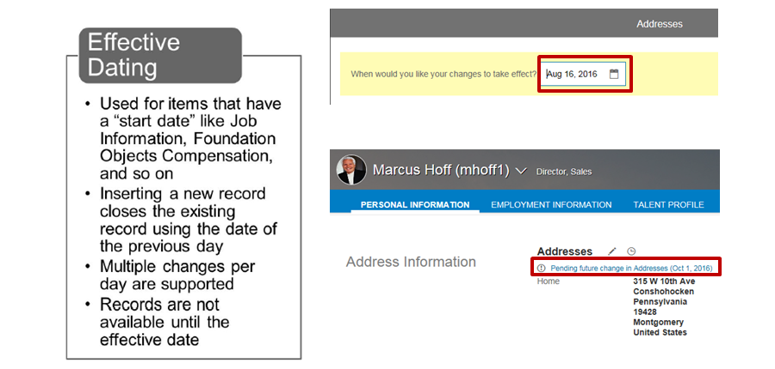

**Administration Records Management**

Có nhiều cách để thay đổi employee files in People Profile layout. Bạn chỉ thấy những options này nếu được assign quyền từ RBP.

***Clicking on the Pencil Icon*** allows you to insert a new dated entry into the Employee's file. If ***Event Reason Derivation*** is enabled, then they will be determined based on the change being made. Each new record added to the employee's file must be connected to a date in the past, present or future. (tóm tắt: Pencil Icon -> thêm ngày hiệu lực -> Event Reason Derivation)

***Event reason*** is an activity derived from events that drives changes in employee data. ***These events are predefined for all instances and cannot be added (as of 1508)***. Of course, you can deactivate part of them or rename the current events if needed. Standard events delivered from SuccessFactors are listed below (today we will focus on those marked green). The reason why to focus only on these is that they are all available in MSS and we will try to find the right approach how to offer the managers a simple way to use the SuccessFactors to manage employees.

Additional Job – this event is not used. When activating additional job, you go to the new hire process and use the event Hire

Assignment

Assignment Completion

Job Change

Completion of Probation

Data Change

Demotion

Furlough

Hire

Job Reclassification

Leave of Absence (used for time off activities)

Pay Rate Change

Position Change

Probation

Promotion

Rehire

Return from Disability

Return to Work (used for time off activities)

Suspension

Termination

Transfer

Add Global Assignment

End Global Assignment

Obsolete

Start Pension Payout

*This action can trigger an approval process, which will need to be completed before the record is active in the system.*

If you navigate to the history of a portlet and click on a dated record, you will see a variety of options. Edit enables an administrator or permissioned user to make changes to the historical record. For example, Marcus Hoff moved on January 5, 2010, but accidentally entered the incorrect ZIP code. To make changes to the historical record, choose History → Edit. This record will show corrected zip code only, however, you can still see the change was made in an audit report.

This change will not trigger an approval process.

Insert New Record (clock button, top-right corner). An event and event Reason là bắt buộc. Therefore, it is important for users with this privilege to be familiar with ***Events*** and ***Event Reasons*** in their system.

Navigating this way will ***not trigger an approval process***. Approval processes are only triggered through the ***Pencil Icon or Take Action*** --> Change Job and Compensation Information.

**Insert New Record (Clock Button)** không trigger approval process. Trigger approval process khi **Personal Information (Pencil Icon)** hoặc là **Take Action**.

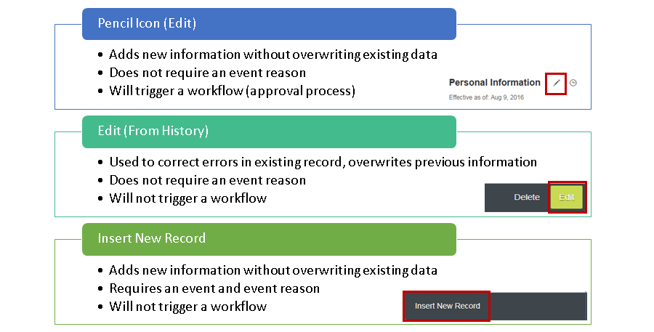

**EC Audit Trail (Lưu vết chỉnh sửa EC)**

The final layer of EC security is a complete audit trail. The audit trail is ***available both in the history of a record and as an ad-hoc report for records***, as shown in the figure, EC Audit Trail. Có 2 cách truy cập vào audit trail, qua history of record và qua ad-hoc report.

The first example in this figure is the record history. To access the record history for Jane Miller, choose ***Personal Information → Address → History***. Then, choose the record that is effective on November 12, 2012. On the bottom right, you can see that this record was last modified on December 13, 2012 by the Admin User on behalf of Nancy Nash.

The second example in this figure is an ***ad-hoc report***. This report shows the ***date*** and ***time*** of each ***record change*** and the user ***who made the modification***. Để tạo và xem Audit Report, bạn phải đăng nhập và có quyền truy cập Reporting/Analytics và vào ad-hoc reports.

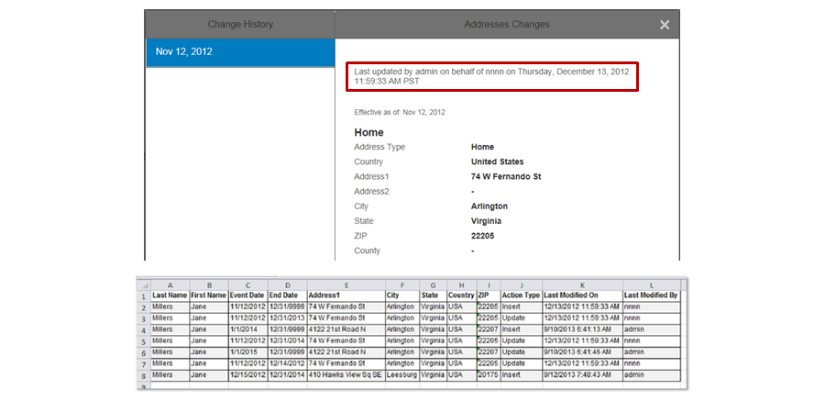

**Audit Report Features**

The audit trail has the following features:

* It returns all change history for person and employment objects for each employee
* It is visible in *History*.
* It is available as an ad-hoc report
* It is available for
  + Home/Business Address
  + Compensation
  + Emergency Contacts
  + Email
  + Employment
  + Job Info
  + National Id
  + Recurring/Non-Recurring Pay
  + Personal Info
  + Work Relationships
  + Person Info
  + Succession
  + User Info

# Unit 3 Foundation Object Management

## AGENDA

Storing Foundation Data

Populating a Foundation Object (FO) Records

Customize Foundation Objects

Configuring the Country-Specific Fields (CSF) for Foundation Objects

## 3.1 Employee Central (EC) Structure and FO:

*EC is currently undergoing a process to convert all content managed through XML Files and Data Models to MetaData Framework (MDF). MDF allows administrators to manage the structure of an object directly in the EC instance, rather than through XML coding.*

The first phase of this process started in 2015, with the conversion of some FO to MDF FO. As of the current release, *the following Foundation Objects have been moved over to MDF:*

* *Legal Entity*
* *Business Unit*
* *Department*
* *Division*
* *Cost Center*
* *Job Classification*
* *Job Function*
* *Pay Group*
* *Pay Calendar*

**Over the next few years, all of the objects currently managed through data models will be converted to MDF, eliminating the need for XML**. However, as this process is completed, there will be different ways of accessing objects managed through XML versus objects managed through MDF. The modules in this course explain both of the ways that you can access data during this process. Diễn giải cả 2 cách truy cập vào data – thông qua XML và thông qua MDF.

In EC, Foundation Objects (FO) and Records capture detailed information about a company’s organization, pay, and job structures. The FO remaining in the Corporate Data Model are managed (populated) in Admin Center, under *Manage Organization, Pay, and Job Structures*, and configured in the Corporate Data Model. The FO converted to MDF are managed (populated) in *Manage Data*, and configured in *Configure Object Definitions* within the *Admin Center*.

**EC Structure**



**FO Definition**

FO are effective dated and provide company structure. The objects themselves can be customized to hold company-specific data. The records built from these FO define the customer's organization, pay and job structures. ***These must be built before any employee data can be added into the system***.



**FO Example**

In the figure, FO Example, you can see a FO Record. Legal Entity is the highest organization structure. Legal Entity can only belong to one country, and it captures basic information about the company in that country.

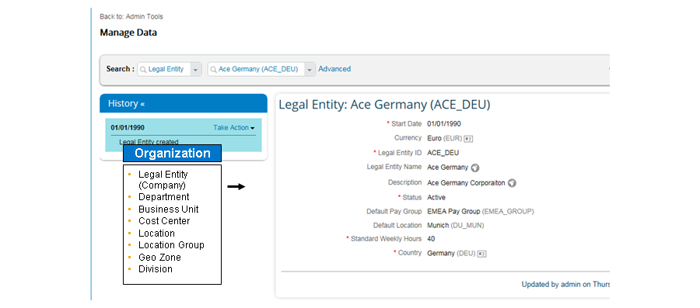

**FO Effective Dating**

Effective dating means that EC can maintain a historical record of data. The start date for any record is the first date entered. For previous records, the end date is one day before the new record begins.

For example, in the figure, Effective Dating of FO, the start date is January 8, 2013. This means that the *Legal Entity created* record closed on January 7, 2013.

The system records the changes between updates using cross outs. Most FO are effective dated; on the screen, look for *Effective as of*.

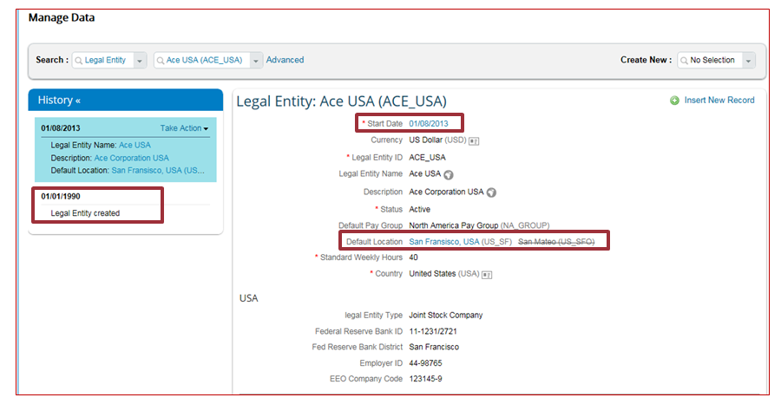

**Effective Dating of FO: Administrator Tasks**

For each FO Records, an administrator can complete the following tasks:

* Insert a new dated record with an effective date in the past, present, or future
* Make a correction
* Permanently delete an entry for past, present, or future records

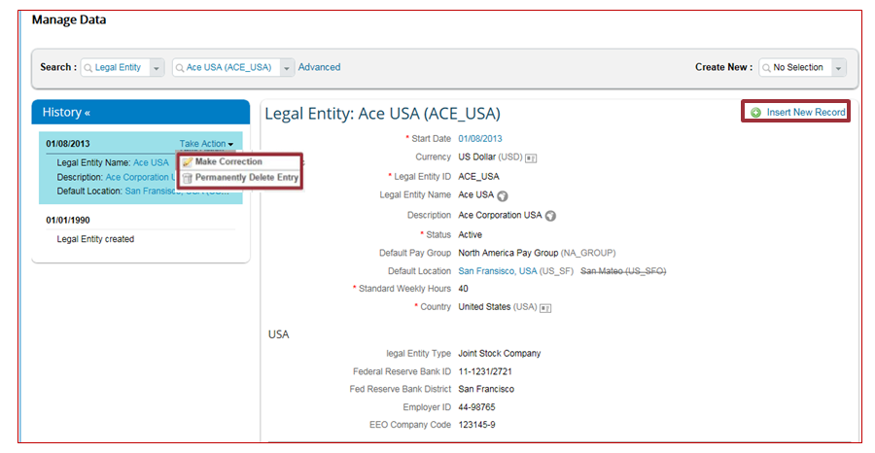

The system records which user made changes and when.

**FO and Employee Files**

FO provide the underlying information for employee files. The only options for an employee’s company are Legal Entity records created in Manage Data.

**FO Records and Employee Files**

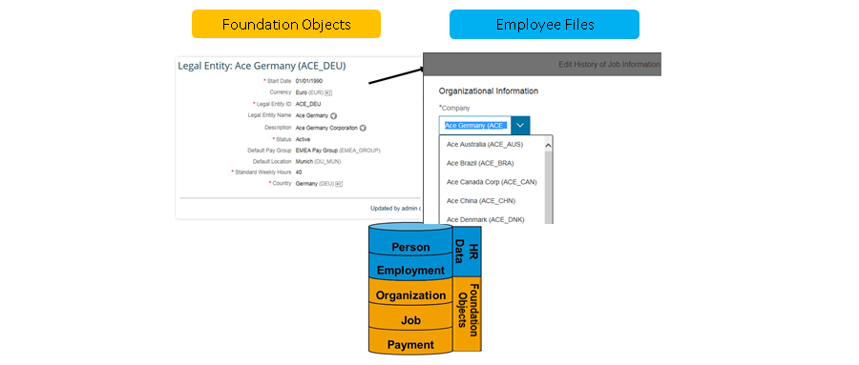

**FO Propagation**

FO are also used in propagation. For example, your company is hiring multiple employees with the same Job Classification. During the new hire process, the HR admin selects Job Classification: Engineer (ENG). Propagation then uses information from the FO records to automatically propagate subordinate fields like Job Title, Pay Grade, Regular/Temporary, and so on. You will learn how to configure propagation in a later module. (tự “lan ra” các trường thông tin về vị trí, lương… khi nhập Job Classification)

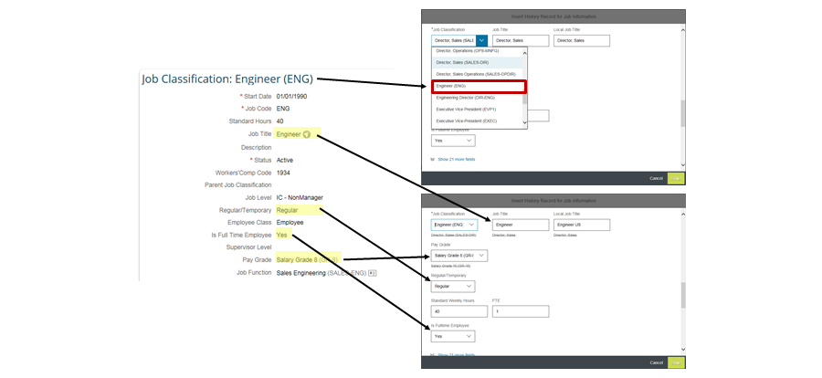

**FO Records Usage**

With FO, you can assign the following items:

* Employees’ business address
  + For example, every employee in the South San Francisco office has the same business address: 1 Tower Place, Suite 1100, South San Francisco, CA 94080. If an employee’s location is the South San Francisco location, the employee’s business address automatically becomes 1 Tower Place, Suite 100, South San Francisco, CA 94080.
* Pay ranges by Legal Entity and Geo Zone (group of locations)
  + For example, a pay range is assigned to all employees with *Job Classification*: **Engineer (ENG)**.
  + For example, the pay range is $80,000–100,000 in North America, and the pay range is €90,000–110,000 in EMEA.
* Different payroll information
  + For example, the company must feed the data of US employees to ADP US and the data of Germany employees to SAP.

**Standard, Custom, and Country-Specific Fields (CSF)**

Each Foundation Object has standard fields and custom fields. Additionally, most objects have country-specific fields, which allow you to collect locally-relevant data.

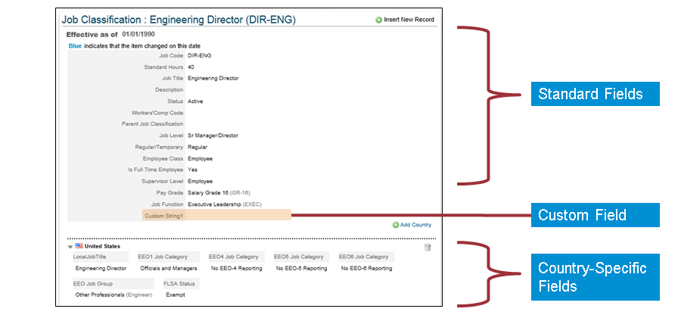

**Associations with Foundation Objects (FO)**

FO can also have relationships, which are known as associations. In the figure, Relationships: Associations, you can see that the San Mateo office belongs to the ACE_USA Legal Entity. When you change an employee’s company to ACE_USA, you can only see records in the Location field of that are associated to the ACE_USA Legal Entity record.

You will learn how to configure associations in a later lesson.

**Relationships: Associations**

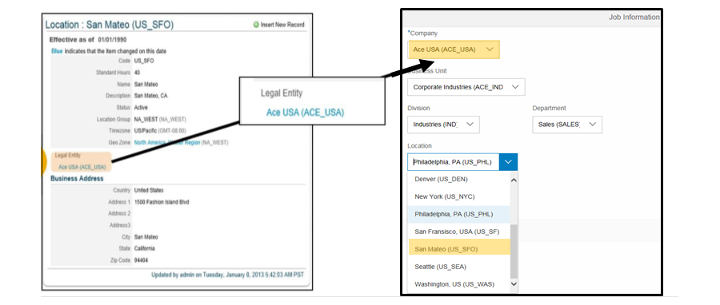

**Picklists**

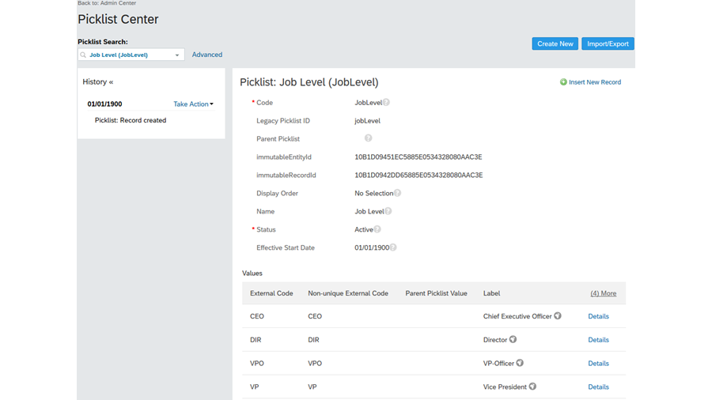

Picklists are lists of values defined in the instance, which you can reference from any of your Corporate Data Models, Succession Data Models, or MDF Objects. Picklists can streamline data and make data entry more efficient. Some picklists are already specified in your instance; for example, the Job Level dropdown menu is populated from a list of job levels defined in the JobLevel picklist.

As an administrator, you manage picklists using the Picklist Center. In order to do that, you will need Picklist Management and Picklist Mappings Set Up permission in RBP.

**Organization Data**

Organization Data is a category of FO. These records are the building blocks of the organization. Not only do you populate these records, but by using associations, you also mimic the organization’s structure within the employee files. Additionally, just as with Locations, the system filters choice out of the menus based on hierarchy (hệ thống cấp bậc).

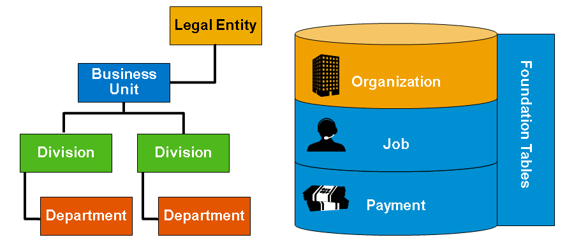

**Legal Entity**

The Legal Entity object stores all legal entities of a company. In the demo instance for this module, you can see several examples like ACE_USA and ACE_CHINA. Each Legal Entity can only belong to one country, and that country determines the employee’s country. You can also see the *Standard Weekly Hours* field. This field is used for ***Full Time Equivalent (FTE) calculation***. Even though standard weekly hours are set up in the instance by default, you can also define them in Location or Job Classification. ***Country-specific fields appear based on the country that is selected for the Legal Entity.***

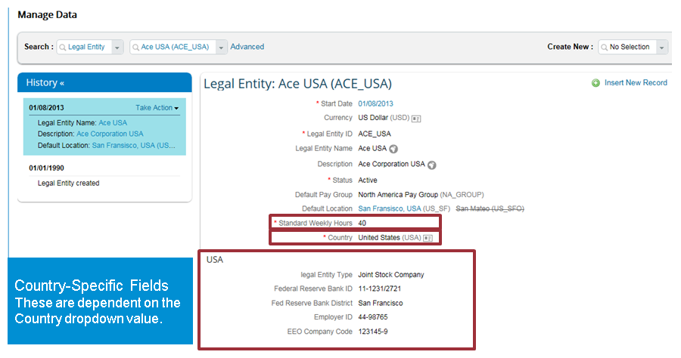

Business Unit

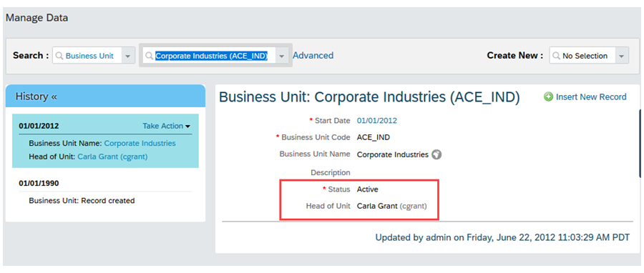

A Business Unit is the level of the organizational hierarchy lower than the Legal Entity. It is the Business area of the company, representing one operating unit or representing the business function within the Company (not geographical).

**Division**

A Division stores information for all divisions within a company. You can create a hierarchy using the *Parent Division* field. In this example, one Division can belong to multiple business units.

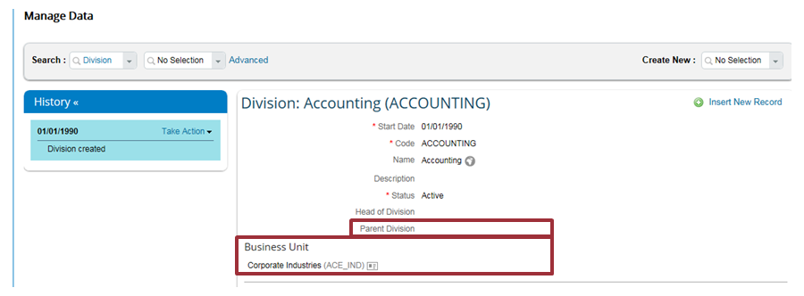

**Department**

A Department has similar properties to a division. A Department stores information for all departments within a company. You can create a hierarchy using the *Parent Department* field. In this example, one Department can belong to multiple divisions.

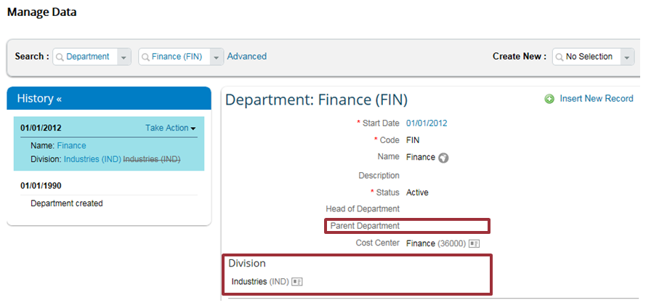

**Location**

A Location stores information regarding all physical locations of a company. One Location can belong to one Location Group and Geo Zone, and one Location can belong to many Legal Entities. The Business Address can be defined by country in the Country-Specific Corporate Data Model.

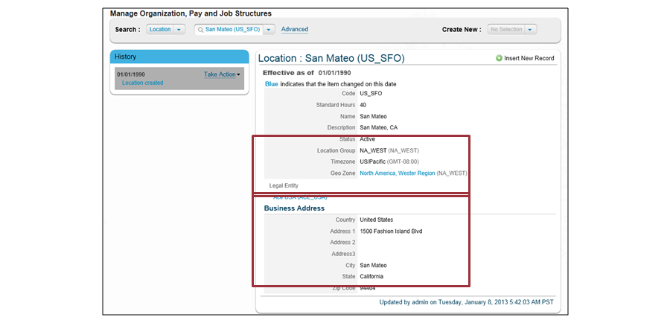

**Location Group**

Customers can group ***multiple locations into one Location Group***. For example, Location Group West Coast contains several locations, including the San Mateo Office, San Diego Office, and so on. Location groups are primarily used for EEO reporting in the USA.

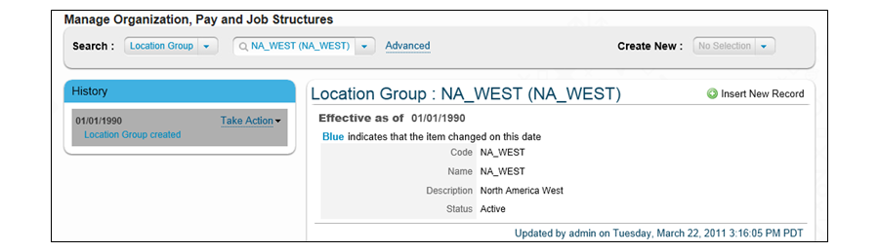

**Geo Zone**

You can group ***multiple locations into one Geo Zone***. For example, Geo Zone North America, Western Region contains business locations in San Mateo, San Diego, and so on. ***Geo Zone includes an Adjustment Percentage field, which allows the pay range to be adjusted based on cost of living***. For example, a company can decide to adjust the pay for employees on the West Coast by 15%.

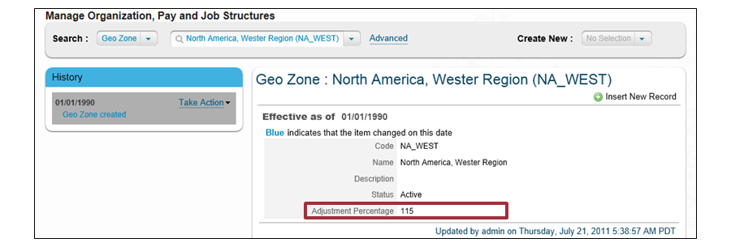

**Job Data**

Job Data is the second category of FO in EC. Job Data provides repeatable job codes to assign to employees and stores job-specific data like Full-Time and Standard Hours.

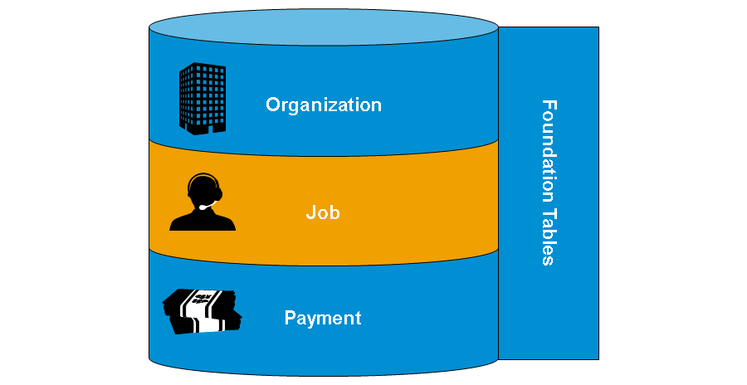

**Job Classification**

Job Classification stores all job codes and associated information for a company. Common fields include the following: *Supervisor Level*, *Job Level*, *Regular/Temporary*, *Full/Part Time*, *Employee Class*, *Job Title*, and *Pay Grade*. You can also have country-specific fields for Job Classification.

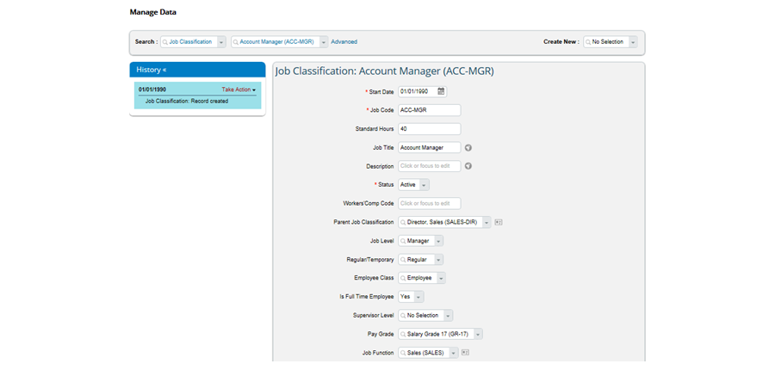

**Job Function**

Several job classifications can share the same Job Function. For example, the Job Classification: Developer and Job Classification: Developer Manager belong to the Job Function: Engineering (ENG).

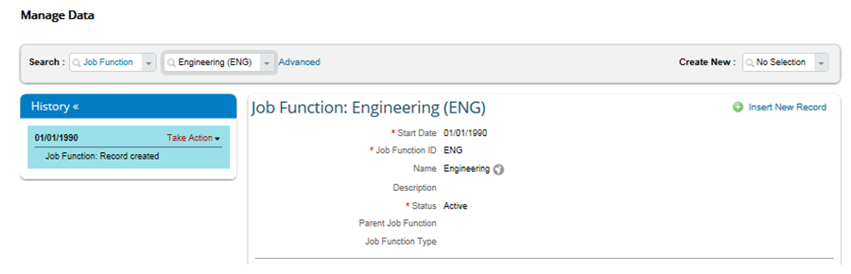

**Pay Data**

The Pay Data FO Records provide repeatable pay data to assign to employees and collect pay information like pay range, pay grades, and so on.

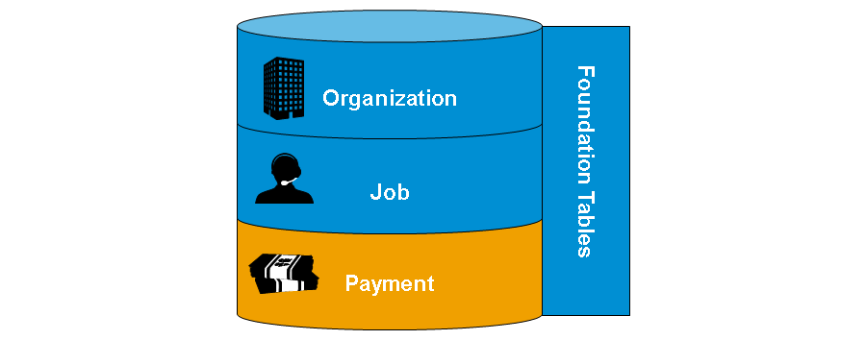

**Pay Group**

***You can group employees who share the same payroll into one Pay Group***. In the figure, Pay Group, the instance is set up to group by region, North America. Pay Group is primarily used for payroll-related activities.

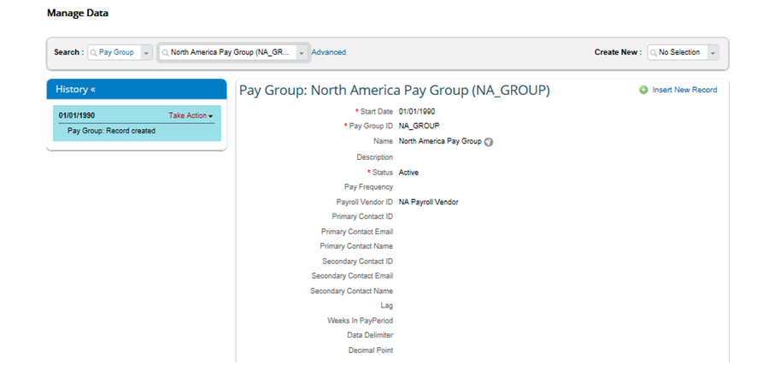

**Pay Range**

You can decide the Pay Range for employees. In the figure, Pay Range defines that the *Minimum Pay*, *Maximum Pay*, and *Mid Point* are $120,000, $129,999, and $124,999.50, respectively, if the employee meets the following requirements:

* *Geo Zone* is set as **North America, Western Region (NA_WEST)**.
* *Pay Grade* is set as **Salary Grade 12 (GR-12)**.
* *Legal Entity* is set as **Ace USA (ACE_USA)**.

Pay Range is primarily used for the calculation of ***Compa Ratio*** and ***Range Penetration***. You can define as many pay ranges as needed.

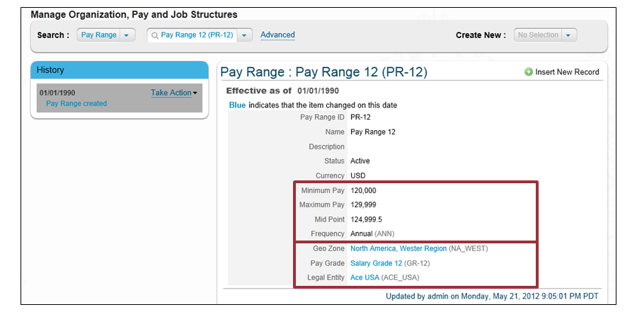

**Pay Grade**

The Pay Grade object defines the pay grade available on the Job Classification FO.

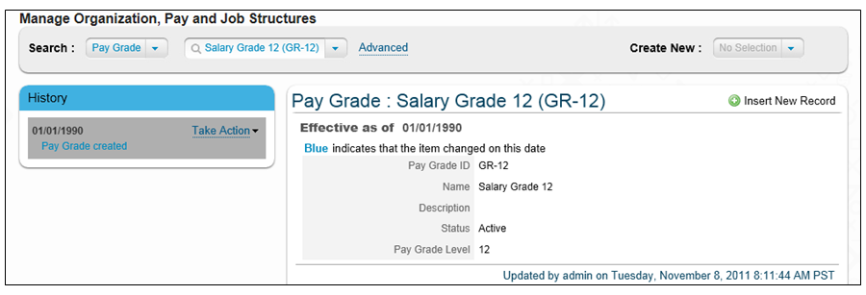

**Pay Component**

***The Pay Component FO stores all information about how the company pays an employee,*** such as Base Salary, Bonus Target, Car Allowance, and so on. For each pay component, you can define the following:

* Recurring (frequency) or one time pay
* Amount as percentage or value
* Earning or deduction
* Actual pay or a target
* ***Visibility for managers on Manager Self-Service***
* ***Used in Comp Planning***
* Taxable

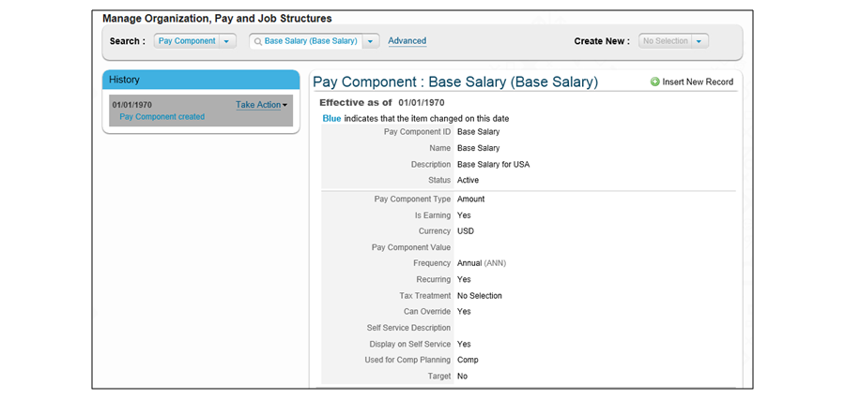

**Pay Component Group**

You can group ***multiple pay components into one Pay Component Group***. *The amount of a Pay Component is equal to the sum of the pay components it includes*. The system automatically completes annualization and currency conversion during the calculation. For example, “AnnualizedSalary” is a Pay Component Group that has five pay components.

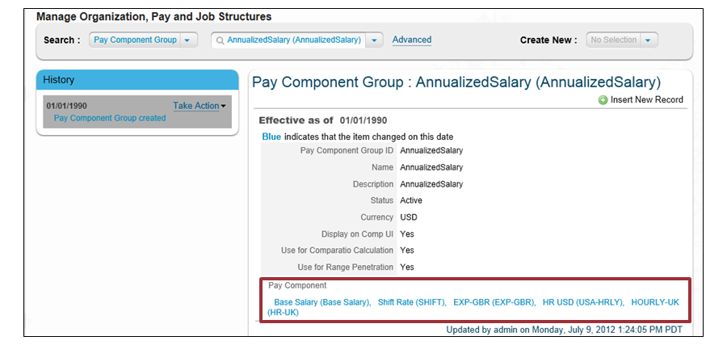

**Pay Calendar**

The Pay Calendar stores pay periods within a year. It is associated with a Pay Group.

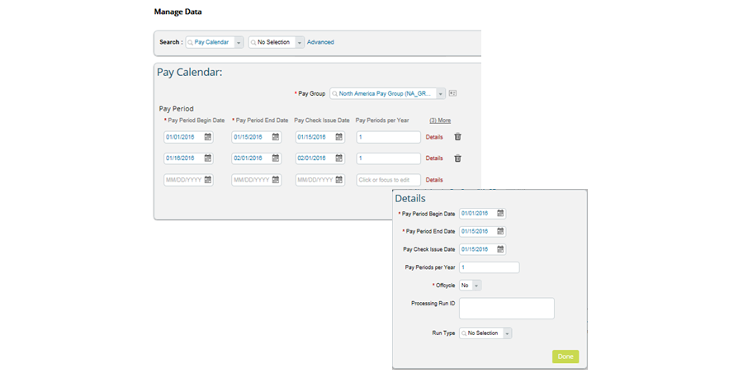

**Frequency**

Frequency defines how often a pay out occurs for a Pay Component.

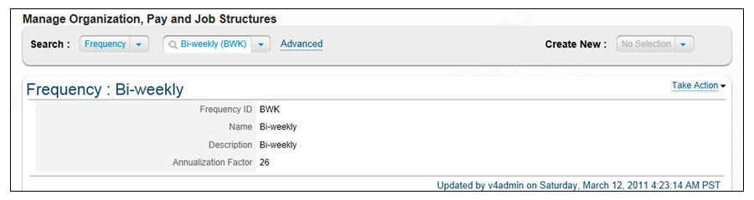

## 3.2 Populating a Foundation Object (FO) Records:

**FO Records Administration**

Administrators can add, delete, and update records for any FO directly in the instance or by using the import tool.

Once you have navigated to *Manage Organization, Pay, and Job Structures* you can see the main administration page. There are three different parts, which are referenced in the figure, FO Record Administration (XML):

1. The *Search* dropdown menu allows you to review any XML FO; for example, Location.
2. Once selected, you can use the additional dropdown menu to choose the specific record, such as New York. You can also use the *Advanced* link to change the date of the search and look for inactive records.
3. To create a new FO record, in the *Create New* dropdown menu, select the Foundation Object.

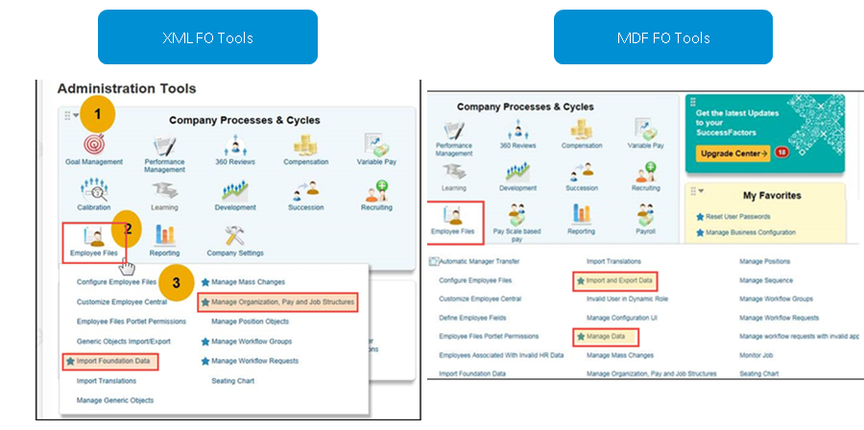

**FO Record Administration (MDF)**

Once you navigate to *Manage Data* you can see the main MDF administration page. There are three different parts, which are referenced in the figure, FO Record Administration (MDF).

To add, delete, and update FO Records managed through the *Corporate Data Model*, use Manage Organization, Pay, and Job Structures tool. You can also import records with Import Foundation Data tool.

To add, delete, and update FO Records managed through *MDF*, use Manage Data tool. You can also import records with either Import and Export data tool or Import Foundation Data tool.

The *Search* dropdown menu allows you to review any MDF Object (for example, Legal Entity).

Once selected, you can use the additional dropdown menu to choose the specific record, such as ACE_USA. You can also use the *Advanced* link to change the date of the search and look for inactive records.

To create a new FO record, in the *Create New* dropdown menu, select the *Foundation Object*.

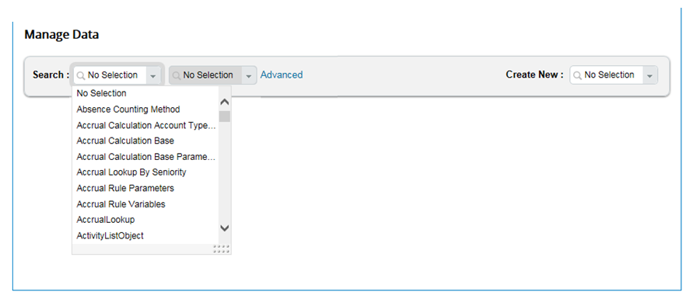

**FO Record Import Process**

In the figure, FO Record Import Process, you can see the import process.

You can download templates directly from the UI. The CSV template matches the configuration of the FO in the system; therefore, two customer instances could have different templates (1). Ensure that you download the templates from the system.

In the *Type* section, imports must follow the order shown in the previous figure, FO Import Process. For example, you must start with *Location*, then *Pay Group*, and so on (2 and 3). There are two types of modes: *Full Purge* and *Incremental Load*. *Full Purge* means that data in the import file replaces matching records in the system. Any previous history on the record is deleted with *Full Purge*. *Incremental Load* loads additions to existing FO Record data into the system.

The *Validate Import File* button ensures that the import headers match and that the CSV file you are attempting to upload contains valid data (4). We recommend that you use this button before any import.

This import process also works for FO that are converted to MDF. Additionally, you can use the tool *Import and Export Data* to download MDF FO templates and import the records.

Nói về import các FOs.

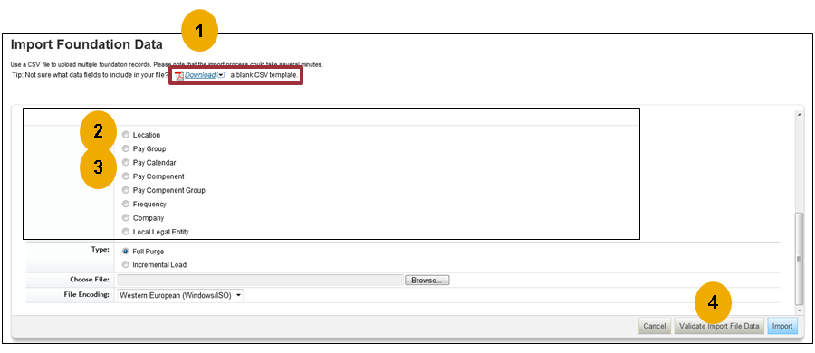

## 3.2 Customize Foundation Objects:

**Corporate Data Model**

Two data models (XML) define the configuration of XML FO:

*Corporate Data Model and Country-Specific Corporate Data Model.*

The Corporate Data Model enables you to customize an FO structure. You have already seen some of the standard objects and fields when adding FO Records for ACE Corporation.

Configuring the Corporate Data Model enables you to define what fields are labelled in the UI and which ones are visible and required.

You can also specify if any custom fields are necessary. This data model also enables you to define the associations between FO.

The following figure, Corporate Data Model, shows the Corporate Data Model. The first element is Location. You can see several of the Location fields, including the following: *Code*, *Standard Hours*, *Name*, and so on.

When you look at the UI, you can see how these fields are reflected. The Location element label is the name of the object in the UI, and *Code* is the first field. Additionally, you can see that the *Code* has additional parameters. It is set to “required” using the **required** = attribute, which generates the star in the UI.

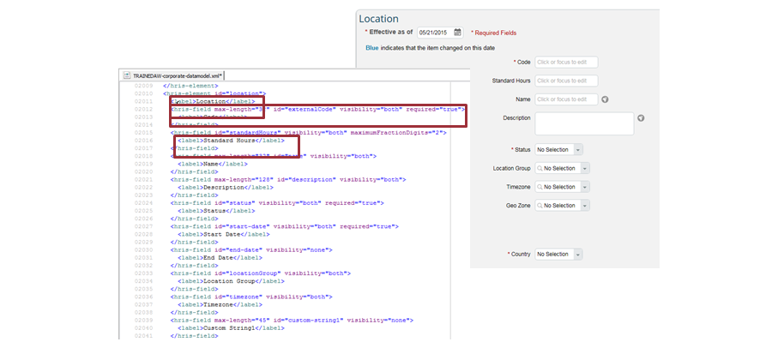

**Meta Data Framework (MDF)**

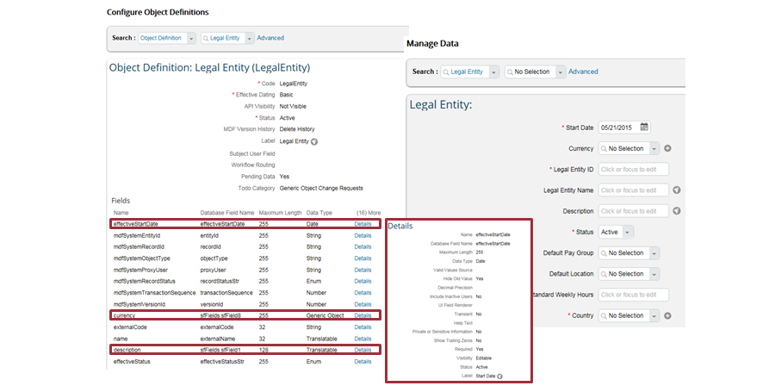

**MDF Object: Currency Exchange Rate**

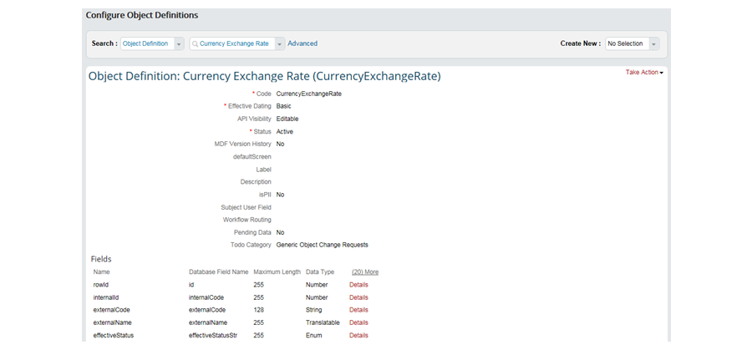

Q2 2016 bản release, Currency Exchange Rate Table được thêm vào MDF.

Bảng này effective dated và cấu hình ở Configure Object Definitions.

All currency exchange rates quản lý ở Manage Data. They can also be mass imported into the system using the Import and Export Data tool.

Any picklists used for this object must be maintained in the Picklist Center tool.

If you are working with a new customer, check whether there is ***already an existing picklist*** with ID = "CurrencyExchangeRateType" and a picklistvalue = "DEFAULT". If it is not available, create the picklist and the default value. However, if you are working with an existing customer, the picklist will be created automatically during the migration.

## 3.3 Configuring the Country-Specific Fields (CSF) for Foundation Objects:

**CSF Corporate Data Model**

The CSF Corporate Data Model can be used to configure fields used for **specific countries** for **Foundation Objects (FO) still managed by XML**.

In the figure, CSF Corporate Data Model, you can see the Location: Business Address for two countries. On the left, you can see information for the United States, and on the right, you can see information for China. The different fields are configured in the Corporate Address element of the CSF Corporate Data Model.

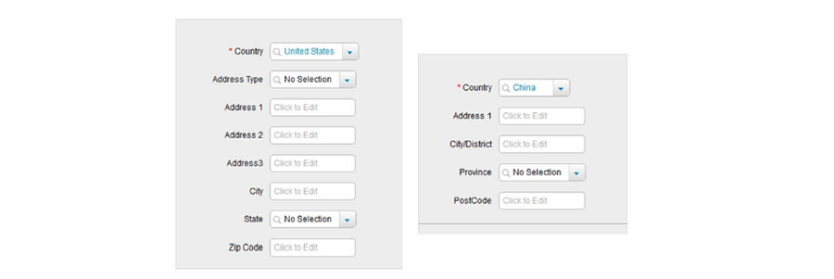

**CSF Corporate Data Model: Mapping of XML and Address Instance**

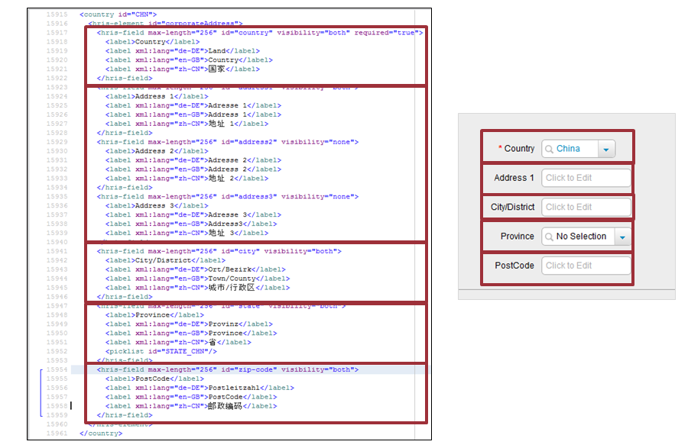

In the figure, CSF Corporate Data Model: Mapping of XML and Address Instance, compare the XML to the instance for the Chinese address. On the left, you can see that the first field, Country, is set to visible and required. In the second set of fields, Address 1–3, you can see that only Address 1 is visible. Finally, look at Province, where you can see that a picklist is referenced in the XML, creating a dropdown menu in the instance.

**Country Specific Fields in MDF: Legal Entity**

Legal Entity and legal entity Local is an example of a Foundation Object migrated to MDF.

You can use the*Configure Object Definitions*page to manage this MDF. There will be one Legal Entity for each country. For example, for USA, you would select the Legal Entity USA object and for Germany, you would select the Legal Entity Germany object. A sample object definition for Legal Entity USA is shown in the figure, Country Specific Fields in MDF: Legal Entity.

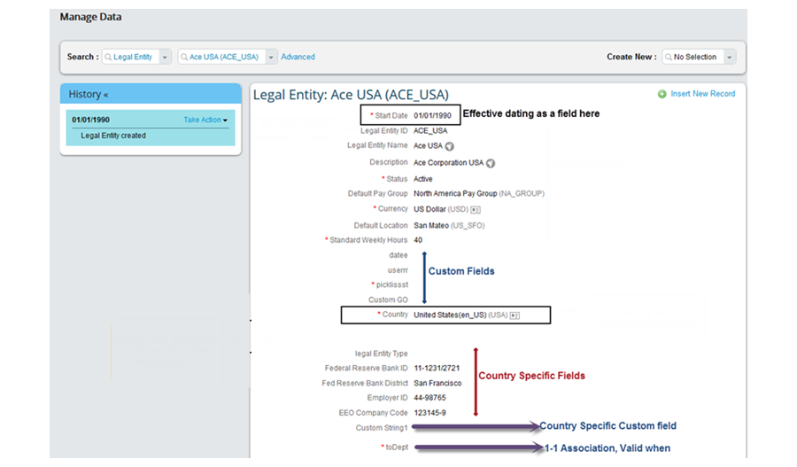

# Unit 4: Employee Data

## AGENDA

Storing Employee Data

Importing Users and Data and Implementing Mass Changes

Configuring the Succession Data Model

Configuring the Succession Data Model with Manage Business Configuration

Configuring the Country-Specific Field (CSF) Succession Data Model

## 4.1 Storing Employee Data:

**Employee Central (EC) Structure**

In EC, employee data is information gathered about an employee. EC uses an employee file divided into two sections: ***Personal Information and Employment Information***. ***The information is stored as a historical record*** and configured using the Succession and CSF Succession Data Models.

**EC Structure**



**Personal Information**

To access *Personal Information*, choose *Navigation Menu* → *My Employee File* → *Personal Information*. The information is organized into portlets as shown in the figure, Personal Information. You learn how to configure portlets later in this module.

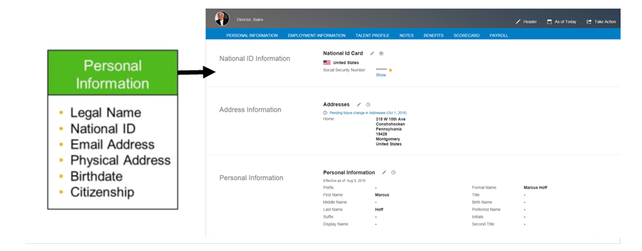

**Employment Information**

To access *Employment Information*, choose *Navigation Menu* → *My Employee File* → *Employment Information*. This information is also organized into configurable portlets.

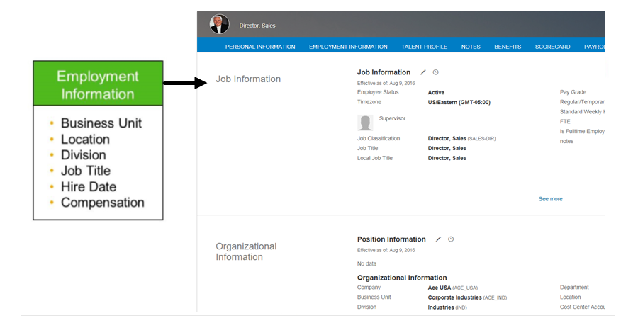

**Employee File**

To navigate to Personal Information or Employment Information for an employee, type their name in the search box on the top-right. When the correct result appears, hover over their name to reveal their quick card and choose Take Action. This action allows you to navigate to any area of the employee file to which you have access, such as Personal Information.

**Employee File Navigation**

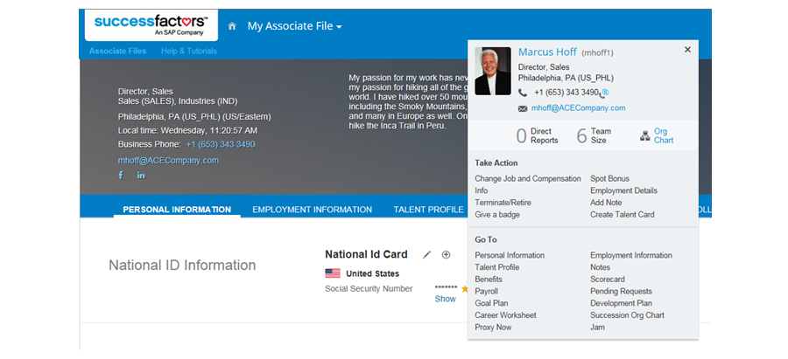

**Employee Data Features**

Employee data in EC has the following features:

* *It can be effective dated.*
* *It connects with the other SAP SuccessFactors HCM Suite products.*
* *It is reportable and exportable.*
* *It is controlled using Role-Based Permissions (RBP).*
* *It is configurable using HRIS standard, custom, and country-specific fields.*

**Effective Dating**

Effective dating means that you have a historical record of data. The start date for any record is the first entered date. In the figure, Effective Dating, the start date is August 9, 2016. The end date is either one day before a new record begins (for example, in this figure, the end date for the June 2nd record is August 8, 2016) or December 31st, 9999, which allows for future dating such as upcoming promotions. The system records the changes between updates. Most employee data is effective dated. See Effective as of, as shown in the figure.

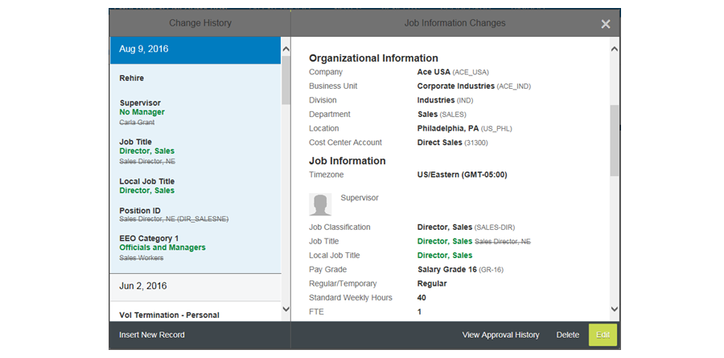

**Employee Data Maintenance**

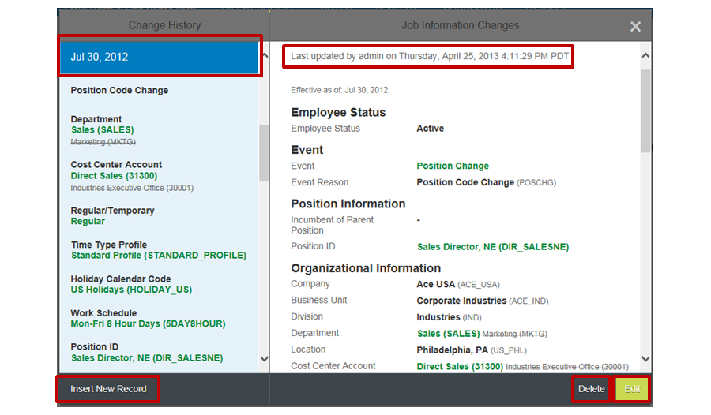

To maintain the employee data in the system, you select Insert New Record with an effective date in the past, present or future, or Edit or Delete for existing records. The system records which user makes the changes and when. The ability to Insert New Record, Edit, and Delete must be reserved for administrators because it bypasses workflows. Workflows will be discussed in a later module.

**Field Types**

There are three types of fields available in person and employment portlets, as shown in the figure, Field Types. These fields are standard fields, a custom field, and three country-specific fields for the Philippines.

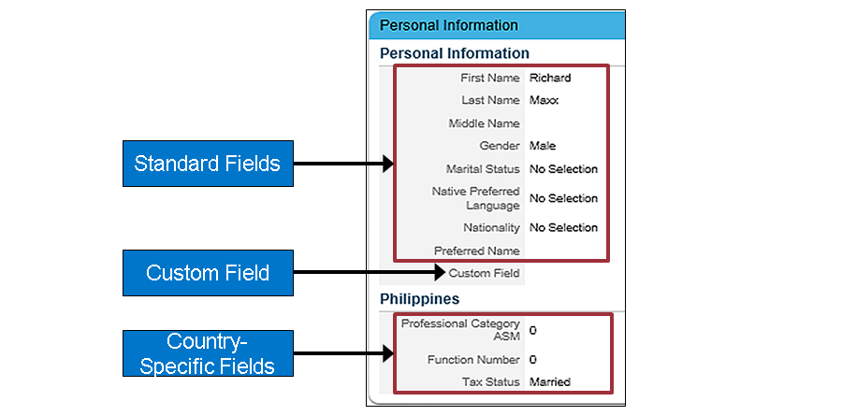

**Role-Based Permissions (RBP)**

RBP controls what employees, managers, and administrators can see, read, and write within the system. As shown in the figure, RBP, if you log in as Emily Clark, you can see a full history of Richard Maxx’s compensation information including Compensation Information fields such as Pay Type, Is Eligible for Benefit/Car, and so on. However, if you log in or proxy as Richard Maxx, you cannot see any of the Compensation Information fields. You can only see Base Salary and Bonus potential.

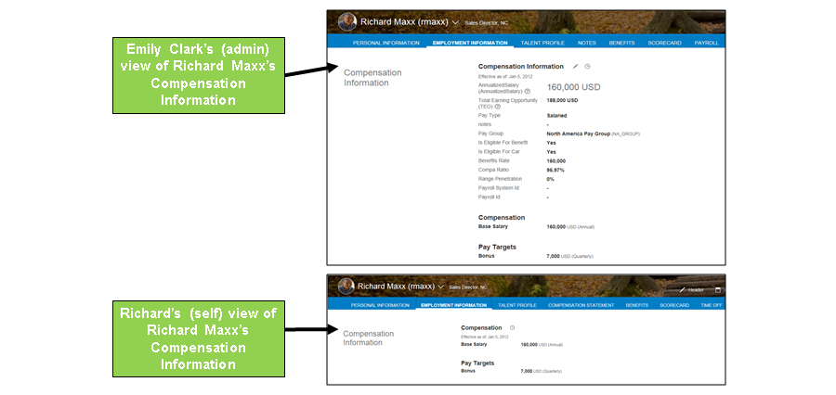

**Personal Data**

*Personal information is employee data that is independent of employment*, such as date of birth, nationality, and so on. EC stores personal information to meet country-specific legal requirements for employment, provide emergency contact information for an employee, and provide work permit and visa information. Employment data can be effective or non-effective dated, depending on the type.



**Non-Effective Dated Personal Data**

*Person Info* is not dated. The information, such as birth date or country of birth, is not subject to change. You can also tell that it is not effective dated because there is no *History* link.

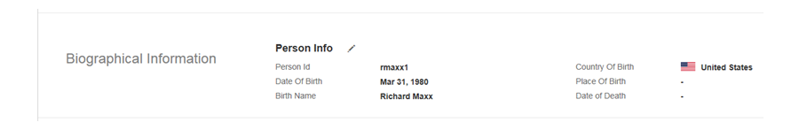

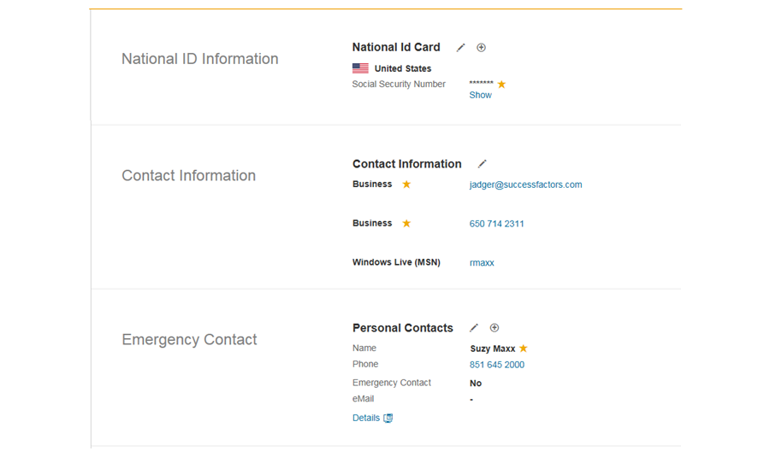

**Effective Dated Personal Data**

*Personal Information* is effective dated, as indicated by *History*. *Personal Information* keeps a historical record of name and marital status changes, and changes to country-specific fields. The *Dependents* portlet is also effective dated and keeps a record of changes in dependent status.

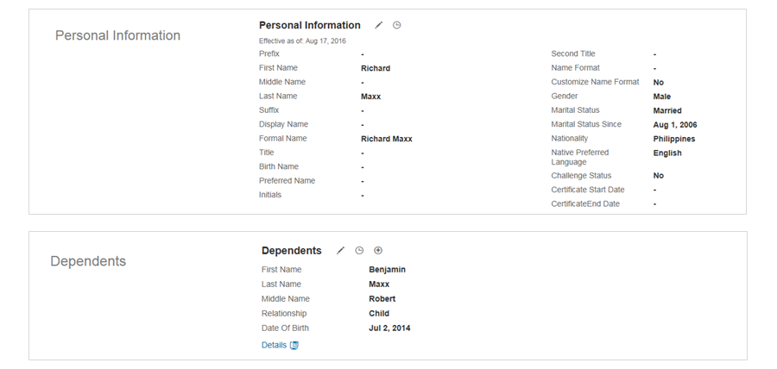

**Examples of Effective Dated Personal Data**

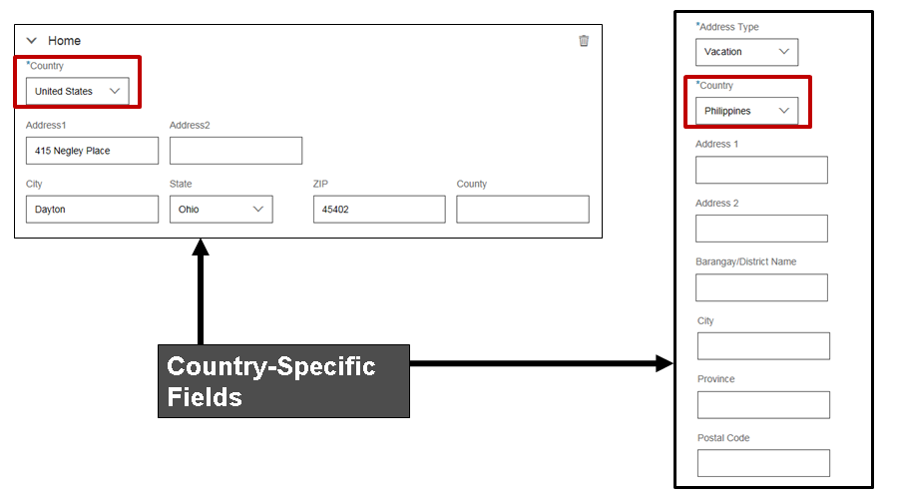

Addresses are also ***effective-dated personal data***. You can keep track of historical addresses and multiple address types for an individual, as shown in the figure, Examples of Effective Dated Personal Data. You can also see that the address formats are country-specific.

**Employment Data**

Employment information is data about an employee that is connected to their employment, such as job code, job title, and so on. EC stores employment information to meet country-specific legal requirements and provide organization and compensation information about the employee.



**Non-Effective Dated Employment Data**

Employment details are not dated, since this information generally does not change. If an employee is terminated, their termination information is stored in this section as well.

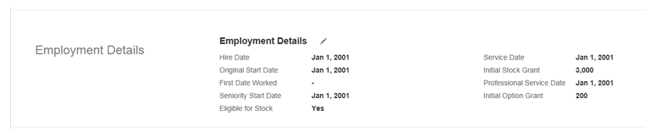

**Effective Dated Employment Data**

The job information of an employee is effective dated and organized into several different sections. In the figure, Effective Dated Employment Data, you can see position, organization, job, and Time Off information. You can also see USA-specific Equal Employment Opportunity (EEO) information. The legal entity assigned to an employee determines which country-specific fields are used in employment data.

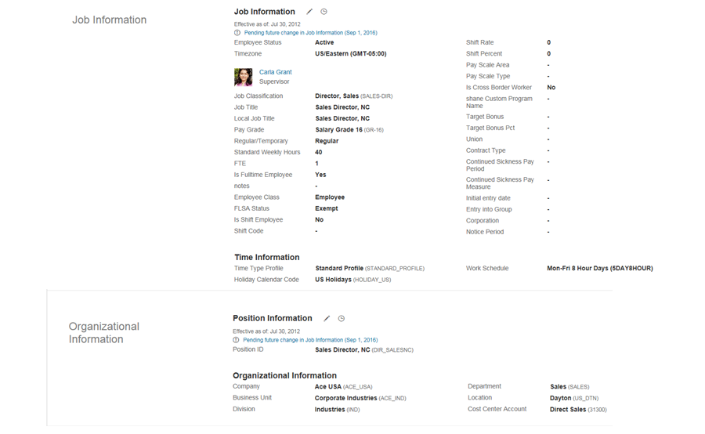

**Examples of Effective Dated Employment Data**



HR, matrix, delegates, and additional managers are effective dated and stored in the *Job Relationships* portlet.

**Additional Examples of Effective Dated Employment Data**

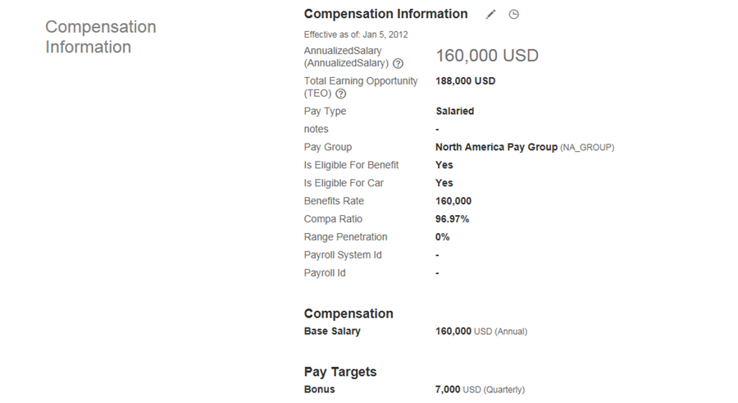

Compensation data is also effective dated and has three sections. These sections are generic compensation information, recurring pay components, and calculated fields.

**Effective Dated Employment Data - Global Assignment**



*Global Assignment* enables EC to manage expatriates. Employment data is maintained in home and host assignments, and future dated global assignments can be recorded. *Global Assignment*details are available on the *Employment Info* page.

**Concurrent Employment (Kiêm nhiệm)**

One person can have more than one active employment at the same time. The EC UI has the following recently-added functions and features:

* *Management of multiple employments at one point in time.*
* *Creation and termination of Concurrent Employment (CE).*
* *Architecture that follows the concept of Global Assignments (GA). That is to say, one person, one user account, and one user ID per employment.*
* *Management of CE using the EC UI . For example, search results, switch between employments, and so on.*

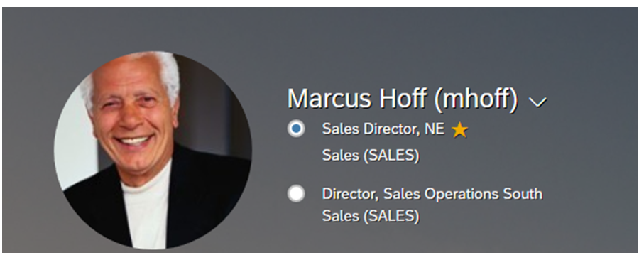

**Concurrent Employment Enablement**

To enable concurrent employment, set the Concurrent Employment Management option ON in the *Manage Employee Central Settings*. You also need to give edit rights to the company field in *employmentInfo* to administrators in RBP.

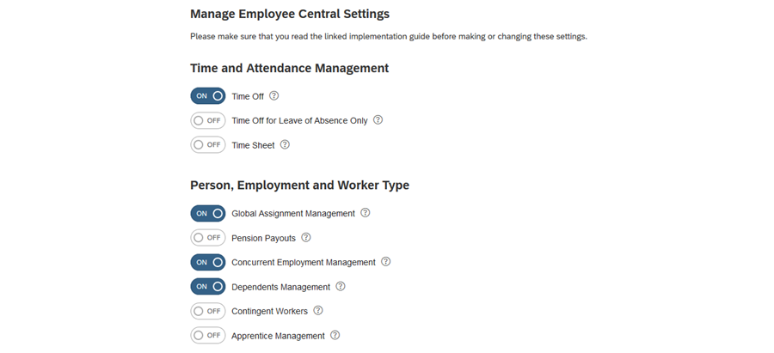

**Concurrent Employment Configuration**

To configure concurrent employment, choose *Take Action* → *Add: Concurrent Employment*, where you can choose details for new employment. You must specify which Job Classification is the primary employment.

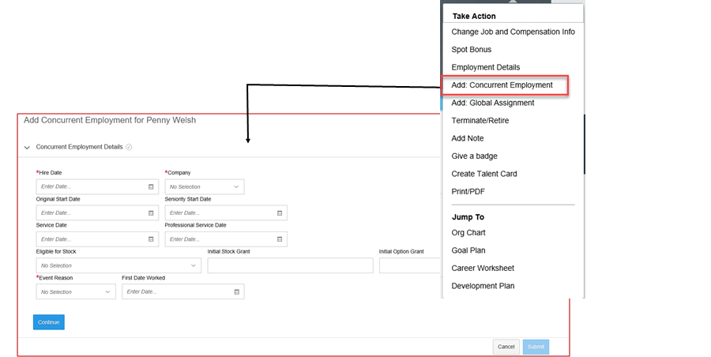

**Concurrent Employment Display**

Once the new employment is saved, a switcher is available that allows the administrator to move between different employments. You can edit concurrent employment in the same way that you edit the usual one. You also can end any of the employments at any time.

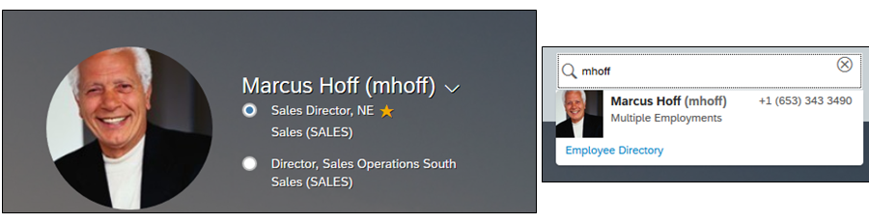

**Concurrent Employment Ids**

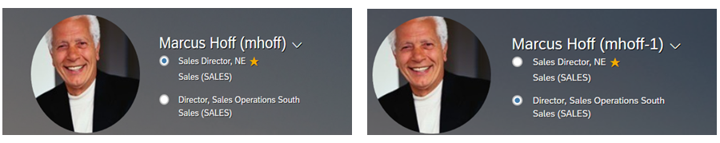

An employee with two employments has two User IDs and usernames that help with Time Off and financial management. Since the system treats the employee as one person and the employment as two jobs, all personal information is copied between IDs.

## 4.2 Importing Users and Data and Implementing Mass Changes:

**Employee Import**

Employees are added in multiple ways (for example, new hires, connectors, and so on). However, in this lesson you learn how to import employees using the system templates. In the figure, Employee Import Navigation, you can see how to navigate to the *Import Employee Data* area in *Admin Center*.

**Employee Import Navigation**

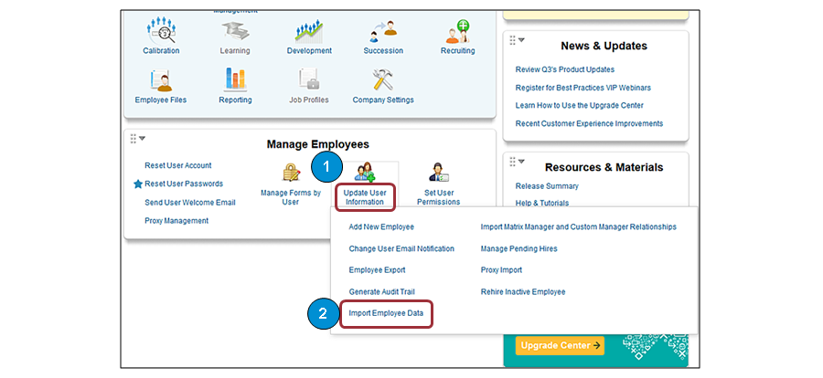

**Import Process for Employees**

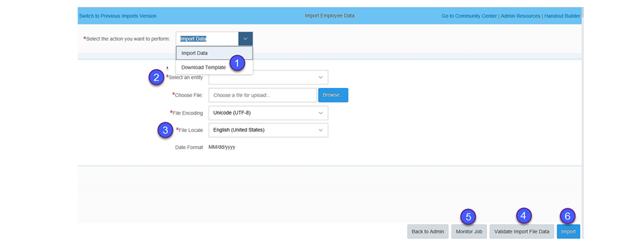

There are several different sections in the import process for employees, which are similar to those for importing foundation data. The sections are as follows:

1. *You can download the templates directly from the UI.* ***The Comma Separated Values (CSV)*** *template matches the configuration of the Employee portlet in the system. Therefore, two customer instances might have different templates. The download template tool automatically includes all required fields and displays the Label of other enabled fields in alphabetical order. You can choose the optional fields for inclusion in your import template.*
2. *Select an entity allows you to determine which area of the employee file you are uploading data for. The type of entity you select must match the template you downloaded.* ***Depending on the effective dating of the entity you are importing, you may have to choose between full purge or incremental load****.*

***Full Purge wipes out all previously stored data in that entity*** *for the* ***employees******included*** *in the import file, and replaces the deleted data with what's stored in the file. Incremental Load adds the import data to what already exists for the employees.*

1. *File Locale allows you to choose the language and locale for the data you are importing. This is especially important for date, number, and picklist fields, as the format can change based on the locale.*
2. *The Validate Import File button runs a check to ensure that there are matching import headers and that the CSV file you are attempting to upload contains valid data. This check is recommended before any import.*
3. *For jobs that are too big or can't be validated directly on the screen, you can navigate to monitor jobs to check on the status of the validation or import and see if there were any errors.*
4. *Once you file has validated successfully and no errors are found, you must select the file again and choose Import in order to enter the data into the system.*

**Basic Import**

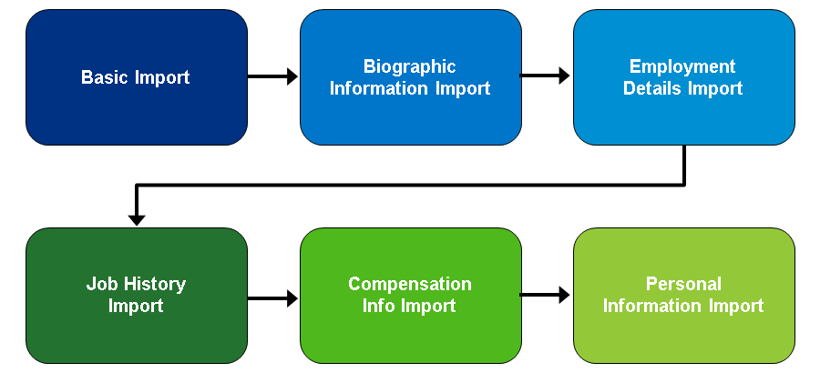

The order of imports into EC is critical. For more information about how to verify the upload order and additional details about this task, see the most recent Imports Handbook. The Basic Import gets the employee started in the system and each of the subsequent imports populate a different portlet in the employee’s file. For example, the third import, Employment Details Import, populates the Employment Details portlet.

Employment Details Import Example

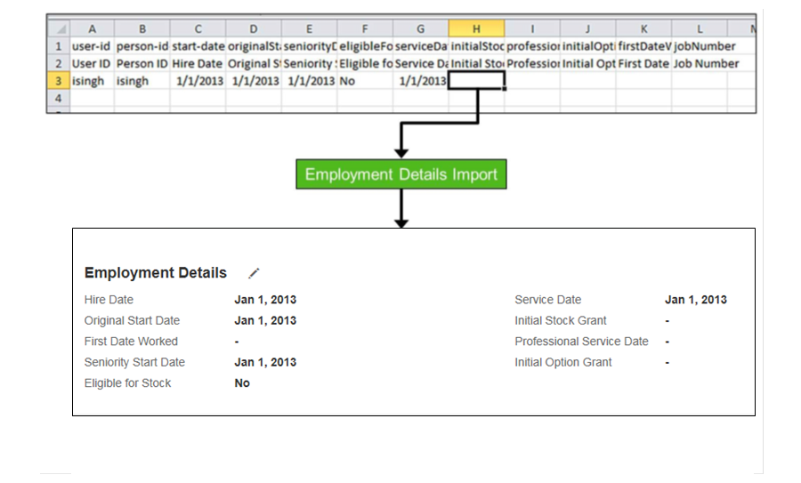

The figure, ***Employment Details Import*** Example, shows an Employment Details Import example. You can see that the template and the resulting information in the Employment Details portlet on Irvi Singh’s profile are populated. When importing information for employment details, job history, compensation, and personal information, you are prompted to choose between *Full Purge* and *Incremental Load*.

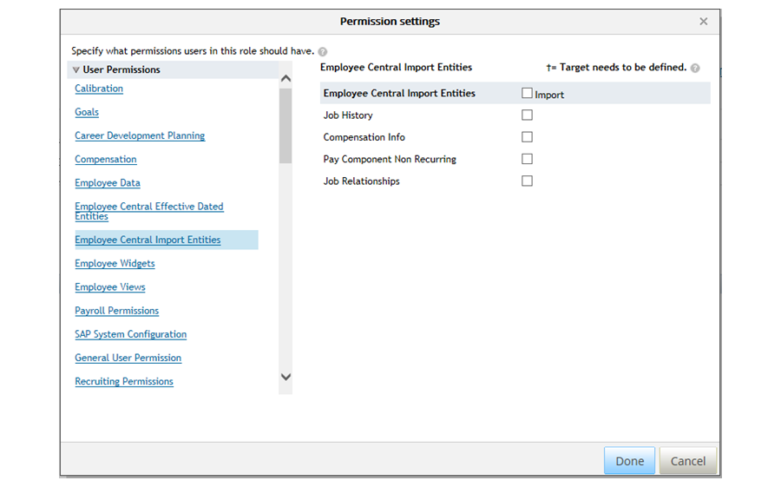

**RBP Restrictions on Imports**

*You can now restrict the importing of certain data based on the Granted Population for Role Based Permissions. This only applies to the following Employee data sections:*

* *Job Information/History*
* *Compensation Information*
* *Non Recurring Pay Components*
* *Job Relationships*

**Incremental Import Scenario: Append**

Append - An employee is moving from Department A to Department B, starting on November 1, 2016. There is currently an active record in the system that lists the employee in Department A. You download the template and add the new information. When you complete an incremental import, the record is appended. The Department A record is closed on October 31, and the Department B record now starts on November 01.

**Incremental Import Scenario: Append**

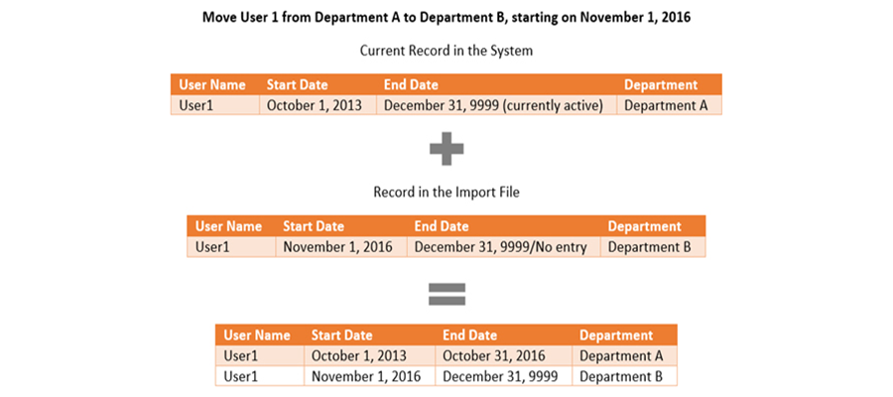

**Incremental Import Scenario: Insert**

Insert - An Employee is missing historical data about their previous department. The most current record shows the employee in Department B, starting on October 1, 2013. You download the template and add the new information. When you complete an incremental import, the historical record is inserted. The Dept A record is inserted before the Department B record.

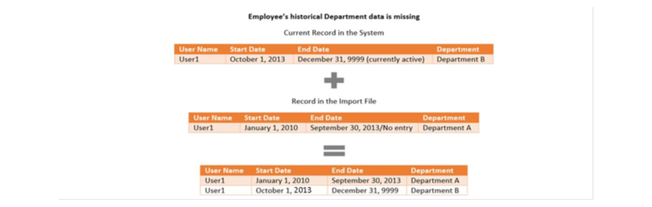

**Incremental Import Scenario: Correct**

Correct: An employee has incorrect information in the system about a past Job Classification. User 1 was a Developer from January 01, 2013 to September 30, 2015. However, they are incorrectly listed as an Engineer. You download the template and add the correct information. When you complete an incremental import, the historical record is corrected. User 1 is listed as a Developer from January 1, 2013 to September 30, 2015. You can place an end date in the file, but again, it is not necessary, since the system automatically stops the record at the next effective start date.

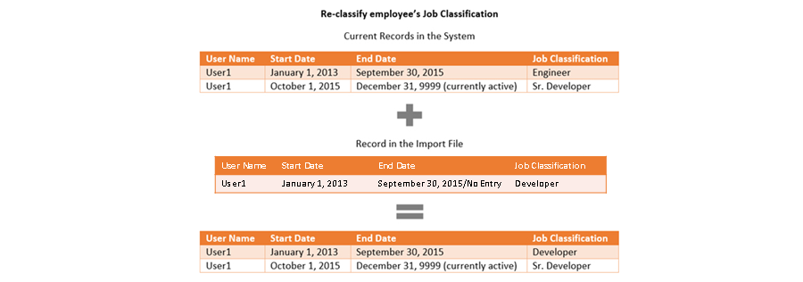

**Mass Changes**

In EC, mass changes is a feature that allows an administrator to apply changes to job information or job relationships to multiple employees simultaneously. The examples of mass changes include changing office location, corporate restructuring, or assigning a new manager to a group of employees as part of an organizational change. For example, if you need to assign a new HR representative to Carla Grant’s sales department, use mass changes to make the process more efficient.

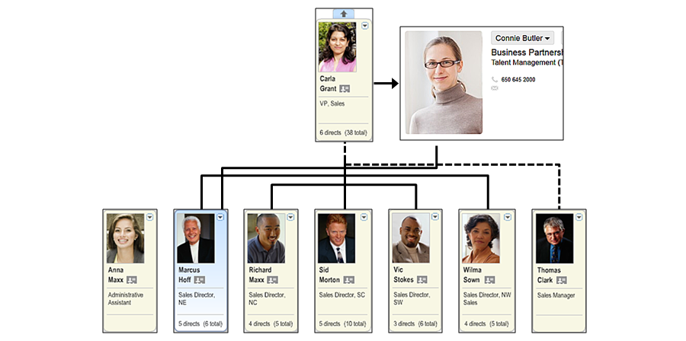

**Manage Mass Changes**

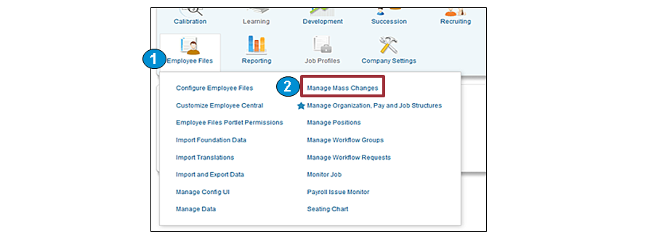

Mass changes are defined in Admin Center in the instance with Manage Mass Changes, where you are prompted to change a name and define a group. The group definition process is the same as the process of creating a permission group in RBP. You can name your group, define your people pool, and choose DONE. You can also assign the date when you want the change to take effect. Once you have set the date and people, you can assign the fields that are being changed.

## 4.3 Configuring the Succession Data Model:

**Succession Data Model**

There are two XML data models that define the configuration of Employee Data, the Succession Data Model and the CSF Succession Data Model. The Succession Data Model has several sections: Elements: Standard, Userinfo, Background, Tab, HRIS, HRIS Action, Element Permissions, DG Filters, View Template, and HRIS Sync Mappings. In this module, you learn how to configure HRIS elements only.

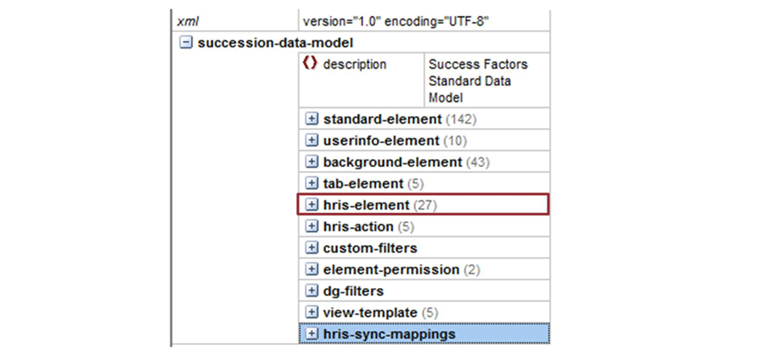

**HRIS Elements in Succession Data Model**

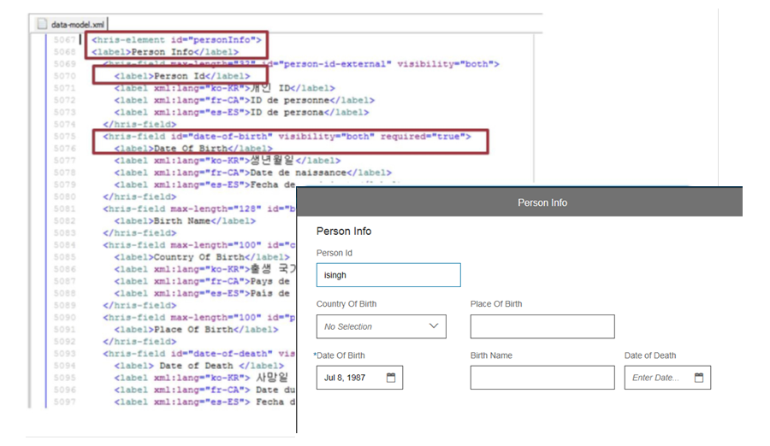

*The HRIS elements in the Succession Data Model allow you to customize the data file* of an employee within EC.

Earlier in the module, while looking at the employee imports, you learned about some of the standard objects and fields. By ***configuring the Succession Data Model*** (XML), you can define what the fields are called in the UI and which ones are visible and required. If a customer requires custom fields, you can also control those fields.

The first screenshot HRIS element is Person Info or Biographical Info, depending on your instance. In this figure, you can see several of the Biographical Info in the figure, HRIS Elements in Succession Data Model, is from the Succession Data Model. The first fields: Person ID, Date of Birth, Birth Name, and so on. When you look at the UI, you can see how these fields are reflected.

The second screenshot in the figure, HRIS Elements in Succession Data Model, is from Irvi Singh’s personal information page. The HRIS element Person Info label is shown at the top of the portlet and the Person Id is the first field. You can also see that the field Date of Birth has additional parameters. The field is set to required using the required= attribute, which generates the red star in the UI.

**Example of HRIS Elements in Succession Data Model**

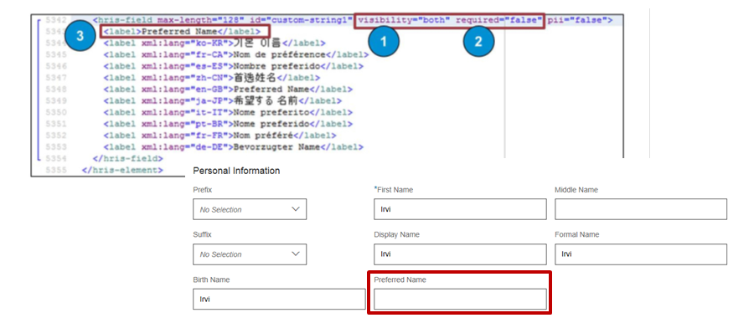

The label attribute sets what the user sees in the instance for that field. In the figure, Example of HRIS Elements in Succession Data Model, you can see a custom field within the Personal Information HRIS element. You can set the field to visible or required. You can also update the label. In this figure, you can see that *custom-string1* is updated to *Preferred Name*. Although this field does not require a picklist reference, it can be inserted just before the closing </hris-field> tag.

Permission Custom Fields in Succession Data Model

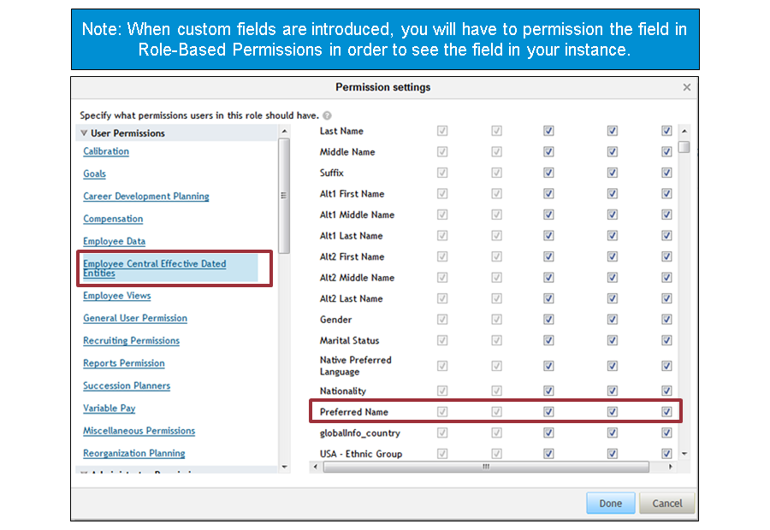

As previously mentioned, custom fields need to be permissioned using RBP for any role that needs access to view or edit. The Preferred Name field is added to both the Employee Self-Service and System Admin roles at minimum. When editing the role, choose Employee Central Effective Dated Entities and select from five columns: View Current, History, Edit/Insert, Correct, and Delete.

## 4.4 Configuring the Succession Data Model with Manage Business Configuration:

**Manage Business Configuration Tool**

The Business Configuration UI (BCUI) allows administrators to maintain certain elements of the Succession Data Model using their end-user UI instead of maintaining these elements in the XML file. Since the BCUI is available in the Admin Center, administrators can make configuration changes themselves whereas they previously had to contact colleagues with access to Provisioning.

The BCUI covers the following frequent use cases:

* Changing labels
* Adding or changing translations
* Activating fields
* Changing the display sequence of fields
* Changing the visibility of fields
* Setting fields to *required*
* Adding custom fields

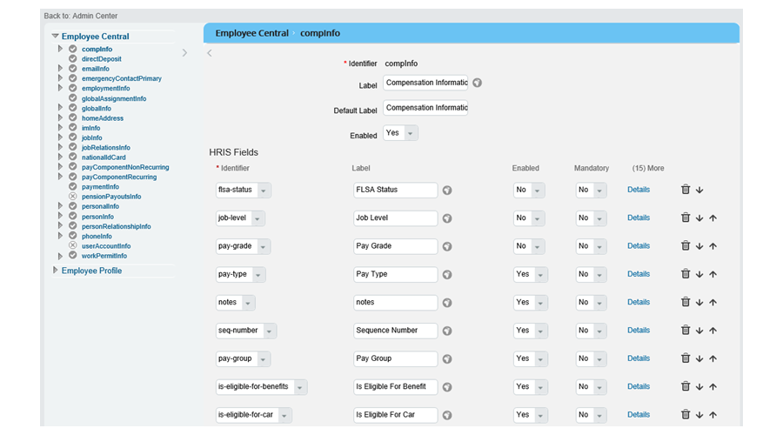

**Business Configuration UI (BCUI) Limitations**

The Succession and Country-Specific Succession Data Models must be configured and uploaded before the BCUI can be used. ***This is not a replacement for all XML configuration***, but rather a way for customers to independently make minor changes to configuration. The XML takes priority over BCUI and will overwrite and configurations made directly in the instance. It is important to incorporate changes made in the BCUI into the Succession and CSF Succession Data Models to ensure they are not lost.

**BCUI Limitations**

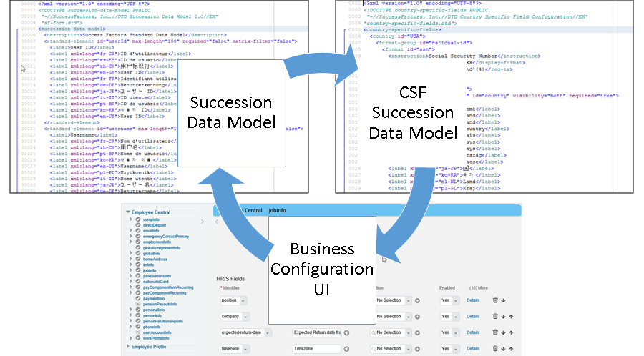

**Getting Started with BCUI**

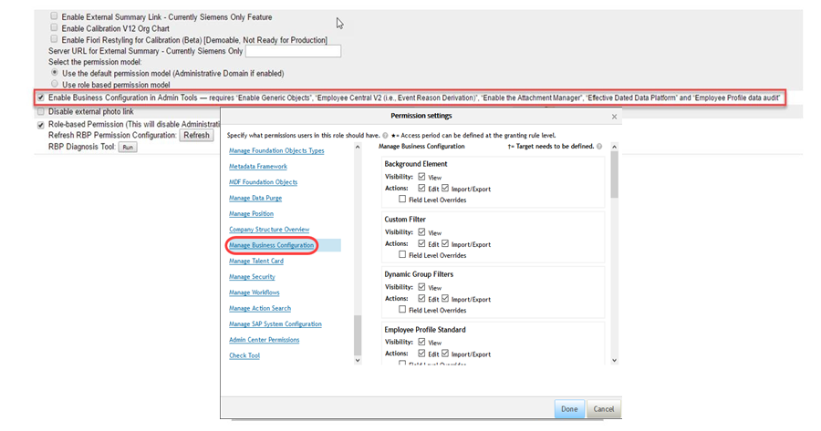

Business Configuration must be enabled in Provisioning before it can be used:

1. Navigate to Provisioning→Company Name Company→ Settings
2. Open the relevant Permission Role
3. In Permission, grant access to the Manage Business Configuration section

**Provisioning Sync Job**

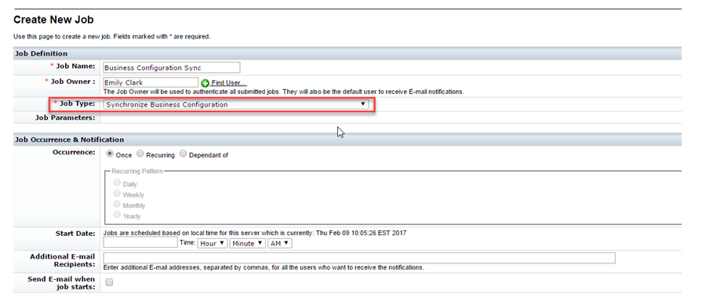

After you have set the permissions, you need to synchronize the ***Succession Data Model*** with the ***metadata framework (MDF) storage of the BCUI***. To allow for the maintenance of configuration data, the data is stored as MDF generic objects. The data is maintained on the MDF UI.

***Run the synchronization job in Provisioning:***

1. ***In Provisioning, go to Managing Job Scheduler→ Manage Scheduled Jobs***
2. ***Click Create New Job***
3. ***Select Synchronize Business Configuration under Job Type***
4. ***Use an admin user to run the job***
5. ***Run the job by going to Actions > Select and then either Submit to run the job at a scheduled time, or Run It Now to run the job immediately. You can monitor the progress of the job on the Monitor*** ***Jobs UI.***

*A sync job of the BCUI and the Succession Data Model needs to be carried out after the switch in Provisioning has been set and is required only once after you have set up the company and selected the Provisioning features.*

Using BCUI

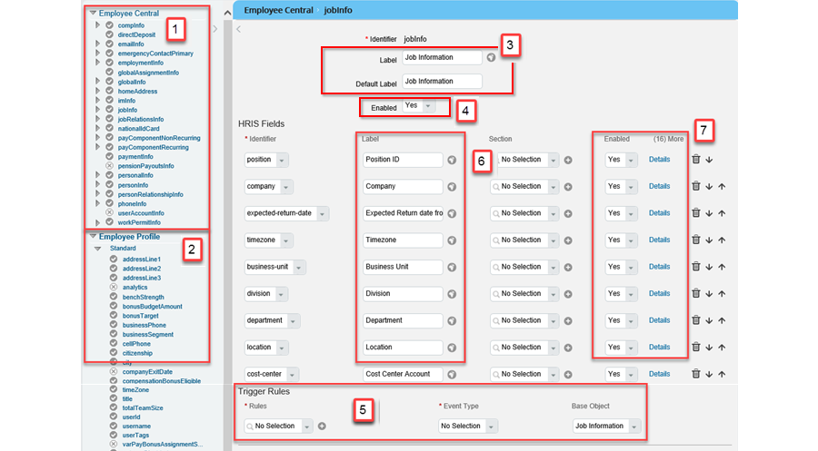

On the left-hand side of the screen, an activity list appears with elements that can be configured using the BCUI. Two sections are available:

Employee Central: Here you find the HRIS elements that are shown in Personal Information and Job Information.

Employee Profile: Here you find standard elements and userInfo elements that are shown in the different portlets of the Employee Profile.

The Employee Central section displays all configurable HRIS elements. Using the Business Configuration UI, you can maintain country-specific fields, HRIS sync mappings to profile elements, and configurable rules.

**Typical Use Cases for Configuring HRIS Elements on an Element Level**

Most likely, you would modify the HRIS element on an element level to:

* *Change the label or add translations for a label*
* *Disable or enable the element*
* *Add onSave Business Rules*

Most likely, you would modify the HRIS element on a field level to:

* *Change a label or add translations for a label*
* *Disable or enable visibility and requirement for a field*
* *Add or change a picklist for a field*
* *Add an onEdit Business Rule*

BCUI and Person Types

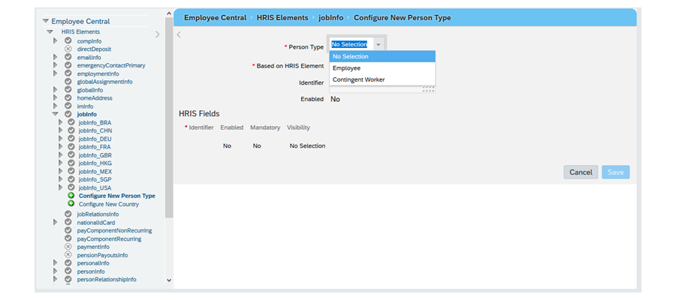

Person type in BCUI allows you to define a set of fields specific to a group of persons. Administrators can define person type in BCUI. Person type can be configured for both global and country-specific HRIS elements.

For a person type, you can configure these attributes:

• Enabled

• Mandatory

• Visibility

When a person type is created, all the HRIS fields specific to the person type gets copied from base element. Person type is only supported for HRIS elements

With BCUI, you can add different person types for different portlets. Not all person types are supported at all elements. The following person types might be available in you instance, depending on configuration:

* Employee
* Dependent
* Student
* Candidate
* Onboardee
* Contingent Worker

For more detailed information including a matrix of supported person types and supported elements, review the Setting Up and Using Business Configuration UI documentation in the SAP Help Portal.

## 4.5 Configuring the Country-Specific Field (CSF) Succession Data Model:

**CSF Succession Data Model**

The CSF Succession Data Model allows you to add or remove specific fields based on the selected country. For example, you can add custom formats for national IDs or custom field orders for addresses. You can configure the country-specific data that appears in the following:

* For *Personal Information*, you can configure national ID card, home address, and global information.
* For the *Employment Information* page, you can configure job information, compensation, employment information, and details.

There are many details and exceptions when dealing with these country-specific areas. For the most up-to-date information, download the

In the figure, CSF Succession Data Model, you can see the *Personal Address* portlet for two countries. On the left, there is a portlet for the United States, and on the right, there is a portlet for the Philippines. The different fields are made possible by the CSF Succession Data Model.

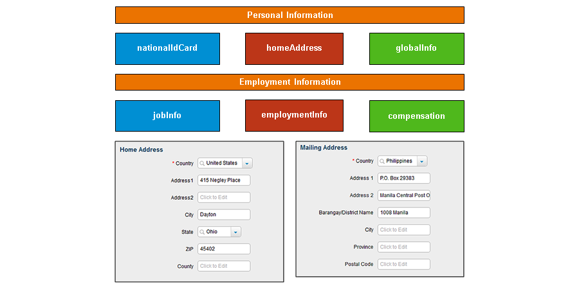

**National ID in the CSF Succession Data Model**

National ID card is the first field in the CSF Succession Data Model. In the figure, National ID in the CSF Succession Data Model, France and the USA are selected.

The ID card types appear in the dropdown menu. In the text box, you are prompted with formatting instructions.

In the source XML, the important details are the instructions that give the card a name, the display format that appears as the gray formatting prompt, and ***the regular expressions information***. The regular expressions information tells the system what format to expect. In the figure, you can see that the following format is required: ***three digits, a dash, two digits, a dash, and four digits are required***. If you look at France, you can see the format with the French ID information.

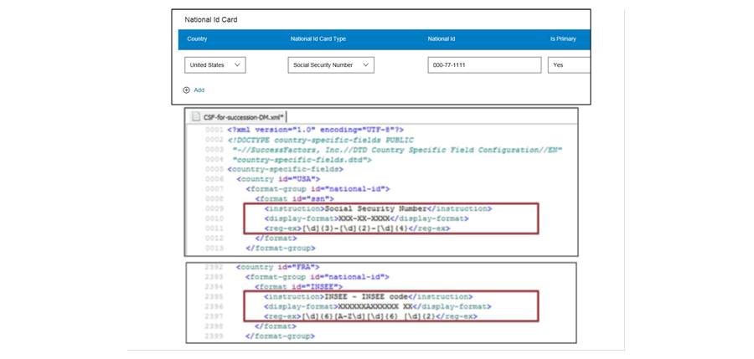

**Home Address in the CSF Succession Data Model**

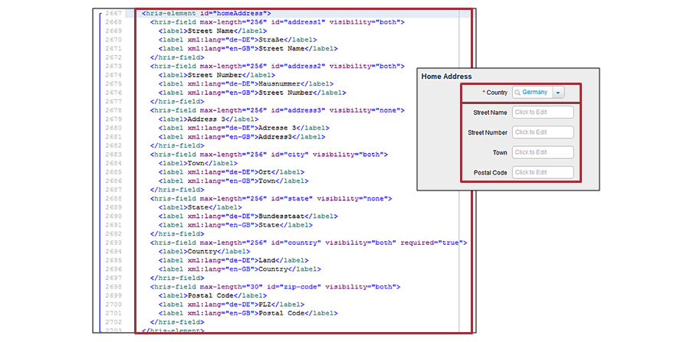

The HRIS element homeAddress is typically configured in the CSF Succession Data Model. In the figure, Global Information in the CSF Succession Data Model, you can compare a sample from the XML to an instance for a German personal address. In the left screenshot, you can see that the first field, *Country*, is set to visible and required. However, for the second set of fields, *Street Name*, *Street Number*, *Address 3*, and *State*, you can see that only *Street Name* and *Street Number* are visible. *Town* and *Post Code* are both set to visible and optional. The elements must exist in the Succession Data Model and CSF Succession Data Model. However, all field attributes (for example, **Label** or **required**) must be the same in each data model. To ensure that a field is country-specific, you must take it out of the Succession Data Model and add it to the appropriate countries. The *Home Address* fields can have different functions in each data model.

**Global Information in the CSF Succession Data Model**

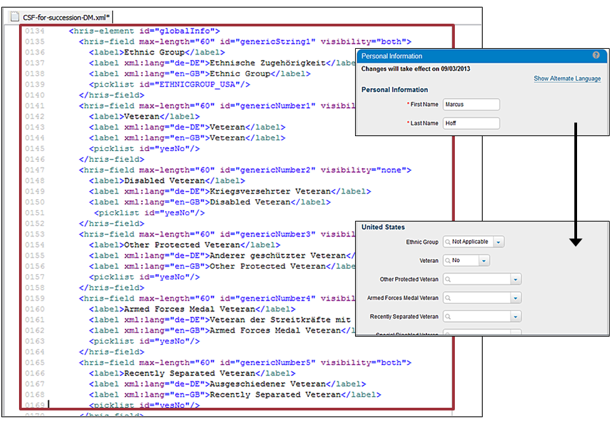

**Job Information in the CSF Succession Data Model**

When you look at the *Employment Information* for an employee, there are a few differences. The country for *Employment Information* is determined by your Legal Entity. If you work for ACE USA, you are assigned country-specific fields for the United States. In the figure, Job Information in the CSF Succession Data Model, you can see Marcus Hoff’s *Job Information* with several USA-specific fields: *FLSA Status*, *EEO Category 1, 5, and 6*. If you open the CSF Succession Data Model, you can see those same fields reflected.

In the Succession Data Model in the figure, there is also a jobInfo HRIS element. If you want fields in that element to appear for certain countries and not for others, you need to remove that field from the standard Succession Data Model and copy it over to the correct countries in the CSF Succession Data Model. You cannot have duplicate jobInfo, employmentInfo, globalInfo or nationalID fields in your Succession and CSF Succession Data Models, apart from home address.

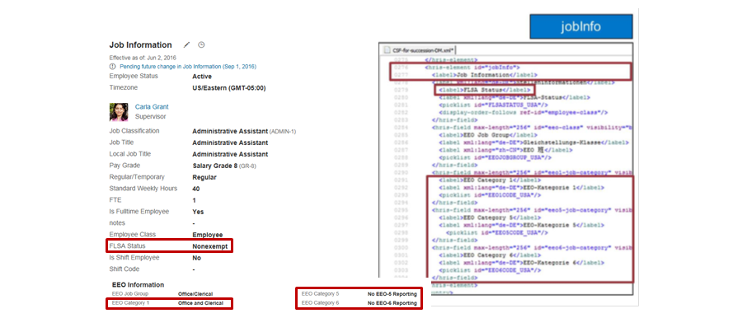

Job Information in the CSF Succession Data Model: employmentInfo

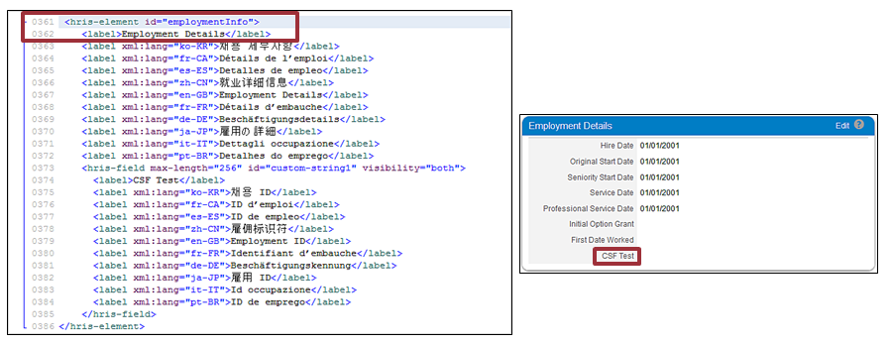

Country-specific fields are also added to the Employment Details portlet using the HRIS element employmentInfo in the CSF Succession Data Model. Compensation fields configured in the CSF Succession Data Model appear in the Compensation portlet and are both based on the Legal Entity country.

# Unit 5: Advanced Foundation Object and Employee Data Management

Module Knowledge

1. HRIS Propagation
2. Foundation Object Association
3. Creating Internal Integration using HRIS Synchronization
4. Translating Foundation Object Data

## 5.1 HRIS Propagation

**Propagation Preparation**

Employee data often relies on the FO Records created in the system. For example, in the figure, Propagation Mapping Preparation, you can see that Carla Grant works for ACE USA in the Sales Department in San Mateo location. Propagation allows you to use relationships between FO Records and employee data to auto-populate fields. **For example, in the figure, you can change Carla’s Location to Chicago, and the Timezone automatically updates to US/Central**. Propagation allows you to make data entry more efficient and accurate.

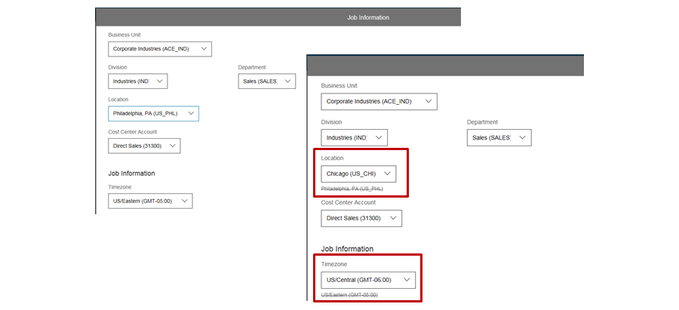

**EC Structure**

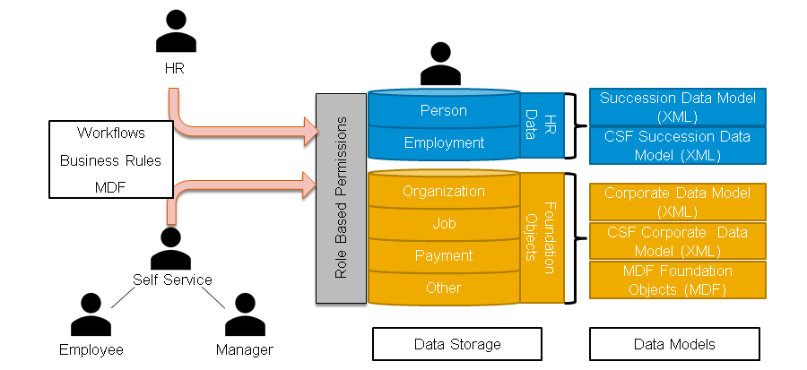

In the figure, EC Structure, you can see the EC model. In previous lessons, you learned about the corporate structure using both the XML Corporate Data Models and Meta Data Framework in the instance. You have also learned about HR Data and configuring the Succession Data Models. In this lesson, you will put those together and use information from the Corporate and Succession Data Models to propagate values from foundation records to employment records.

**Configuring Propogation with Business Rules**

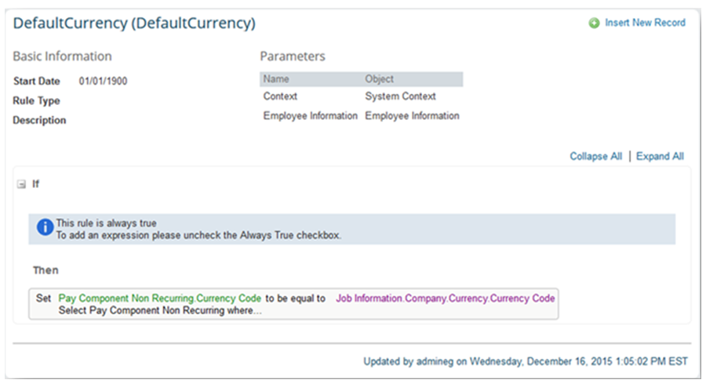

**Business Rule for Propagation**

You can define propagation rules to have the system automatically copy over the data from one field to another field. This way you can have the same data in several places of the system, while keeping just one data record.

Here are some examples for typical use cases:

• Example 1: Update Job Codes in Employee Central

IF…

the jobcode is changed in Employee Central

THEN…

retrieve all the job-code-related data from the job-related foundation objects to update the data in the Employee Central

• Example 2: Propagate FLSA Status

IF…

the country is USA

AND the job classification is changed

THEN…

propagate the FLSA status to jobInfo

• Example 3: Propagate Standard Hour

IF…

the legal entity is changed in Employment Info

THEN…

propagate the standard hour to Employment Info

**(Nếu dữ liệu ở các nhánh khác thay đổi thì dữ liệu ở EC sẽ tự động cập nhật)**

**Custom Rule for a Rule Type Picklist**

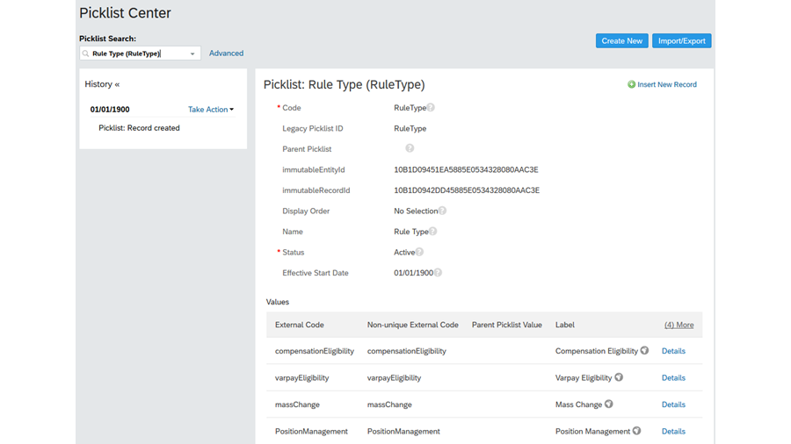

**To classify our custom rules as a single rule type**, we must first add a rule type to this picklist using the following steps:

1. Navigate to *Picklist Center*.
2. Search for “rule type”.
3. On this picklist, navigate to *Take Action* → *Make Correction*.
4. In the last field of the values section, add the external code and label for your custom rule type. For this rule, the external code is “startdate” and the label is “New Position Start Date”.
5. Click *Save*.

**(Bỏ các Custom Rules vào 1 Picklist)**

**Foundation Object Propagation Example**

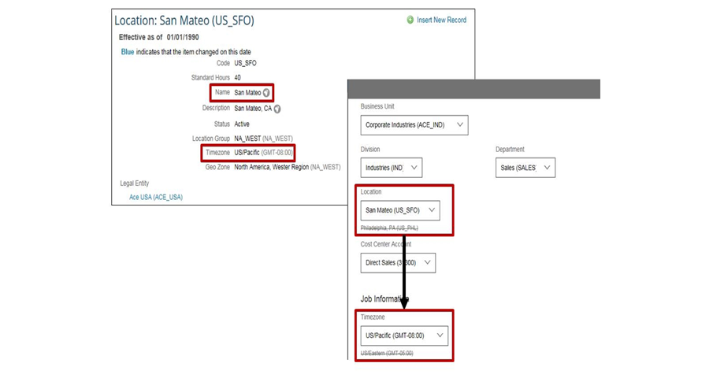

For the ***configuration of the business rule***, we need to ***determine the appropriate fields*** required on the **Foundation Object (source of the data value)** and the **Portlet (destination of the data value).** In the example, we want to copy the timezone value from the Location Foundation Object Records to the timezone field in the Job Information Portlet. This is based upon the selection of a record in the location field of the Job Information Portlet. This can be summarized in the following table:

|  |  |  |
| --- | --- | --- |
|  | **Object / Portlet** | Field |
| When I select a Foundation Object record in this field | Job Information | Location |
| Copy the value from the field | Location | Timezone |
| To the field: | Job Information | Timezone |

We use the information to create a business rule that will apply the propagation.

Employee Central has limited support for cross portlet rules. Cross-portlet rules can set values for fields in a different portlet. Currently it is supported only for specific employment-related entities which includes Job information, Compensation Information, Pay component Recurring, Pay Component Non Recurring, Job Relationships and Employment Details. Even if the portlet support cross portlet rules, there still are limitations to what can actually be performed. You should review the Business Rules documentation and SAP Support site for more specific information.

**Create a Business Rule from the Propagation Requirement**

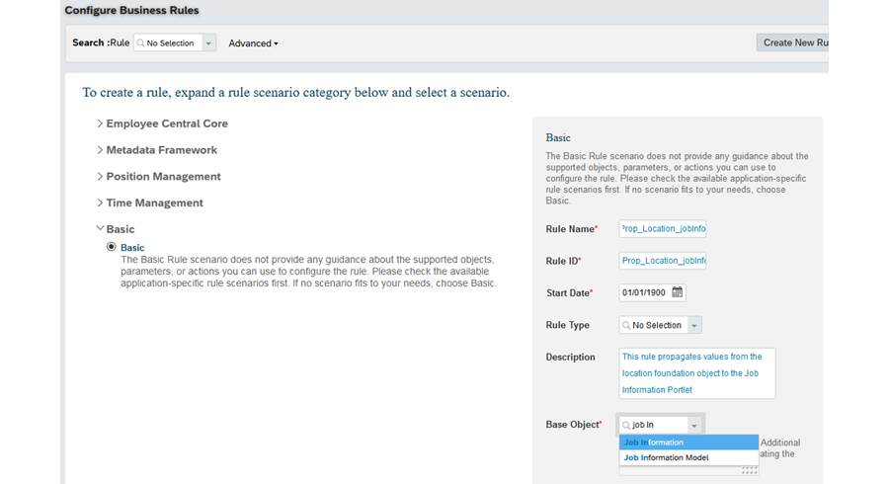

From the previous example, we now have the **building blocks** we need to build the Business Rule.

The first item will be to create the business rule and select the base object. **The base object should be where the change is occurring**. In our example, the base object will be Job Information.

There are two possible objects related to the Job Information portlet: Job Information, and Job Information Model. **The Model base objects are used to set field properties for EC objects** (for example, making a field mandatory, or hiding fields) OR compare a changed value with the previous value. **Each EC object** is defined once as a **base object**, and then as a Model base object.

We will simply trigger the rule to run every time the location field changes, without regard for what the previous and current values are. Therefore we can use the Job Information base object. To create the Rule and select the base object:

1. Navigate to Configure Business Rules. This will open the Business Rules Admin tool.
2. Click on the plus sign to add a new rule.
3. Select the Basic scenario
4. Type in the information for the Name and ID
5. Leave the start date as Jan 1 1900.
6. Optionally Select a Rule Type
7. Type in a detailed description
8. Select the appropriate Base Object

**Configure the Logic for the Propagation Requirement**

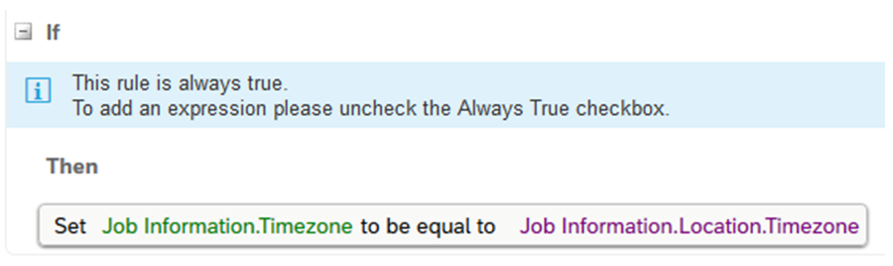

The IF statement contains the logic required to trigger the propagation. In this scenario, you are not concerned with the actual value. Therefore you will set the IF statement to always true. Setting the IF to always true implies the THEN statement will run any time the rule is triggered. We set the trigger event in the next section.

The THEN statement is where you set the value of the timezone field. You need to set the value to be equal to the value of the timezone for the selected location record.

**Configure the Trigger for the Propagation for the Requirement**

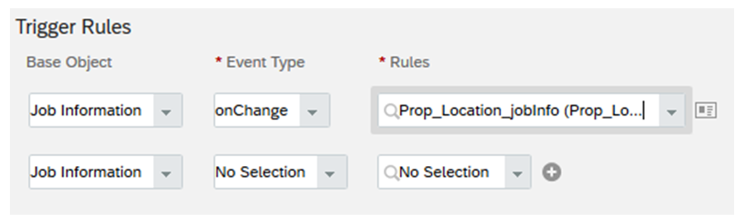

In order for any Business Rule to trigger, it needs to be attached to the base object. Since the Job Information portlet is configured in the Succession Data Model, you can use either Manage Business Configuration or your XML editor to update the model.

***Để bất kỳ Quy tắc kinh doanh nào được kích hoạt, nó cần được gắn vào base object. Do portlet Information Information được cấu hình trong*** Succession Data Model***, bạn có thể sử dụng Quản lý cấu hình doanh nghiệp hoặc trình soạn thảo XML của mình để cập nhật mô hình.***

To assign the Trigger in Manage Business Configuration:

1. Navigate to Manage Business Configuration
2. Select the appropriate portlet, usually the base object of the rule
3. Locate the field that when changes should initiate the propagation and click details.
4. In the Trigger Rules section, select the appropriate Base object
5. Set the event type to onChange
6. Select the rule you created for Rules.
7. Click Done.
8. Click Save.

Assigning a trigger with XML is covered in a later lesson.

## 

## 5.2 Foundation Object Associations **Foundation Object Associations**

**Associations enable you to define relationships between Foundation Objects and their records to define a corporate hierarchy**. The associations themselves are built in the Foundation Object configurations, either on the MDF Object or within the XML. Once the association is built, then records are linked together.

The associations built on the FO records define behavior on the employee files. The choices you see on the different lists will be restricted based on the relationships and hierarchy’s built. This makes it easier for the person working on the employee file to find the correct value, and it also ensures the information is compliant with the defined hierarchy. **For example, let’s say you are working with a customer that has 500 locations worldwide. Only 25 of these locations are within the United States. You can create an association between the Legal Entity FO and the Location FO to establish a relationship between them. You then can connect the 25 US location records to the United States Legal Entity. When the US Legal Entity is chosen on the employee files, only those 25 locations will display as options, even though we have 500 active location records in the system.**

Whether you are creating MDF or XML associations, there are two types of Multiplicities: One to One and One to Many. We will go through examples of both types of multiplicities.

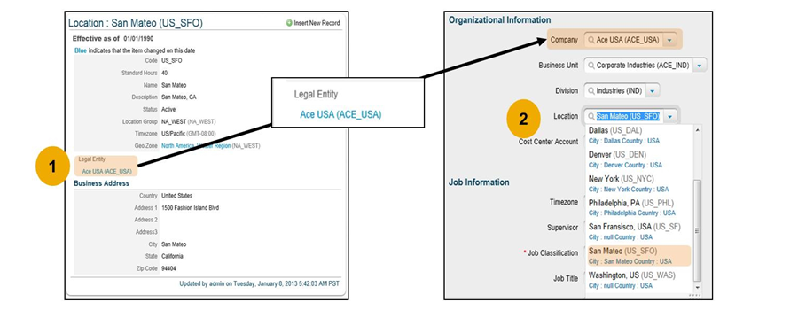

**One to One Associations**

Here you can see an example of a One to One Association between Geo Zones and Locations. At the bottom of the chart, you can see that the Seattle Location only belongs to the NA_West Geo Zone. Seattle does not connect to the NA_East Geo Zone. If none of the Location records ever belong to more than one Geo Zone, than you can set the multiplicity as One to One. Simply stated, this means that a location can only belong to one Geo Zone.

**Note**

There are existing One to One relationships that come standard with Employee Central. SAP SuccessFactors recommends that you do not create any new custom One to One associations. All new and custom associations between ***Foundation Objects should be built as One to Many***

***One to one associations*** will display ***at the record level as picklists***, since you can only choose one option.

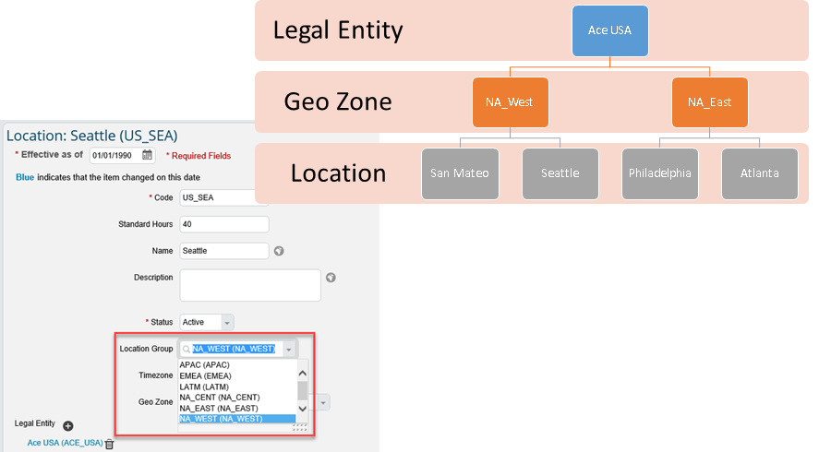

**One To Many Association**

The most common type of multiplicity when it comes to Foundation Object Records is One to Many. Here we see an example of a One to Many Relationship between Business Units and Divisions. The Division Professional Services falls under both Global Professional Services and Corporate Industries. This means Professional Services will show up as an option on the Employee Files if either Business Unit is chosen. Simply stated, **this means that a Division can belong to Many Business Units.**

The display for One to Many associations is a little different. There is a separate section on the bottom of the FO Record where multiple records can be connected.

**Note**

Just because you create a One to Many association, that doesn’t mean you have to always choose multiple records. For example, if the Professional Services Division only fell under the Global Professional Services Business unit, that individual record would still maintain a one to one relationship. One to Many opens up the possibility of being connected to more than one option.

One to many

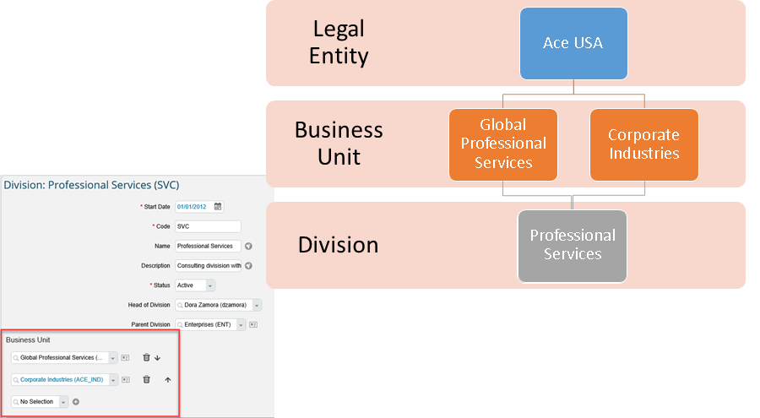

**Types of Foundation Object Associations**

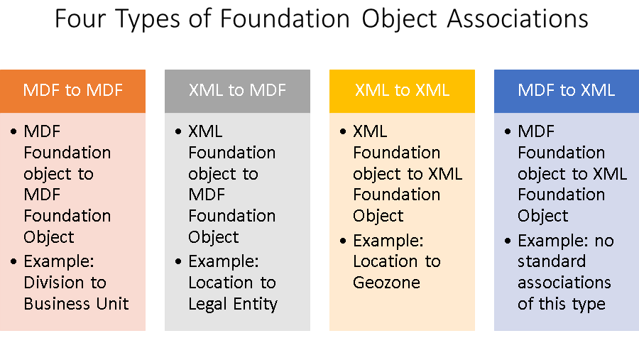

**Create MDF FO Associations**

MDF MDF FO Association Step 1 **(Tạo Association giữa MDF và MDF)**

**Steps**

1. *Configure the association on the Foundation Object to be filtered. This allows you to attach the parent MDF FO doing the filtering (Business Unit) to the child MDF FO being filtered (Division*). **(Định cấu hình Liên kết trên FO cần lọc)**

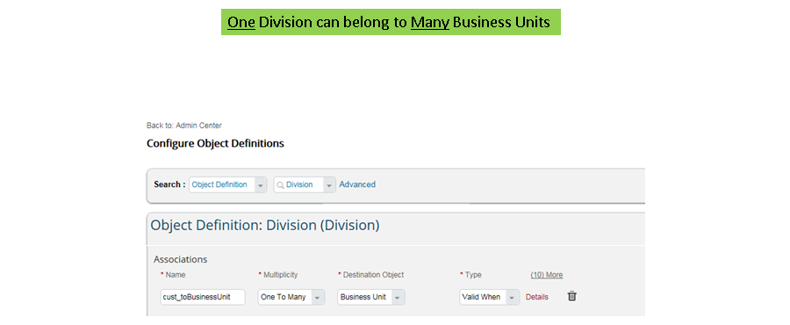

The steps are as follows:

* 1. Navigate to the **Admin Center**
  2. In the Tools Search field, type **Configure Object Definitions**.
  3. From the Search drop down, select **Object Definition**and then select **Division** (the Generic/MDF Object to be filtered) from the dropdown next to it. The **Configure Object Definitions** page is displayed.
  4. From the **Take Action** drop down, select **Make Correction**.
  5. Scroll to the **Associations** section at the bottom.
  6. Click **Details**. We will now set the association for the source object i.e., the object to be filtered. (**Bây giờ chúng ta sẽ thiết lập liên kết cho đối tượng nguồn, tức là, đối tượng được lọc.)**
     + In the **Name field**, specify a name for the association.
     + In the **Multiplicity** **field**, select the type of association, either One to One* or One to Many.
     + In the **Destination Object field**, select the destination MDF FO that will filter the values for source object.
     + In the Type field, select Valid When

**Note**

All Foundation Object associations built on MDF FOs are Valid When associations. We will learn about other types of associations in a later unit.

1. *Define field criteria on the field (Division) for the MDF FO being filtered in the data model*

**(Xác định tiêu chí trên trường (Division) cho MDF FO được lọc trong data model)**

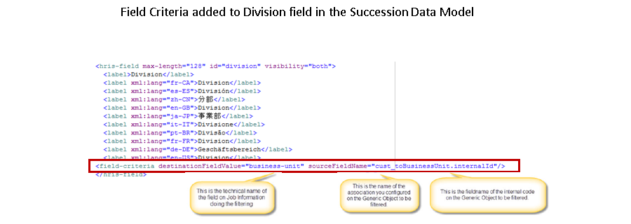

In the Succession Data Model, define Field Criteria for the FO field being filtered. This ensures that the relationship built between the FO records are maintained in the Employee Files as well.

The steps are as follows:

* 1. Open the latest version of your **Succession Data Model** (data-model.xml).
  2. Navigate to the Job **Information HRIS Element** (jobInfo).
  3. Navigate to the field that corresponds to your **MDF FO** being filtered (ex – division).
  4. After all of the labels for the field, place a new field criteria line. Use the figure to determine what information you place in that line.
  5. Validate your xml file.
  6. Save your file as a new version.
  7. Upload the data model into Provisioning.

Note

The field name of the internal code on the parent Object (in this example, internalID) can be derived from the Configure Object Definition page. Look for the Database Field named InternalCode.

1. Define field criteria on the field (Division) for the MDF FO being filtered in the **Generic Object field.** **(Xác định tiêu chí trên trường (Division) cho MDF FO được lọc trong trường Generic Object)**

This step is to be done **only** when **Position Management is enabled**. Define Field Criteria for the field related to the MDF FO being filtered. Just like the employee files, this ensures the relationships defined between **FO records** translate to the **Position records** as well.

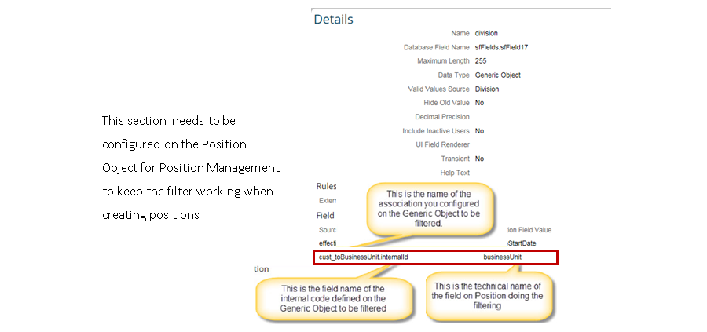

* 1. Navigate to Admin Center.
  2. In the Tools Search field, type Configure Object Definitions.
  3. From the Search drop down, select Object Definition and then select Position from the drop down next to it. The Configure Object Definitions page is displayed.
  4. From the Take Action drop down, select Make Correction.
  5. In the Fields section, scroll to the MDF FO field to be filtered. In this case, division.
  6. Click Details to view configuration.
  7. In the Field Criteria section, fill in the values mentioned in the figure.

**Create XML to MDF FO Associations**

XML to MDF FO Association

Steps

1. Configure the association on the Object to be filtered **(Định cấu hình liên kết trên đối tượng cần lọc)**. This allows you to attach the parent MDF FO doing the filtering (Legal Entity) to the child XML FO being filtered (Location). Since the FO being filtered is a **XML FO**, the association is built in the **Corporate Data Model.**

The steps are as follows:

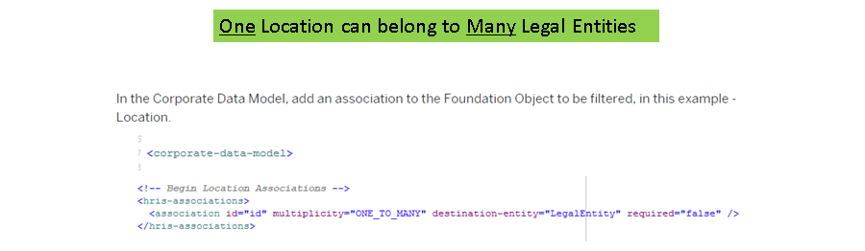

* 1. Open the latest version of **your Corporate Data Model corporate-datamodel.xml**
  2. Navigate to the source **FO** to be filtered location
  3. In the association section of the FO, add an **association line**
     + Set the multiplicity of ONE_TO_ONE or ONE_TO_MANY
     + The destination entity should be the id/code of the MDF FO destination object LegalEntity This can be found in Configure Object Definitions
  4. Validate your data model
  5. Save your file as a new version
  6. Upload your data model into provisioning

1. Define field criteria for the XML FO field being filtered (**Xác định tiêu chí trường cho trường XML FO được lọc)**

In the **Succession Data Model**, define **Field Criteria** for the **XML FO** field being filtered. Just like with the MDF/MDF associations, the MDF/XML association needs field criteria as well to maintain the relationships in the employee files. While the step is the same, the information needed is a little different.

The steps are as follows:

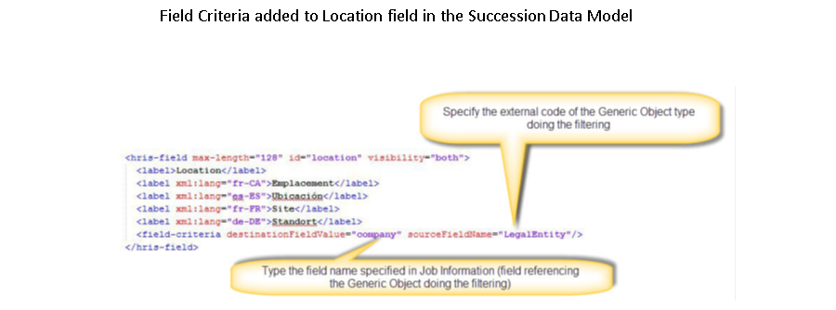

* 1. Open the latest version of your **Succession Data Model data-model.xml**
  2. Navigate to the **Job Information HRIS Element jobInfo**
  3. Navigate to the field that corresponds to your **source FO location**
  4. After all of the labels for the field, place a new field criteria line. Use the figure to determine what information you place in that line
  5. Validate your xml file
  6. Save your file as a new version
  7. Upload the data model into Provisioning

1. Define the field criteria for the **XML FO field being filtered**

This step is to be done **only** when **Position Management is enabled**. Define **Field Criteria** for the source XML FO being filtered.

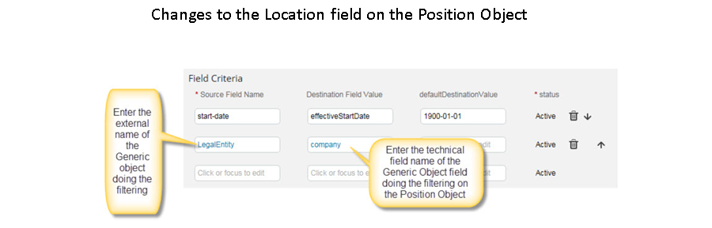

* 1. Navigate to **Admin Center**
  2. In the **Tools Search field**, type **Configure Object Definitions.**
  3. From the Search dropdown, select **Object Definition** and then select Position from the drop down next to it. **The Configure Object Definitions** page is displayed.
  4. From the **Take Action** drop down, select **Make Correction**.
  5. In the Fields section, scroll to the Generic Object field to be filtered. In this case, location.
  6. Click Details to view configuration.
  7. In the Field Criteria section, fill in the values mentioned in the figure

## 5.3 Creating Internal Integration using HRIS Synchronization

**HRIS Synchronization**

HRIS Sync is a one way (unidirectional) update from EC to the User Tables and the Employee Profile. **(HRIS Sync là bản cập nhật một chiều từ EC đến Bảng người dùng và Hồ sơ nhân viên)**

HRIS sync is a background quartz job that periodically looks for data that has been changed in EC and updates the legacy user tables with data from EC. The job itself should be configured to run on a schedule. For data updated using the UI, the synchronization process is triggered automatically at the end of the update for current and past dated records. **(Các thông tin đã thay đổi trong EC sẽ được cập nhật qua User tables)**

User Tables feed data to other modules like Performance, Goals, Compensation, and Recruiting**.( Bảng người dùng cung cấp dữ liệu cho các mô-đun khác như Hiệu suất, Mục tiêu, Bồi thường và Tuyển dụng)**

Include a new separate warning / caution:To avoid future data inconsistency between EC tables and legacy tables, do not use basic import to directly update data in the legacy tables. **(Để tránh sự không thống nhất dữ liệu trong tương lai giữa các bảng EC và các bảng kế thừa, không sử dụng nhập cơ bản để cập nhật trực tiếp dữ liệu trong các bảng kế thừa.)**Note: Additional configuration in EC may be required to utilize all features of integration between EC and other modules.

**HRIS Sync**

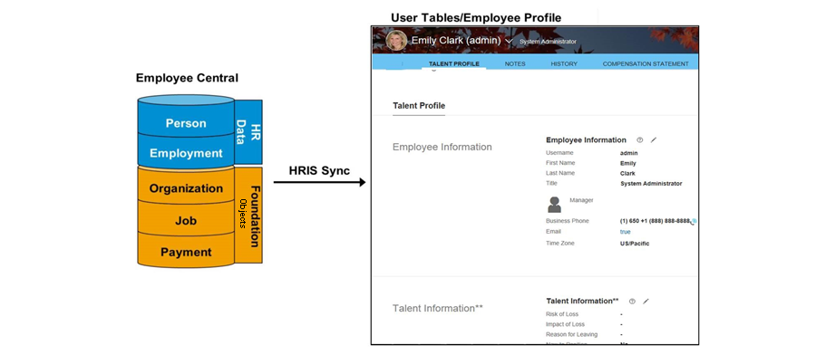

**HRIS SYNC**

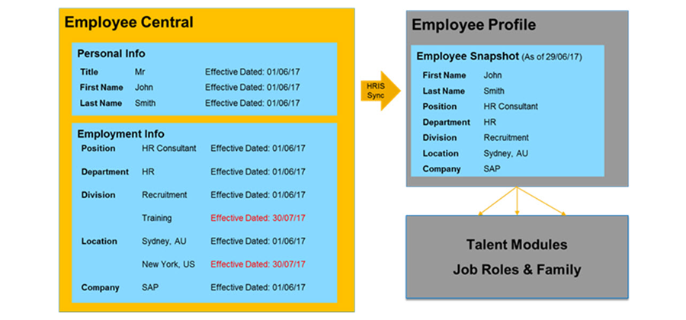

HRIS Sync is configurable. You can also schedule HRIS Sync Jobs in Provisioning.

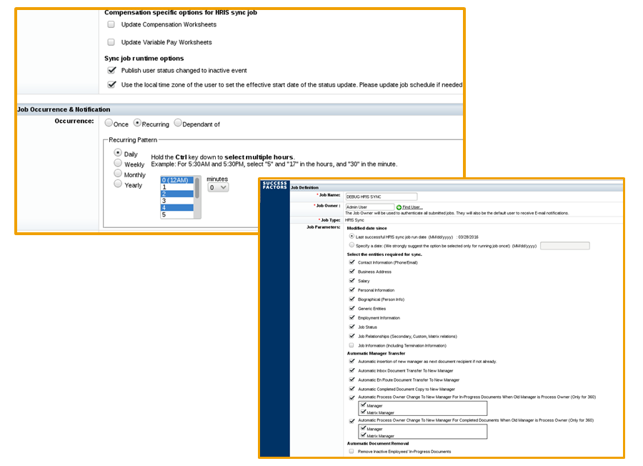

Within the HRIS Sync Job, you can specify if you would like to use the local time zone of a user to set the effective start date for an employee status update. This is especially important for terminations. Normally, syncs run based on the timezone of the data center the customer uses. Therefore if you set an employee in Shanghai to be terminated at noon, but the data center is Eastern Standard time, the user would get an additional 12 hours after termination before they lose access to the system. **You can specify that you are using the employee’s timezone, which would perform all functions related to termination or any other employee status change in real time. (Sử dụng múi giờ của nhân viên thay vì sử dụng múi giờ của hệ thống vì có thể xảy ra sự không nhất quán)**

**Note**

In order to turn on the feature, within the HRIS Sync job in Provisioning, Check the *Use the local time zone of the user to set the effective start date of the status update. Please update job shedule of needed*box. Be sure to update the job schedule for previously scheduled jobs.

**Synchronization Job Options**

The following list describes three options for triggering a Sync Job:

1. **Real-time sync integration by UI** **operationautomatically** triggers Sync Job on changes that are made in the UI for **effective-dated objects (Được User set).**

* Only synchronizes records from the **previous and current day.**
* Synchronizes records from **a future day** when that day **becomes current.**

1. **Scheduled HRIS Sync** **Job**schedules Sync Job in Manage Scheduled Jobs in Provisioning **(Được Provisioning set).**
2. **EC Data Import**: Sync Job from import starts after any in-progress Sync Job completes

**Synchronization Job Types**

The following list describes two Sync Job types:

* **Incremental Sync**
  + Only syncs the records that have changed since last successfully running HRIS Sync Job **(Chỉ syncs các records được thay đổi sau lần sync gần nhất)**
  + Future dated records are synced when the future date becomes the current date
* **Full Sync**
  + Runs HRIS Sync from a specific date to achieve full sync. **(Chạy Sync toàn bộ trong 1 ngày nhất định)**
* **Note**
* The specific date must be a retrospective date and cannot be future dated.
  + Used to remove inconsistent data between EC and User Data Tables
  + Inconsistent data is caused by importing basic user files to update user data tables instead of EC and updating sync configuration or the data model
  + May have a negative impact on performance

You should configure two synchronization jobs in Provisioning. Create a Full Sync that is only run on demand and **is never scheduled to run automatically**. This can be used when data has become inconsistent or you make changes to the sync mappings. **(Sử dụng Full Sync khi dữ liệu không nhất quán)**

You should create an incremental sync job that **runs on a regular scheduled basis**, **daily at midnight is common**. It is also recommended to **configure this job for notification upon failure** so EC administrators can **proactive address HRIS Sync issues**.

**Synchronization Mappings**

The system **already has default field mappings for the following data (Sync mapping đã có những trường sau)**:

* Personal information
* Job information
* Job relationships
* Address information

You can also customize sync mappings. Syncs can be configured for the HRIS elements shown in the following table. (**Bạn cũng có thể tùy chỉnh sync mappings. Sync có thể được cấu hình cho các yếu tố HRIS được hiển thị trong bảng sau**).

**HRIS Elements**

|  |  |  |
| --- | --- | --- |
| emailInfo | phoneInfo | homeAddress |
| corporateAddress | personalInfo | personInfo |
| jobInfo | jobRelationsInfo | compInfo |
| employmentInfo | imInfo | nationalIdCard |
| leaveofAbsence | workEligibilityInfo | directDeposit |

**Custom Synchronization Mapping**

You can **create custom sync mapping** by adding additional XML into your **Succession Data Model**. The separate section in your XML document uses the tag **<hris-sync-mappings>**. C**ustom fields from EC** typically map to **custom-fields in the standard elements** (**Employee Profile**). Custom mapping can also **overwrite default sync mapping** for fields like **Division or Department** in standard elements (Employee Profile). **Custom Mapping Process**

The following steps **describe** the **custom mapping process**.

1. Identify the **Employee Central Portlet**, using e”.
2. Identify the Employee Central field, using hris-field-ref refid=”business-unit”.
3. Identify the Employee Profile field (standard-element), using standard-element-ref refid=”custom01”.
4. Update the XML in your Succession Data Model.
5. Upload to Provisioning.

The code in the Succession Data Model is as follows:

<hris-sync-mappings>

<hris-element-ref refid="jobInfo">

<hris-mapping>

<hris-field-ref refid="business-unit"/>

<standard-element-ref refid="custom01"/>

</hris-element-ref>

</hris-sync-mappings>

5.4 [Translating Foundation Object Data](javascript:parent.ktm.openTopic(4))  
Languages in Provisioning

To enable company languages, log on to Provisioning with your user name and password, and select the company from the list. Choose ***Company Settings***, search for ***Language Packs***, and select the checkboxes for the relevant language packs.

Then, scroll to the top of the screen, and choose *Save Feature*.

**Note**

You can use this process for deactivating a language pack as well.

**Languages in Provisioning**

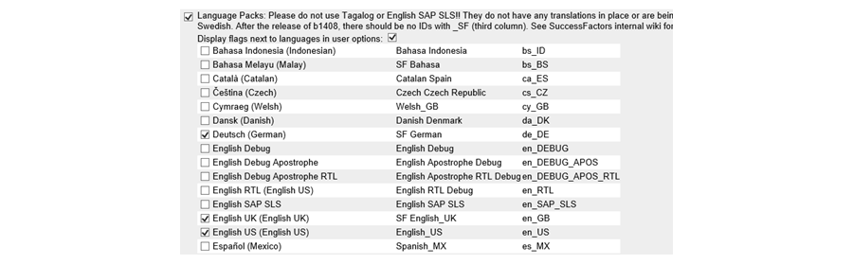

**Translation Enablement**

To enable translation, log on to Provisioning with your user name and password, and select the company from the list. Choose ***Company Settings***, and then choose ***Enable Translation of Employee Central Foundation Objects***. Scroll to the top of the screen and choose *Save Feature*.

**Translation Enablement**



**Languages in an Instance**

You can select the language for your instance by logging on to the instance and choosing *Options*. Then, you can choose your desired language.

**Languages in an Instance**

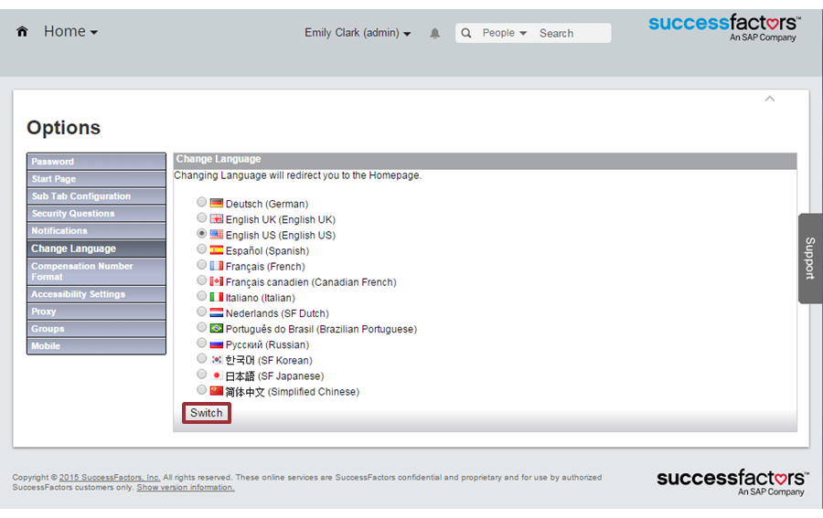

**Data Model and Specific Language Translation**

The **label** is the **descriptor** that displays on the UI. You can change this label by **overwriting** it with a name that the customer prefers. In the following example, the value of the **<label>** tag of the HRIS element is the descriptor for the FO **“location”**.

**Data Models and Specific Language Translation**

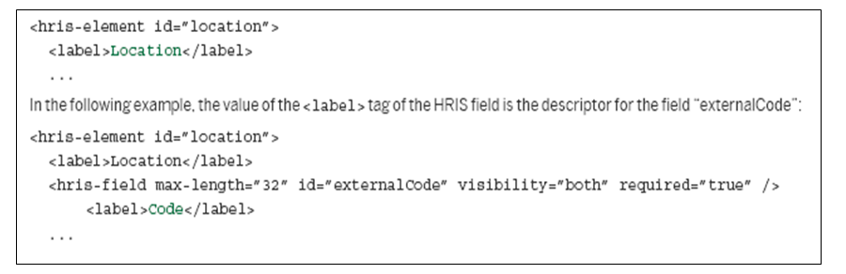

**Label Translation**

The label is the descriptor that appears on the UI. You can change this label. It can also be translated into other languages using the **xml:lang** attribute and the corresponding language code. The corresponding translations are stored in the XML file for the data as shown in the figure, XML Translation Process. **(Có thể thay đổi tên label trong file XML)**

If the system does not find a corresponding label for the system language, it displays the label that has been configured without the **xml:lang** attribute; in the figure, XML Translation Process, **Start Date** displays. **(Nếu hệ thống không tìm thấy nhãn tương ứng cho ngôn ngữ hệ thống, nó sẽ hiển thị nhãn đã được cấu hình mà không có thuộc tính xml: lang, Quy trình dịch XML, Ngày bắt đầu hiển thị.)**

**XML Translation Process**

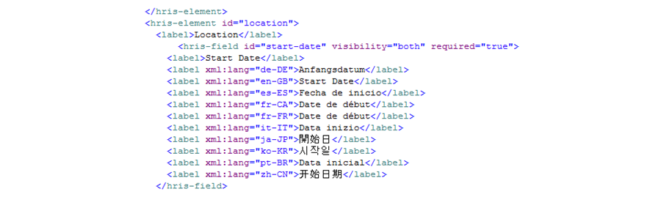

**Label Translation in MDF Foundation Objects**

The figure, Label Translation in MDF Foundation Objects, is for FO managed through MDF, if the field is **translatable**.

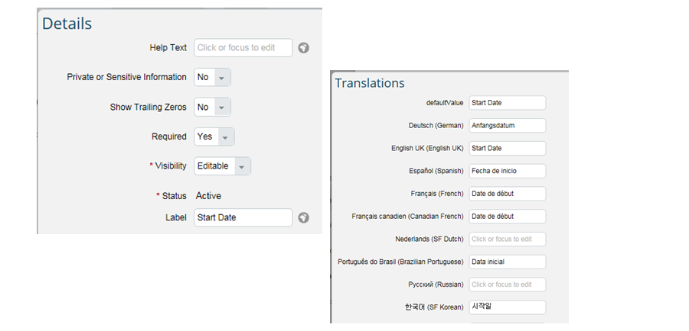

**Limitations of Translations**

The translations of FO **are not shown in the Employee Profile**. The **Employee Profile reuses FO** **data** for basic organizational information, such as **Division, Department, and Location**.

Within EC, there are two areas where the Employee Profile is used and where the FO translations are not shown.

**Limitations of Translations**

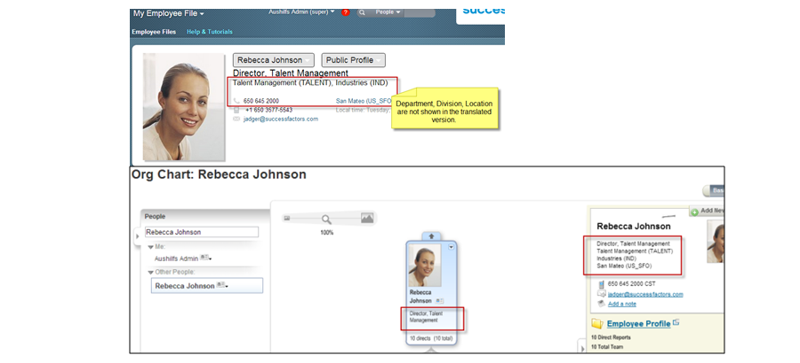

**Foundation Data Translation**

**FO** reflect a **company’s basic information** about the **organization, pay, and job structures**. This information is fundamental data that displays repeatedly throughout the system for both Admin and employees. It is, therefore, important that this information can be shown in the user’s language.

To display information in the **user’s language**, you can translate the **language-specific data of FO**, such as the **name and description of the department, business unit, or job classification**.

The translation process is handled differently for the following:

* Job Classification FO (technical name: jobCode)
* All other FO (except jobCode)

This module **only** covers the **translation of general FOs**, not **Job Classifications FO**. For additional information, refer to the EC implementation handbook.

**Translation Process**

The following steps highlight the general translation process **(Các bước translate)**:

1. Export or list the translatable foundation data.
2. Translate the foundation data.
3. Import the translations.

Export or List the Translatable Foundation Data

Open Import and Export Data. In the Download Data Import File Template field, choose FoTranslation.

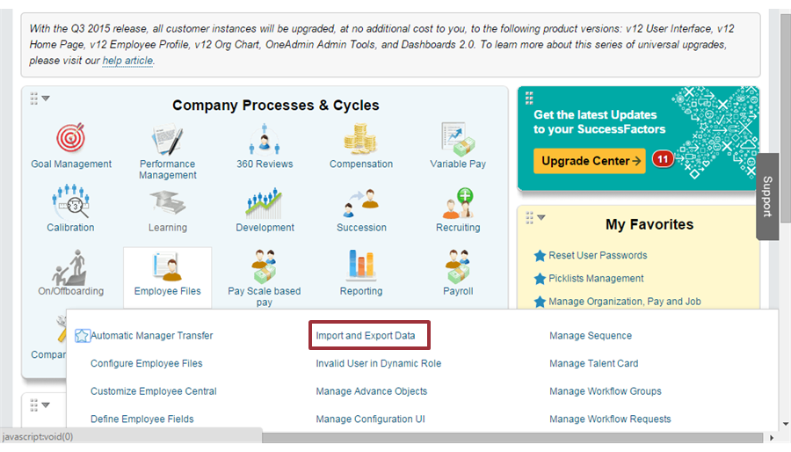

**Export or List the Translatable Foundation Data: Import and Export Data**

In the *Select the action to perform* dropdown menu, choose *Export Data*. In the *Select Generic Object* dropdown menu, choose *FoTranslation*. Then, choose *Export*.

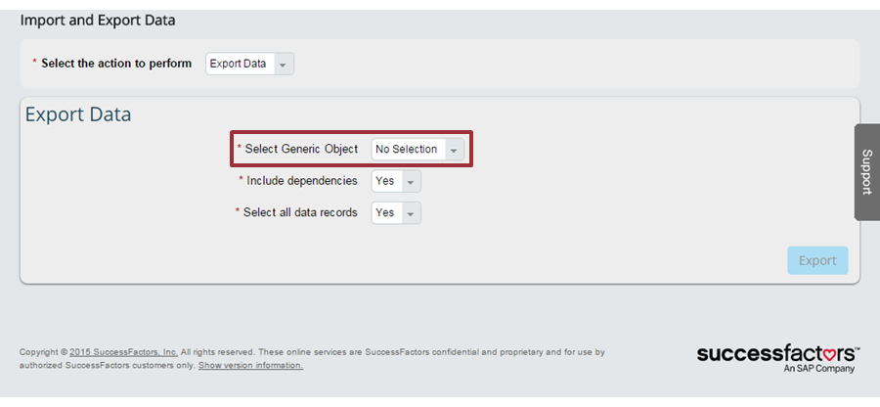

**Export or List the Translatable Foundation Data: Monitor Jobs**

Navigate to Monitor Job.

On the *Monitor jobs* screen, you can check the status of the export. When it is complete, you can select download from the *Download Status* link. The figure, Downloaded CSV File, is a sample of a downloaded CSV file.

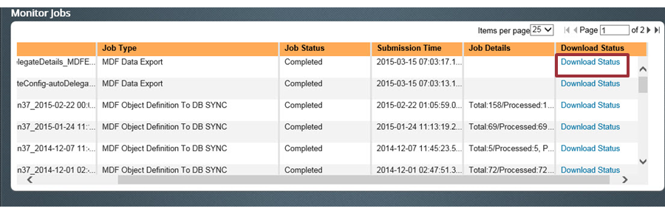

**Export or List the Translatable Foundation Data: Downloaded CSV File**

The figure, Downloaded CSV File, shows the downloaded CSV file.

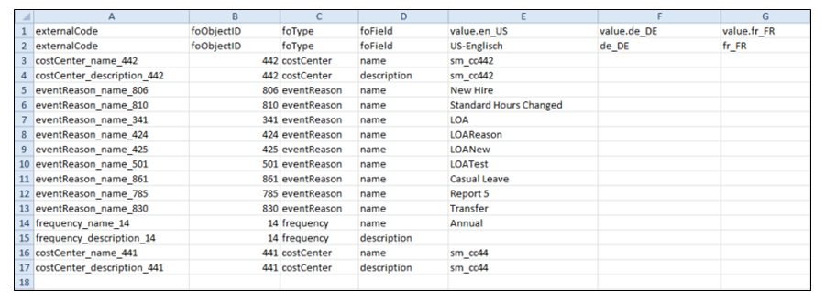

**Note**

If the downloaded CSV file contains only the first two rows, then the initialization of the FoTranslation object has probably not finished yet. This initialization process starts when you activate FO translation in Provisioning, and it can take several hours, depending on the number of FO existing in the system.

The first two rows are the column titles. The columns define the following:

* *externalCode*: this column is a specific external code that the **system assigns** to all instances **of FO that exist in the system**. This is **not** the external code the Admin has created or imported, but it is the FoTranslation-specific external code that is created when you enable FO translation in Provisioning. **(Đây là đoạn code được system assigns cho các Instances FO khi FO translation được bật trong provisioning)**
* *foObjectID*: this column is a specific **ID that the system assigns to all instances of FO that exist in the system**. This ID is created when you enable the FO translation in Provisioning.
* *foType*: this column contains the **HRIS-field ID for all translatable fields** (typically *name* and *description*).
* *value.\**: the remaining columns that begin with *value.* are followed by the locale ID for the corresponding language (for example, **value.en_US** for US English, **value.fr_FR** for French, and so on represent one language).

The texts that the Admin has entered for the name and description of existing FO are contained in the **corresponding language column**. All other language columns are determined by the language pack activated in Provisioning. You must enter the translations into these columns.

Send the CSV file to the translator, who can edit the file offline. Then, consolidate the translations for all required languages in one CSV file.

**Note**

There is no incremental upload for the supported FO translations. If you have already uploaded translations before, the latest CSV file upload overwrites the previous version. It is, therefore, important that the consolidated document contains all translations that are required, even if the translation is a shared process of different translators.

**Translate the Foundation Data**

The following figure is an example of a translated file; the translations are highlighted in column F.

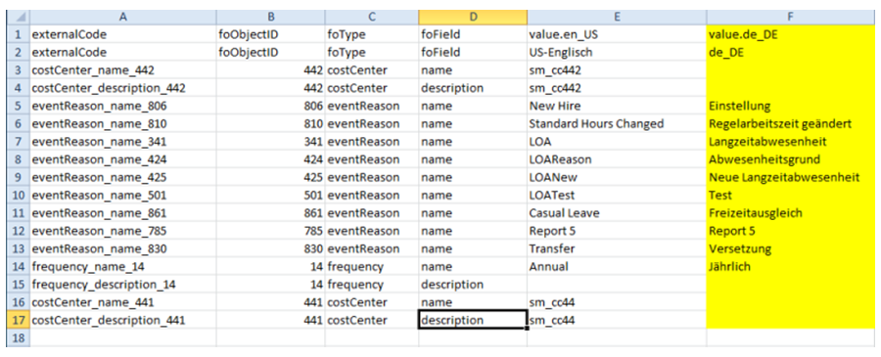

**Import the Translations**

Navigate to Import and Export Data.

In the *Select the action to perform* dropdown menu, choose *Import Data*. Select the *CSV File* radio button. In the *Select Generic Object* dropdown menu, choose *FoTranslation*.

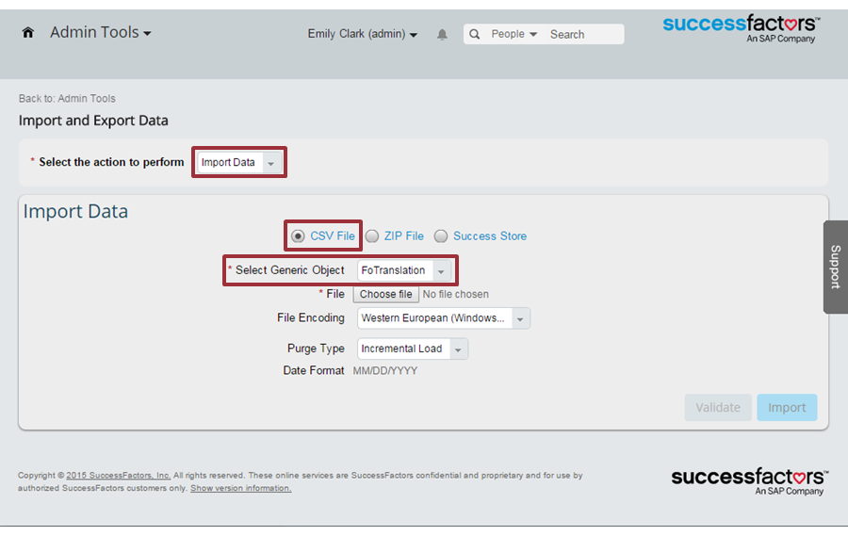

In the *File* field, browse for the translated CSV file. In the *File Encoding* field, select the character set that is appropriate for the languages that you want to import.

**Note**

This action guarantees that all special characters of the languages display correctly.

In the *Purge Type* dropdown menu, choose *Incremental Load*. Choose *Validate* to ensure that the file has no formatting errors. If there are no validation errors, choose *Import*.

**After the Import**

After the import, the system decides which language a FO displays in the following sequence:

1. The system checks whether the foundation data is available in the user’s logon language. This is the language the user has selected under *Options*→ *Change Language*.
2. If there is no translation in the logon language, the system shows the default language that has been set in Provisioning under *Company Settings*→ *Default Language*.
3. If there is no translation in the default language, the system looks for a translated term in US English.

**Translation Testing**

To test your translations, an end-user logs on in the language they wish to see and then validates the translation information. From the home page, choose *Options*→ *Change Language*→*(desired language)*.

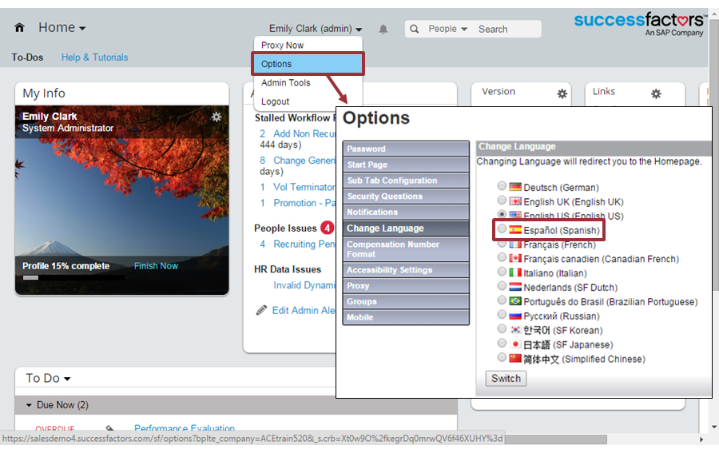

**Translation Validation**

The system returns to the home page. You can then check the labels and navigate to different areas to validate that translation occurred. Repeat the import process, if necessary.

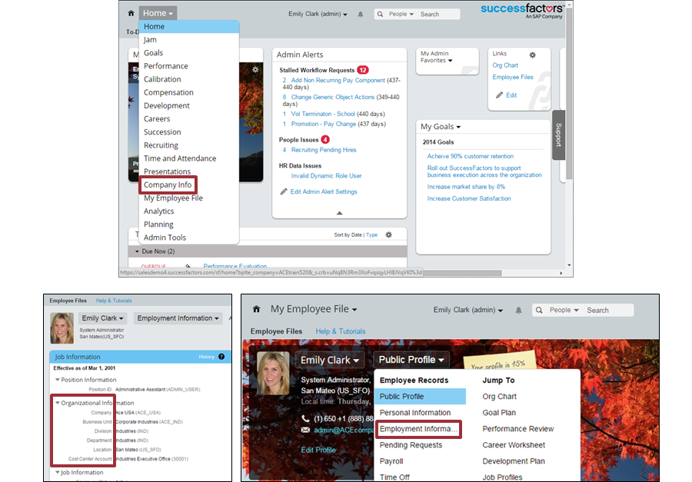

**Modification of Translations**

Use the following process to modify translations:

1. Export and import translations as previously described. We recommend completing these tasks if you want to translate a high number of new or changed fields in multiple languages.
2. Add or change translations on the UI. This is recommended if you want to add or change only a few terms, for example, when you want to **correct single terms that have not been translated appropriately**. Use the following steps to complete this action:
   1. Open *Admin Center*.
   2. Open Manage **Organization, Pay, and Job Structures**.
   3. In the ***Search* field, choose the type of FO** (for example, *Legal Entity*) and the specific FO (for example, *Company USA*) for which you want to add or change a translation.
   4. Choose the ***Translations*** icon next to the translatable field (as shown in the figure, Modification of Translations).
   5. In the *Translations* dialog box, enter or change the translation directly.
   6. Choose *Done* and then *Save*.

**Modification of Translations**

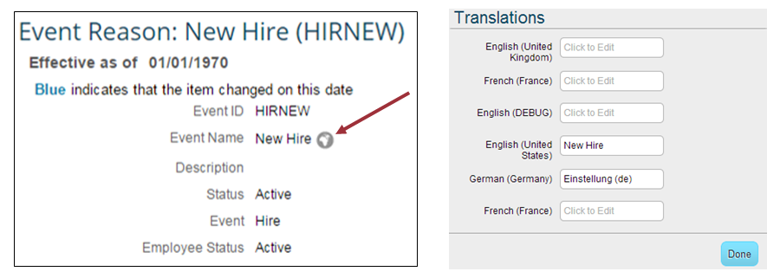

# Unit 6: SAP SuccessFactors Employee Central - Self-Service and Workflows

1. Managing Role-Based Permissions (RBP) for Self-Service Access
2. Customizing Self-Service Transactions Using Workflows
3. Event Reason Derivation

6.1 Managing Role-Based Permissions (RBP) for Self-Service Access  
**RBP for Employee Self-Service (ESS)**

You previously learned about RBP with regard to administrators. In this module, you learn how **Employee Central (EC) uses RBP to manage ESS and MSS**. Self-Service is built into EC and is **not an additional module**.

In the figure, RBP for ESS, you can see an example of ESS. ESS is a feature that allows an employee to **initiate and complete transactions for an employee file without HR assistance**. For example, an employee can change their home phone number. RBP typically has three parts. In the figure, the granted population is all employees, the role is the permission to view and edit the phone number, and the target population is themselves.

**RBP for ESS**

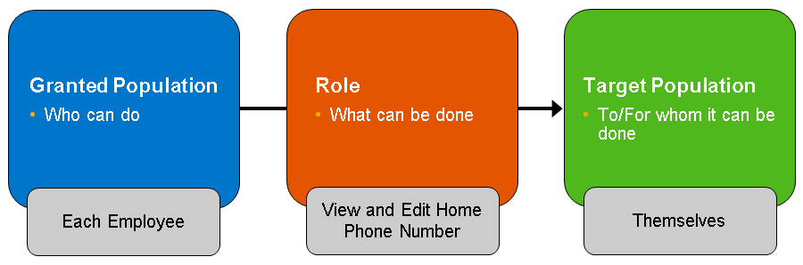

**ESS**

When an employee views their own personal information, **the portlet can have an *Edit* icon on the top right**. *Edit*allows the employee to make updates to personal information without going through HR. In the figure, ESS, you can see examples of typical ESS options, some of which are effective dated, such as Addresses and Personal Information.

**Hint**

ESS is configurable and, even if an employee has permission to change some of the information, **approval might be required.**

**ESS**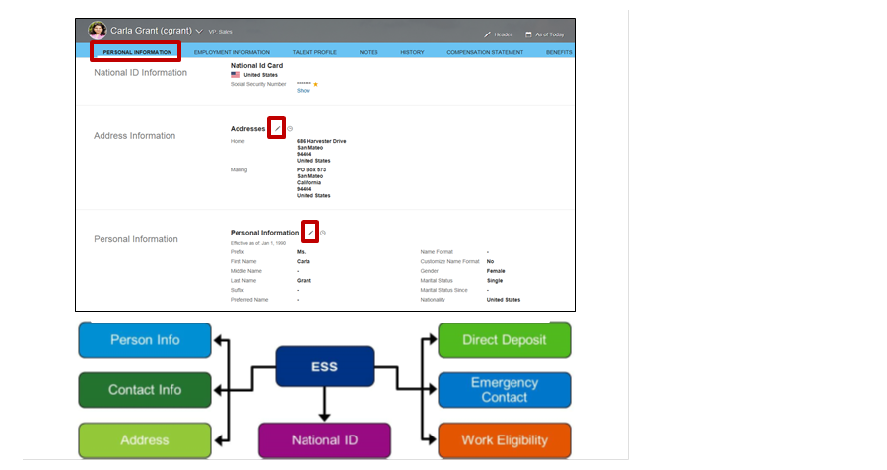

**ESS Permissions**

To **access permissions** for **ESS** in ***Permission Roles***, choose ***Employee Central Effective Dated Entitie****s* for Effective Dated portlets and *Employee Data* for Non-Effective Dated portlets.

You can enable the personal information section as follows:

1. To enable viewing the portlet, select view current or view history for the section action. The example in the figure, ESS Permissions, is for Personal Information.
2. To enable editing fields via people profile, assign the edit/insert permission to edit link.
3. Configure each field for the level of access: none, view current, view history, edit/insert. Some portlets are permissioned a the portlet level and not individual fields.

**ESS PERMISSIONS:**

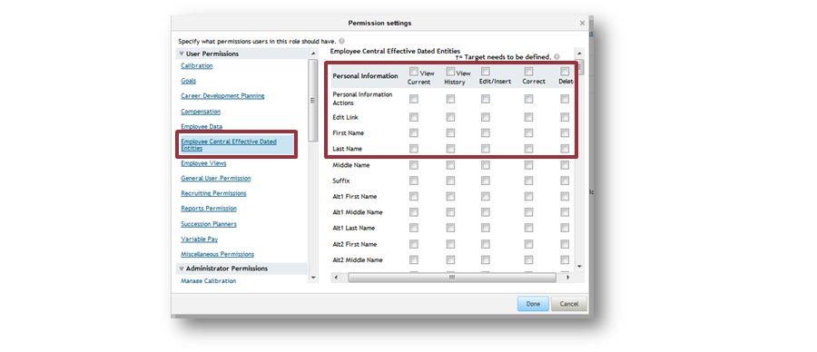

**RBP for MSS**

**MSS allows a manager** to **initiate HR transactions** such **as promotions or transfers for their direct reports** using the ***Take Action* button**. These changes are known as transactions and might require a configurable approval process called a workflow. You learn more about transactions and workflows later in this module.

**RBP for MSS**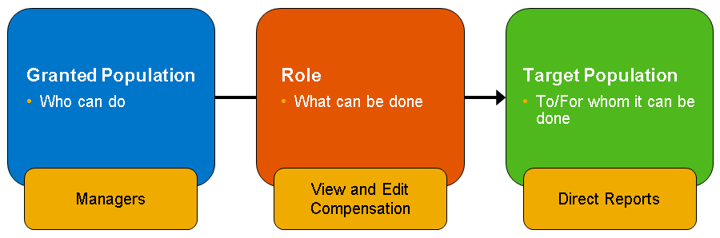

**RBP for MSS**

When a manager selects the ***Take Action*** button, a list of change options appears. The manager selects the kind of change that is required and fills in the appropriate fields. In the figure, MSS 1, you can see examples of **typical MSS options**, most of which activate an **approval workflow**.

**MSS 1**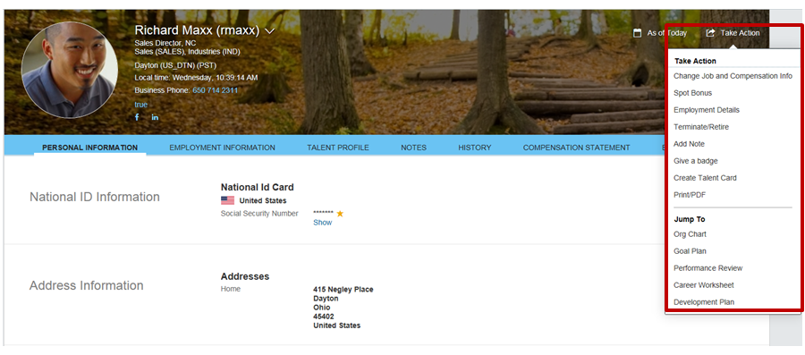

**MSS Options (Các quyền của mss)**

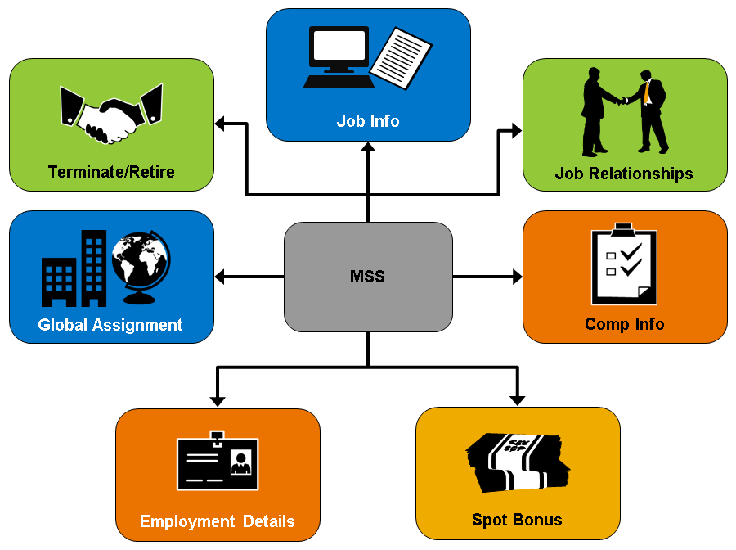

In the figure, MSS 2, you can see a diagram of the options in MSS.

**Note**

MSS is configurable and some managers might be assigned more permissions than others.

**MSS Permissions**

To manage permissions to access MSS in permission roles, choose ***Employee Data*.** Then, navigate to ***HR Actions*** and select ***Update Employment Records***.

To **grant access**, ensure that the user has ***View* and *Edit*** access to the ***Take Action*** button, known as ***Update Employment Records***. This MSS action is available when a manager selects an employee from ***My Team*** on the ***Home* page**. There are other permissions that control user access to a particular MSS action.

**MSS Permissions**

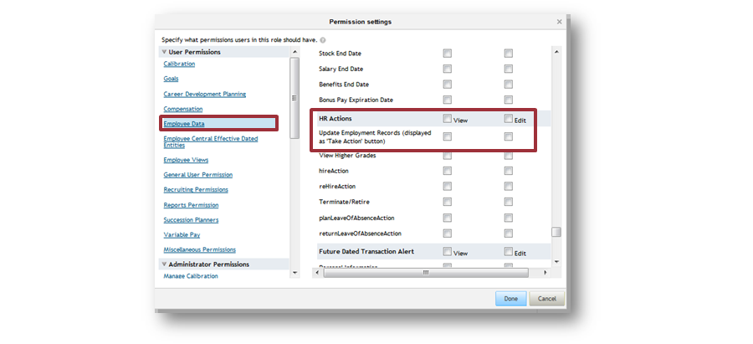

6.2 [Customizing Self-Service Transactions Using Workflows](javascript:parent.ktm.openTopic(2)):  
**Workflow Administration: (quản trị cấu trúc công việc)**

**Workflows** are **part of the self-service process**. **When an employee or manager makes a change, a workflow is activated**. Workflows are generally built in the implementation process. The role of the administrator is to ensure the completion of workflows and to manage the workflow participants. **(Quy trình làm việc là một phần của quá trình self-service. Khi một nhân viên hoặc người quản lý thay đổi 1 cái gì đó, một quy trình làm việc được kích hoạt. Quy trình làm việc thường được xây dựng trong quá trình implementation. Vai trò của quản trị viên là đảm bảo hoàn thành quy trình công việc và quản lý những người tham gia quy trình làm việc.)**

In the figure, Workflow Administration 1, you can see a sample workflow with three approvers. The approvers are a manager, second-level manager, and an HR Dynamic Group. The third approver, HR Dynamic Group, is a pool of people where only one person needs to approve the workflow.

**Workflow Administration 1**

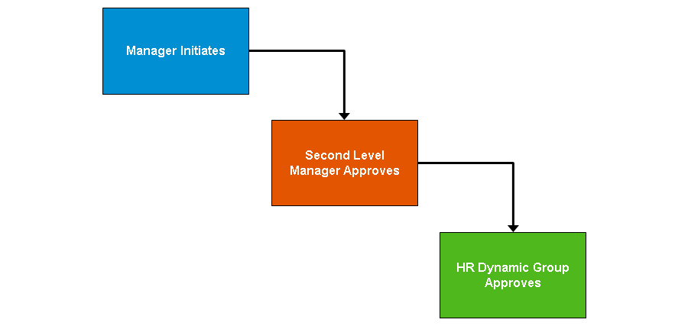

**Workflow Management**

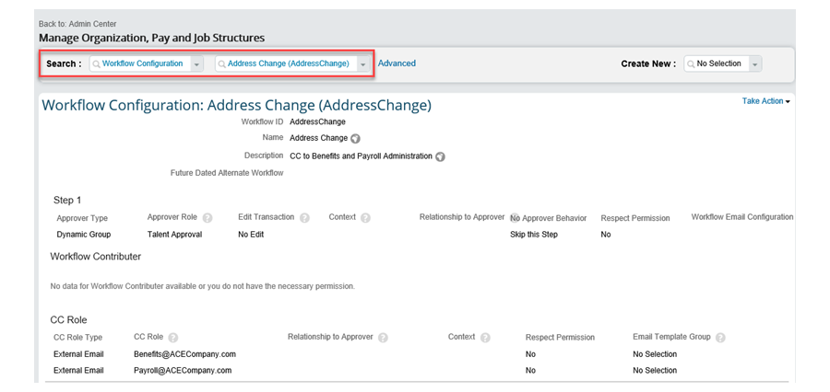

To manage workflows, choose *Navigate to* → *Manage Organization, Pay and Job Structures*. In the *Search* field, select *Workflow Configuration*. The second selector shows all of the workflows currently available in the instance. In the figure, Workflow Administration 2, you can see that for an *Address Change*, auto delegation and future dated transactions are not enabled, the approver is the *Dynamic Group*, **Talent Approval**, and there are two external email addresses that will be cc’d when the process is finalized. To make changes, click *Take Action* and *Make Correction* on the top-right of the screen.

**Workflow Participants Configuration**

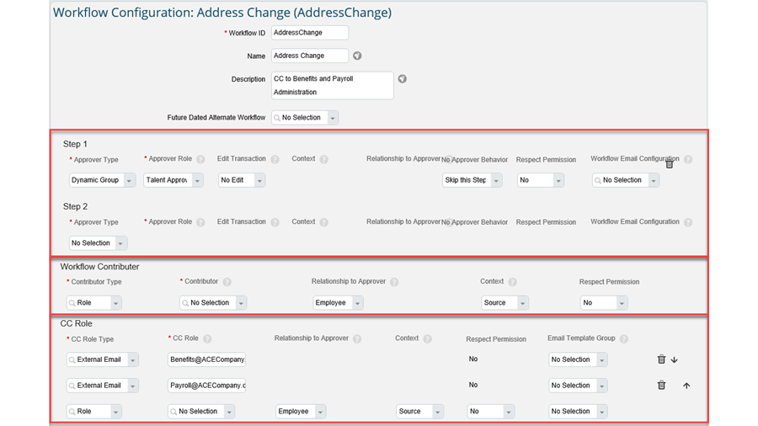

to configure the workflow participants, click *Take Action* → *Make Correction*. Administrators do not change the*Workflow ID* but might make adjustments to the three participant areas. Area 1 is where you add the approvers in the correct order. Area 2 allows you to add contributors. Area 3 allows you to cc additional role types.

**Workflow Administration**

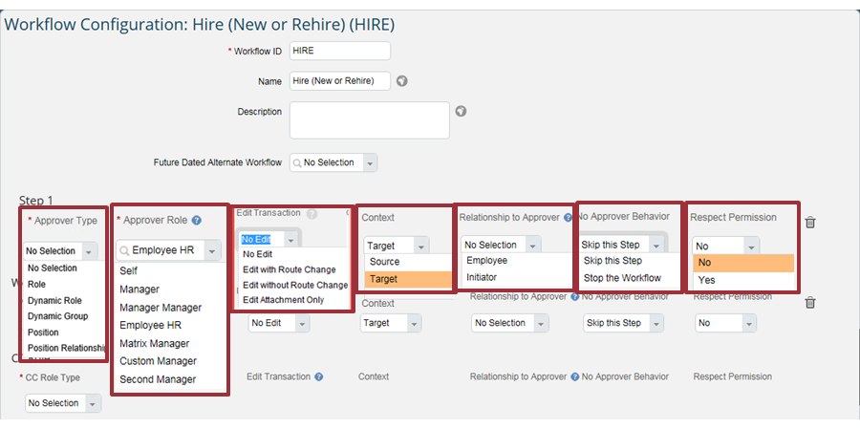

When adding approvers, there are seven areas to consider.

The first area is *Approver Type*. The *Approver Type* can be a role such as the manager of an employee, a *Dynamic Role* (a system determined approver based on employee data) or a *Dynamic Group* (a pool of employees wherein anyone can offer approval). You can now enable the routing of workflows based on the position hierarchy, starting with a position, a subject employee's position or the initiator's position. Previously, the workflow could only be routed based on the reporting hierarchy.

The second area allows you to select from a list of *Role*, *Dynamic Role* or *Dynamic Group* (based on the first area).

The third area allows you to decide if the approver is able to edit the transaction. *No Edit* means that the approver cannot update the request. *Edit with Route Change* means that the approver can make changes and the system decides if a new event reason and workflow are necessary. *Edit with Route Change* means that the approver can make changes and the system decides if a new event reason and workflow are necessary. *Edit without Route Change*means the route is not recalculated when the approver makes changes. Finally, *Edit Attachments Only* means an approver has capability for editing any attachments associated with the workflow transaction.

The fourth area determines whether the approver is for a future role or current role. For example, when an employee is being transferred, you might want to include their current or *Source* manager and their new or *Target* manager.

The fifth area is where you can determine if the workflow role is based on the employee for which the change is made, or the initiator of said change.

The sixth area is where you can decide if a workflow should stall or skip a step if the group or position is empty.

The seventh area is where you can restrict the access to part of the workflow content for which the user has permissions. Permissions allow the workflow participants to only see and edit the content for which they are permissioned. For example, you can use permissions so that changes to compensation are not shown to participants of some groups.

**Note**

A Workflow e-mail Configuration Section now displays as well. This can be used to send out specific e-mail notification for each workflow step. However, you must have Document Generation enabled and several configurations set up before using this feature.

**Workflow Administration Areas**

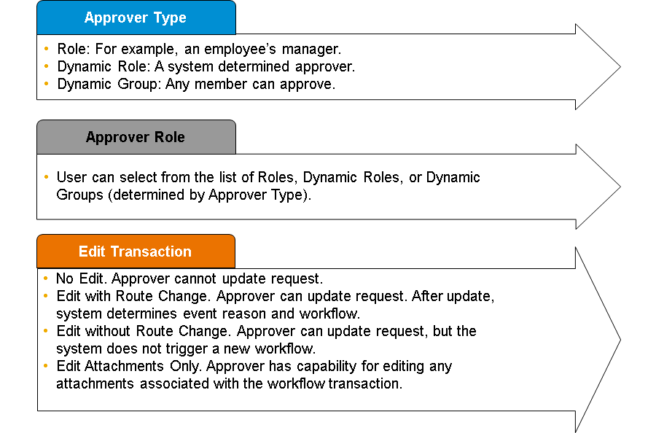

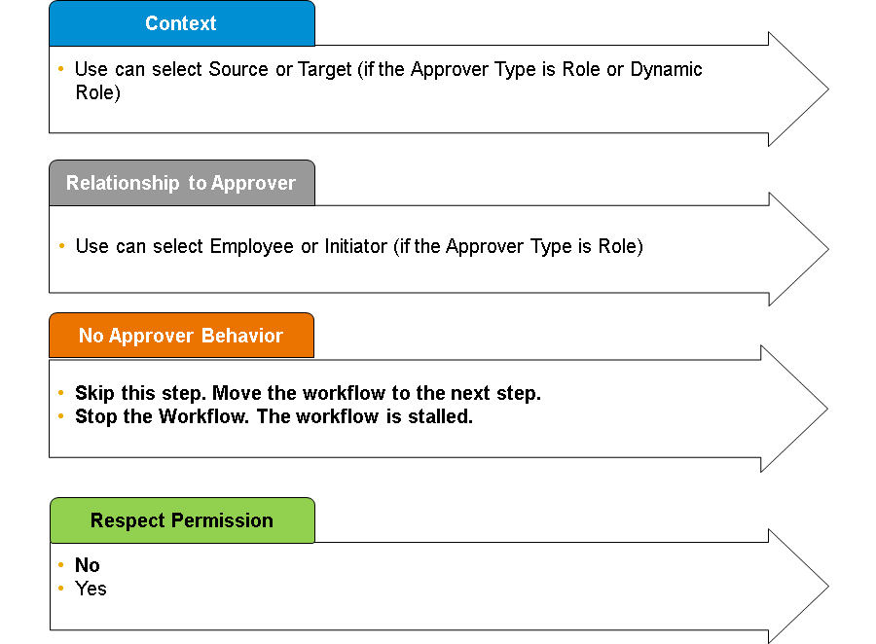

The figures display the areas that may be configured for workflow approvers. These areas are *Approver Type*, *Approver Role*, *Edit Transaction*, *Context*, *Relationship to Approver*, *No Approver Behavior* and *Respect Permission*. For cc roles and contributors, you can have the same options except for *Edit Transaction*.

Administrators can manage workflow requests by navigating to *Manage Workflow Requests*. There, the administrator can search for workflows and take action such as reviewing completed, cancelled, or locked workflows and, for pending (active) workflows, an administrator can lock or unlock, modify approvers, reroute requests, and decline.

**Workflow Administration Notification**

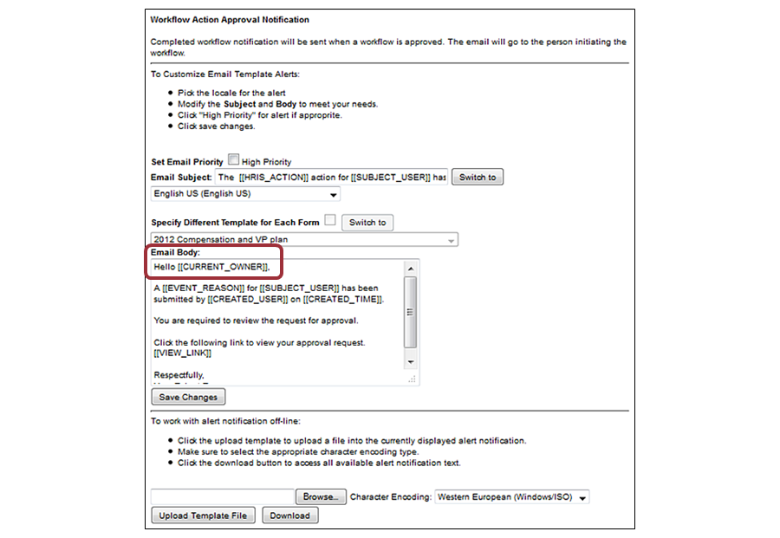

By navigating to *E-Mail Notification Template Settings*, administrators can also modify the email notification templates that are used to notify participants. There, the administrator can update company-specific language for each of the templates listed. These notifications use tags, as shown in the figure, Workflow Administration Notification. For a full list of the supported tags, see the Partner Portal.

Administrators can change the text that an approver receives during the workflow process. They can also manage email notification for the following workflow actions:

* Approval
* Rejected
* Pending
* Cancelled
* Skipped
* Posted
* Lock Down
* Unlock
* Contributor
* CC Role
* Approved
* Sentback

**Dynamic Roles and Groups**

Dynamic Roles are Foundation Objects (FO), which means that they are managed using *Manage Organization, Pay and Job Structures* in *Admin Center*. For example, you can set up Janet James as the finance controller for all employees in Corporate Industries. If Carla Grant promotes Marcus within the Corporate Industries group and the promotion workflow includes the “finance controller”, the system chooses Janet James.

Administrators can also create a workflow or dynamic group. These groups are created using the same interface as RBP, such as *Job Code*, *Location*, and so on. Workflow groups are managed using *Manage Workflow Groups*.  There, you can create new groups and provide the criteria to define them. When a dynamic group is included in a workflow, all employees in the group are notified and if any employee in the group provides approval, the request moves on.

**Note**

You can enable the Four-eye principle that enforces security mechanism so that the initiator cannot be an approver for their own workflows. This is applicable to Dynamic Groups and Dynamic Roles.

**Dynamic Roles and Groups**

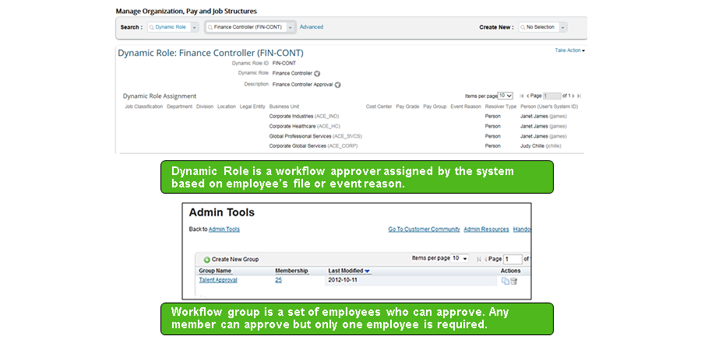

**Approver Permissions**

In the figure, Approver Permissions, you can see the different options for an approver.

**Approver Permissions**

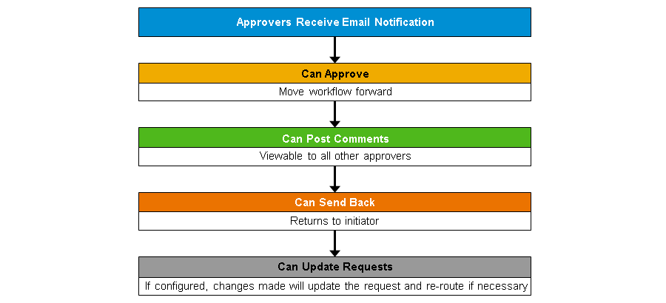

**Workflow Participation**

When an employee is participating in a workflow, they can view the progress using the Manage Pending Requests tool. If you have People Profile turned on, the best way to access this page is to use *Action Search* --> *Manage Pending Requests*. The inbox has four sections. The first section is approvals that require employee action. The second section shows requests that the user has approved, but are still in progress. The third section shows requests that the user initiated that are still in progress. The fourth section is CC notifications.

**Note**

You can navigate to the Pending Requests screen directly from the Employee files if you are using the legacy V12 Profile. If you have People Profile turned on, you must use the Action Search to navigate to Pending Requests.

If you have the new Homepage turned on, you can also turn on an advanced tool for managing your workflow requests. This can be accessed directly from the To Do list on the Homepage by clicking on “Approve Requests”. This new tool allows greater filtering options and an easier interface for approving workflow requests. You can turn this feature on through Role Based Permissions, within the General User Permission section.

* You can now trigger workflows and business rules when importing data for certain Employee Central Portlets. In order to allow for this, navigate Manage Permission Roles—>Permissions—>Administrator Permissions—>Employee Central Import Settings.

Currently workflows only trigger for incremental data loads.

**Workflow Participation**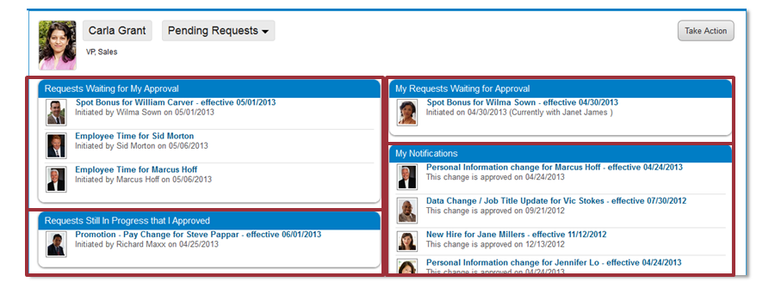

**Manage Workflow Request Professional Edition**

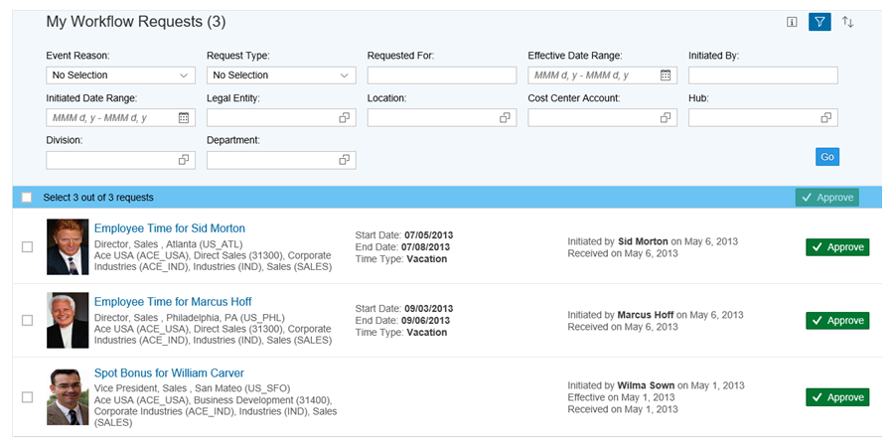

**Permission Setting**

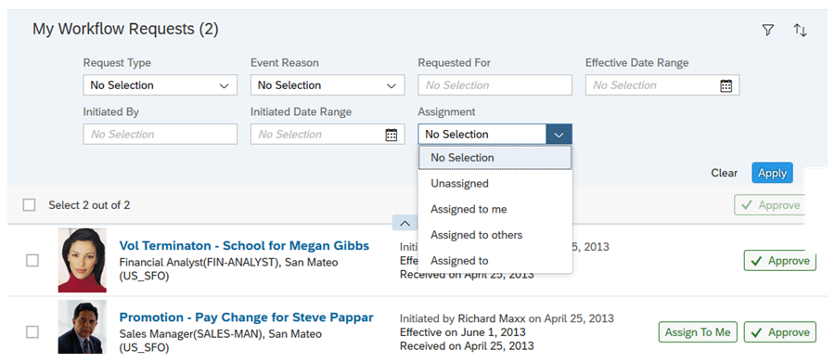

**Self-Assigning Workflows**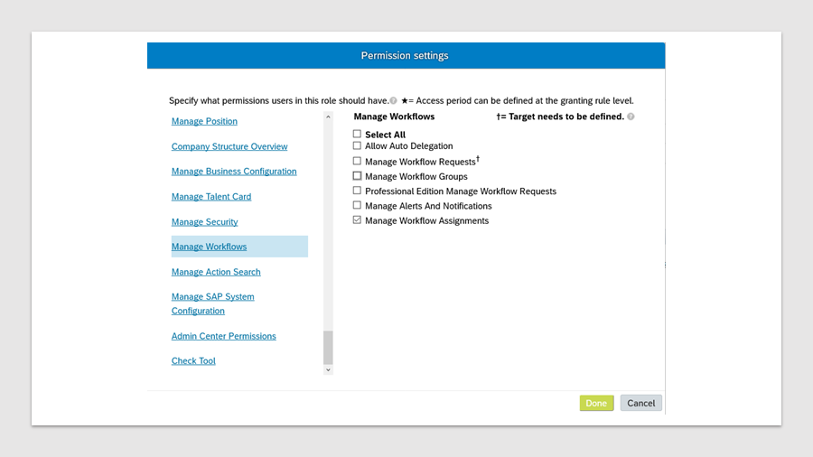

**Why is it Important?**

Multiple users may process the same workflow in parallel. For example, If a workflow requires additional alignment and communication, such as a workflow that has to go through a worker’s council hearing, and there’s no indication that the workflow is already in progress, another user could start to process it. This enhancement indicates when a workflow is in progress and increases the efficiency of the team that processes the workflow.

Configuration of Delegation

With delegation you can enable an option that will allow an approver to forward the workflow to another user in the company, who will take over the workflow and approve or decline in lieu of the initial approver. The recipient can then take over the workflow and approve or decline it in place of the initial approver. He or she also has the option of refusing the delegation. The initial approver can also recall the workflow.

There are two options how to delegate workflows:

* Manual delegation: done individually by the employee workflow by workflow
* Auto delegation: if switched on, all workflows are delegated

Delegation is configured in the Corporate Data Model. The Workflow Configuration FO has a new field called is-delegate-supported. When Corporate Data is configured with the is-delegate-supported hris-field under the wfConfig hris-element, the system allows the admin user to configure a workflow FO with Yes and No options. By default, the field value is No.

Corporate Data Model: hris-field under <hris-element id="wfConfig">

<hris-field id="is-delegate-supported" visibility="both" required="false" pii="false">

<label>Is Delegate Supported</label>

</hris-field>

For both manual and auto delegation, it is necessary that delegation is supported at the workflow, meaning Is Delegate Supported is set to Yes.

**Configuration of Delegation**

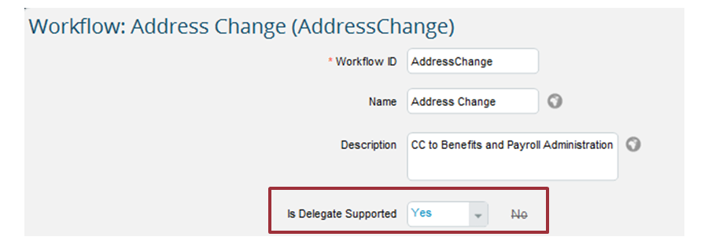

**Activation of Auto Delegation**

A user can set up an auto delegate through the *My Info* tile on the homepage. In order to enable auto delegation, the user needs to have the *Allow Auto-Delegation* RBP permission. When auto delegation is enabled, all workflows with auto delegation enabled are routed to the nominated user. This includes workflows that are received though job relationship, dynamic role, dynamic group, and position.

**Auto Delegation**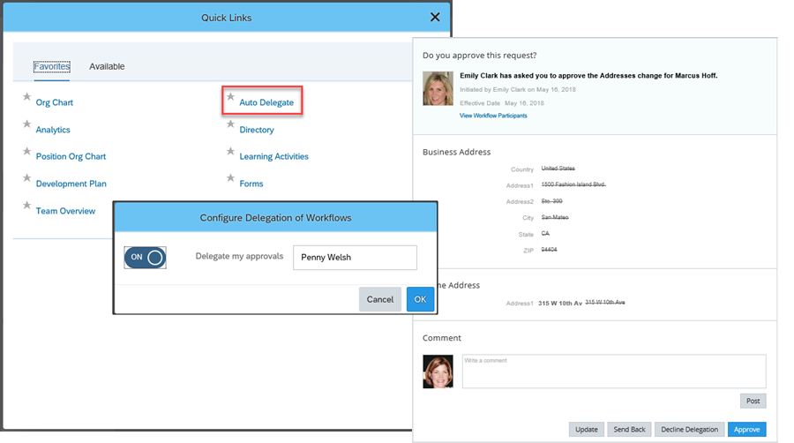

**Future Dated Transaction Check**

This feature enables an alternate workflow route to be assigned if the transaction takes place in the future.

The *Alternate Workflow* is an optional field. If a value is not entered or the change does not take place in the future, the main workflow is used instead.

**Hint**

This behavior is applicable only for EC effective-dated entities and is not applicable for Meta Data Framework (MDF) and FO entities.

**Future Dated Transaction Check**

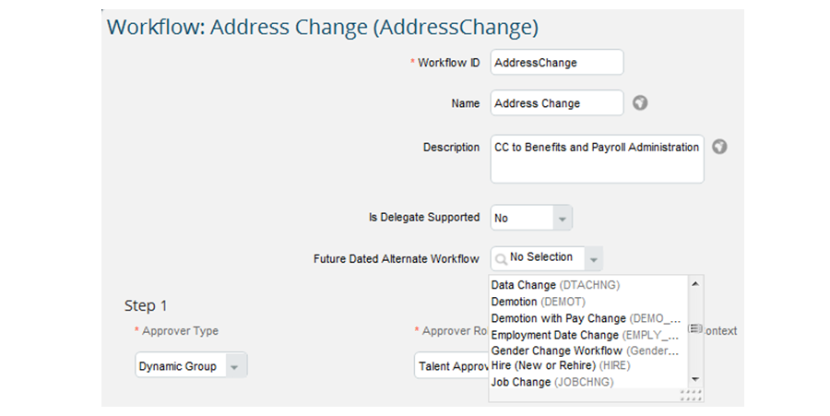

**Reminding Approvers About Stalled Workflows**

You can specify that the current workflow approver is reminded to take action on a pending workflow after a certain number of days. You can configure the notification two ways:

* Set up the same number of days in all workflows.
* Set up individual number of days for different workflow foundation objects.

To configure reminders, you create a job in provisioning with the job type **Workflow Action Reminder**. You can set the Remind in Days value to the number of days for all workflows or leave the value blank to specify the days for each workflow configuration record.

If you are configuring the individual workflow configuration records, you must update the Corporate Data Model to include the remind-indays hris-field in the wfconfig hris-element as follows:

<hris-field id=”remind-indays” visibility=”both”>

<label>Remind in Days</label>

</hris-field>

When the scheduled job runs, the system gets all the pending workflows. The number of days is determined based upon either:

• The number of days entered in the scheduled job in Provisioning.

• The number of days the Admin has entered for each workflow foundation object record if the number of days is empty in the scheduled job.

If the workflow has been pending for that number of days, the reminder notifications are sent to the current approver.

The reminder notification reuses the original notification the approver gets when a workflow is triggered, with “Reminder:” in the email subject line. There is no need to configure a specific email template for reminder notifications.

**Note**

If you configure a number of days in the notification job, values entered on Workflow Configuration Records is ignored.

**Workflow Reminder**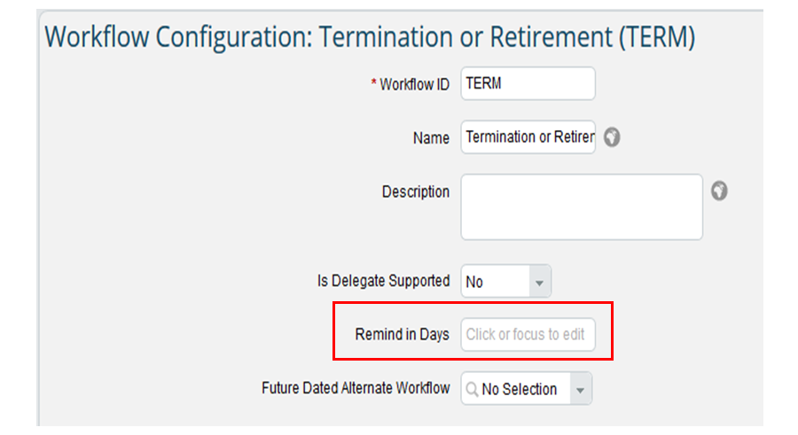

**Workflow Reminder Scheduled Job**

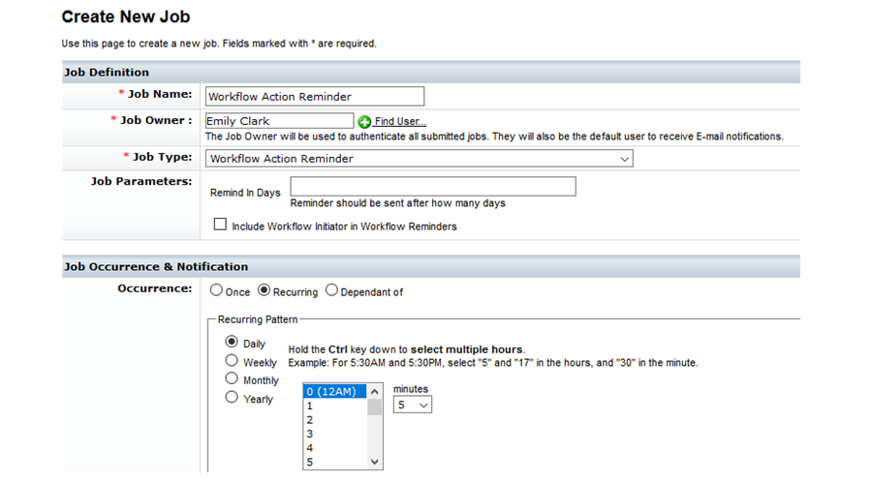

**Auto Escalation of Workflows**

It is now possible to define an escalation path for a workflow. If an approver takes no action on the workflow, the workflow becomes stalled. When the workflow is stalled for the specified number of days, the workflow is automatically escalated to a specified user. The new approver can decline the escalation, so it goes back to the previous approver. The previous approver can also revoke the escalation, thus bringing it back to themselves. After declining or revoking, the escalation would continue with the next escalation step after the defined number of days.

An escalation path must be created within the *Manage Data* tool, then attached to the workflow configuration.

**Auto Escalation of Workflows**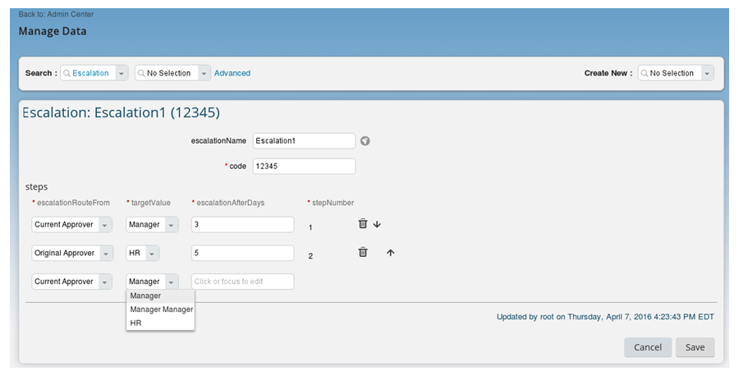

**Configuration of Workflow Escalation**

You must first add the escalation to the Foundation Object wfConfig hris-element in the Corporate Data Model and reimport it from Provisioning. Include this xml tag in corporate data model under <hris-element="wfConfig"> :

<hris-field id=“escalation" visibility="both" required="false" pii="false">

        <label>Escalation</label>

</hris-field>

The second step is to create Escalation records in the Manage Data tool. The third step is to assign the required workflows the escalation records. The final step is to create a job in provisioning to run the Workflow Auto Escalation Job Type. For full details, please refer to the Implementing and Configuring Workflows in Employee Central guide from the SAP Help Portal.

**Configuration of Workflow Escalation**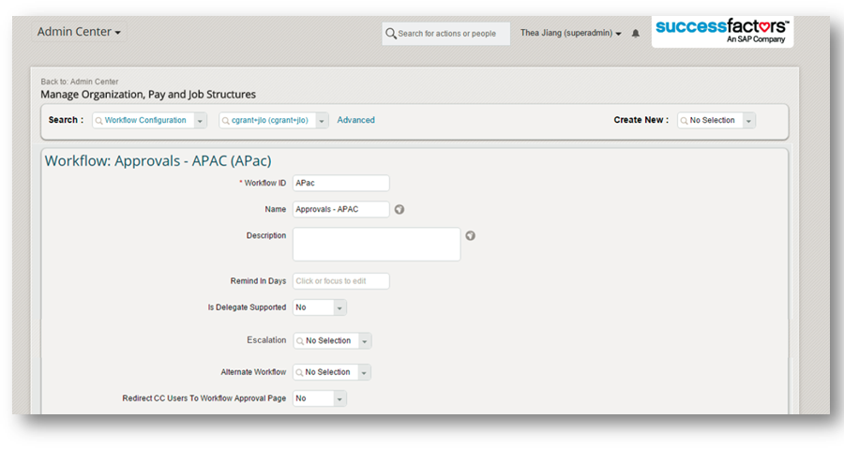

## 6.3  [Event Reason Derivation](javascript:parent.ktm.openTopic(3)):

**Event and Event Reason Administration**

EC is a Human Resource Information System (HRIS) and a way for you to track the changes to an employee record or your company structure over time. Events and event reasons allow you to keep track of changes to an employee record.

This is important for two reasons:

1. It keeps clear reporting about what changes were made.
2. It helps you to comply with legal or corporate policy regarding employee changes.

These events and event reasons also play a role in how self-service is configured in your system. You can see these events and event reasons when you make changes and these might be visible to your managers and employees as they work through self-service.

Events are hard coded in the system. The full list can be seen in the event picklist. You can deactivate events your customer chooses not to use, and you can also rename events.

It is very important to note that you should never create new events. The list that is delivered by SAP Successfactors contains the only events you can use in the system.

Because of the restriction on creating new events, event reasons were created. Event reasons can be built directly in the instance, and are used to differentiate between certain actions in the system. For example, if we look at the figure Event and Event Reason Administration 1, we can see the event "Termination". In order to differentiate between the different types of Termination (voluntary vs involuntary, retirement, lost to competitor) we can create multiple event reasons and tie them back to the one Termination event.

**Event and Event Reason Administration 1**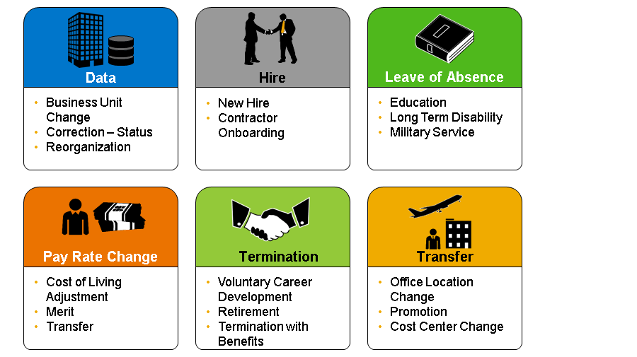

**Event Reason**

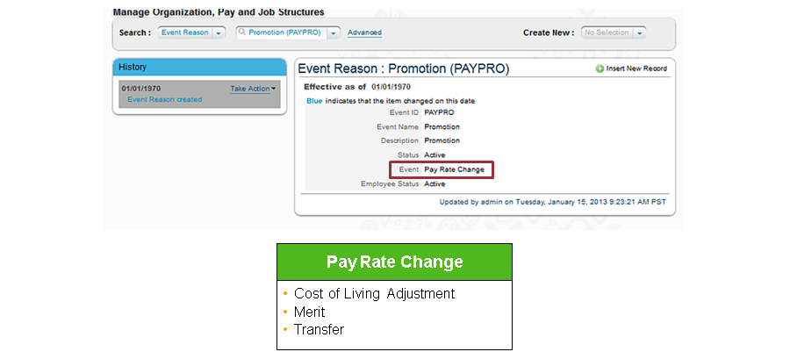

Event reasons are also FOs and therefore are managed in the *Manage Organization, Pay and Job Structures* interface. In the figure, Event and Event Reason Administration 2, you can see an example of an event reason, promotion. You can configure the *Event ID*, *Event Name*, *Description*, *Status*, and *Employee Status*, and to which hard-coded event the event reason belongs. When a data change occurs, depending on your setup, the system can determine the correct event or event reason triggered (Event Reason Derivation) or you can manually choose the event and related event reason occurring.

**Event and Event Reason Configuration**

For reporting purposes, one event and event reason must be tied to each transaction, or change of employee data, that occurs in the system.

Event Reason Derivation (ERD) is a process that can be set up for your customer. It essentially tells the system the correct event, event reason, and workflow configuration (if needed) that should be triggered based on the type of transaction occurring in an employee’s job or compensation sections. ERD requires a lot of initial setup, since each possible data change that could in those employee portlets must be tied to a specific event/event reason. For example, the system needs to be able to differentiate between employee transfers, promotions, location changes, pay changes, position changes, etc. Customers who want ERD set up for their system should first determine the event reasons they need to cover all types of changes in the system, then the triggers or field changes associated with each event reason.

Although ERD setup requires more effort before go live, it greatly improves transaction accuracy, especially for Manager Self Service. Rather than a manager simply guessing which event and event reason is triggered, the system follows a set of pre-defined rules to accurately define what type of action is occurring. This greatly improves reporting on employee changes, which can help customers have a better understanding of what is occurring within their company.

If a customer chooses to not use ERD, the Event and Event Reason will always be chosen by the user initiating the transaction. Business rules can still be configured to tie the event reason chosen to a workflow configuration, to ensure the transaction goes through the appropriate approval process before it is active.

**Event Reason Derivation**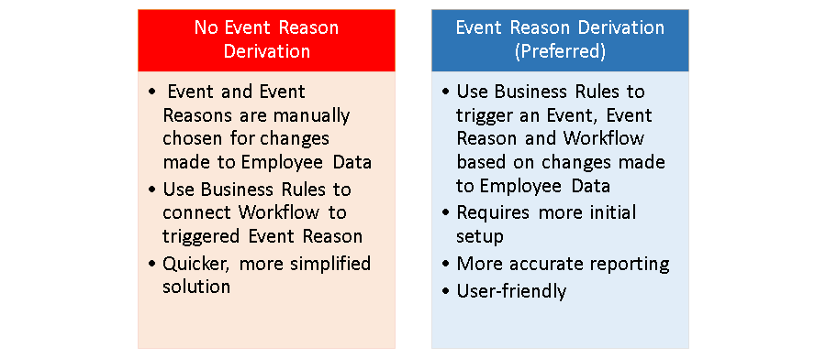

**HR Edit**

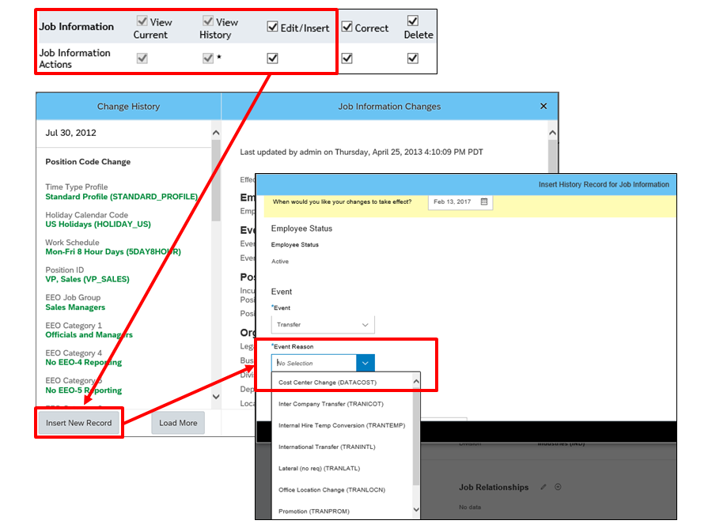

Even with Event Reason Derivation turned on, those given the RBP rights to Insert New Records from the history of a portlet have the ability to bypass this process. If you do not go through the Take Action button available on employee files, you will manually choose the event and related event reason for the change you are making. Once you update the necessary fields and click Save, the change is automatically stored, and no workflow is triggered. This is referred to as an “HR Edit” and this capability should only be given to a more administrative audience.

To review, if ERD is turned on and the individual performing the change navigates through Take Action, then the system chooses the correct event and event reason, and triggers a workflow if one is configured for that particular change. If the individual navigates through History →Insert New Record, then they must manually choose the event and event reason, and no workflow is ever triggered.

**ERD Provisioning Setup**

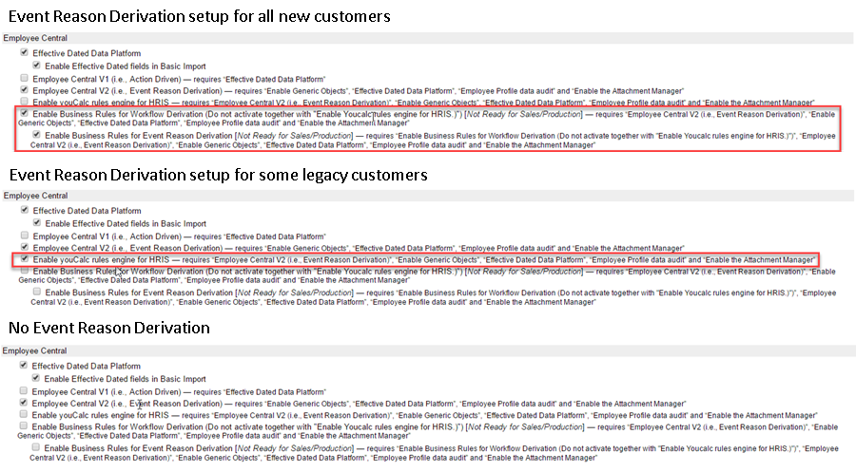

In the Figure, ERD Provisioning Setup, you can see all of the options for setting up ERD within Company Settings in Provisioning

Option 1 – ERD for new customers

As of 2015, all new customers going live with Employee Central should use Business Rules for Event Reason Derivation. In order to be able to set this up, the boxes next to Enable Business Rules for Workflow Derivation and Enable Business Rules for Event Reason Derivation must be checked.

Option 2 – ERD for legacy customers

If you are working with a customer that went live prior to 2015, they may be using our legacy XML setup for Event Reason Derivation. Customers that use legacy ERD have the box next to Enable youCalc rules engine for HRIS checked. This course does not provide instruction for how to set up ERD, but information can be found in the Employee Central Master implementation guide.

Option 3 – No ERD

If your customer chooses not to turn on ERD for their instance, then all three ERD boxes must remain unchecked.

**An Exampleof Standard Hours Changed ERD**

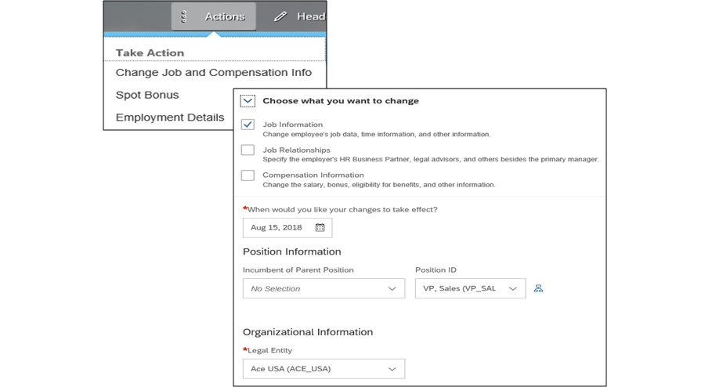

Your customer wants the system to automatically select an event, event reason and trigger a workflow process whenever the Standard Hours field is changed in the Job Information Portlet.

**An Example of Standard Hours Changed ERD 2**

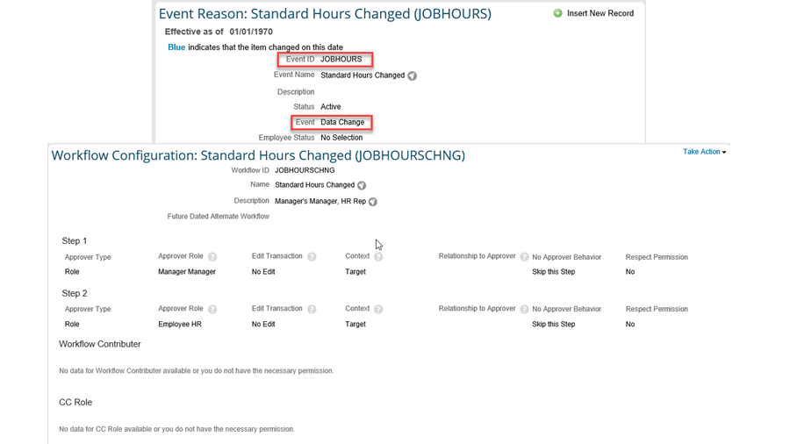

First, event reasons and workflow configurations must be built before they can be connected to the employee data change. The event reason stores the hard-coded event that it falls under. When we use a business rule to choose the correct event reason, it also automatically chooses the event that is connected on this record.

**An Example of Standard Hours Changed ERD 3**

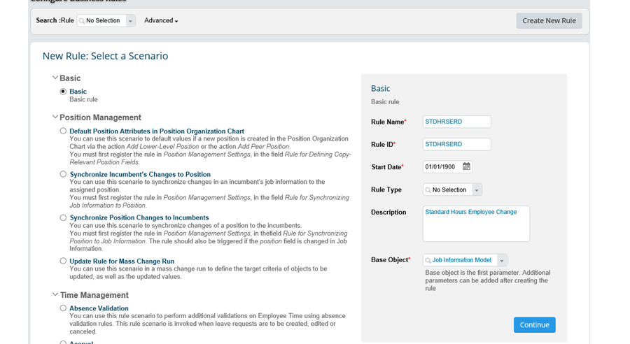

In order to tie the event reason and workflow to the change occurring in the employee files, a business rule must be created. From Admin Center, navigate to Configure Business Rules. This will take you to *Business Rules Admin* tool. You must then click on the plus sign to add a new rule. Because the rule is not related to time off or position management, the Basic rule type is chosen. To create the rule, give it a descriptive name and ID. The ID cannot have any spaces within the name, or it will not trigger correctly. The Rule Type field is optional. This categorizes the rule, so that rules can be grouped together and reported on more easily. You can create new rule types in the Rule Type picklist.

The base object chosen should be where the change is occurring. There are two related to the Job Information portlet: Job Information, and Job Information Model. The *Model*base objects are used to set field properties for EC objects (for example, making a field mandatory, or hiding fields) OR compare the a changed value with the previous value. Each EC object is defined once as a base object, and then as a Model base object.

Because we are changing the value of a field, but not specifying what the new value will be, we must use the Job Information Model base object. This introduces comparative functions such as value and previous value that will track change in a field. Rules for Event Reason Derivation should use the model version of base objects.

**An Example of Standard Hours Changed ERD 4**

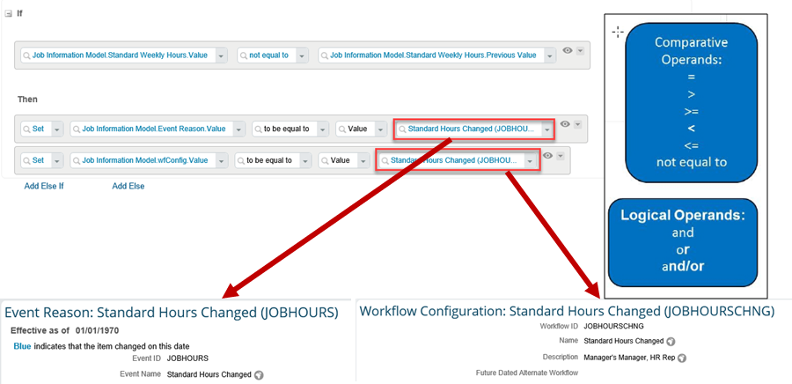

Once the Business Rules details are configured, we are taken to the IF/THEN statement section.

The IF statement is the change in the portlet that is going to trigger the event reason. In this scenario, the value Standard Weekly Hours is changing, so it cannot be equal to its previous value. Using value and previous value allows us to demonstrate a change to a field without having to specify what the new value should be. You can use a mix of the comparative and logical operands shown on the screen to build the conditions for when this rule should trigger.

The THEN statement is where you set the event reason and workflow configuration values to be the records you created in Manage Organization Pay and Job Structures. It is not necessary to include a workflow in every scenario. It is only necessary when additional approval is required for a change.

**An Example of Standard Hours Changed ERD 6**

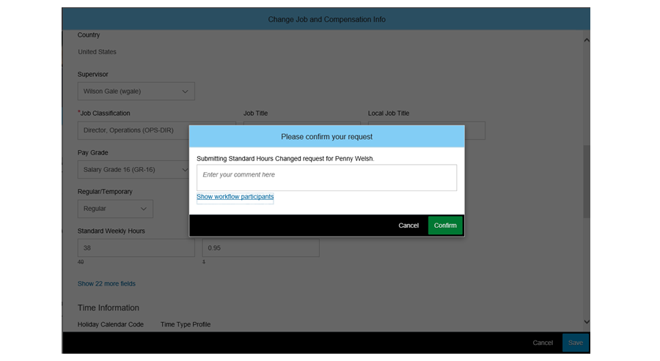

After all of the configuration work is completed, then the rule must be tested. In order to test out Event Reason Derivation, you must go through Take Action→Change Job and Compensation Information. In our example, when we update the Standard Hours and click save, the system automatically confirms that the Standard Hours Changed event reason was chosen, and the correct workflow is triggered.

# Unit 7: Object and Rule Management in the Instance

## Agenda

* Building Meta Data Framework (MDF) Objects for Employee Central (EC)
* Customizing an MDF Object Using Configurable UI
* Creating a Configurable Rule Using the Rules Engine

## 7.1 Building Meta Data Framework (MDF) Objects for Employee Central (EC):

**MetaData Framework (MDF) and Employee Central (EC)**

The Metadata Framework (MDF) is a platform that enables consultants and customers to extend SAP SuccessFactors applications. They can create, modify, maintain, and delete these extensions within the existing UI. These extensions are also known as ***Metadata Objects***.

MDF extends the XML-based configuration and removes the requirement to utilize Provisioning to modify configuration.

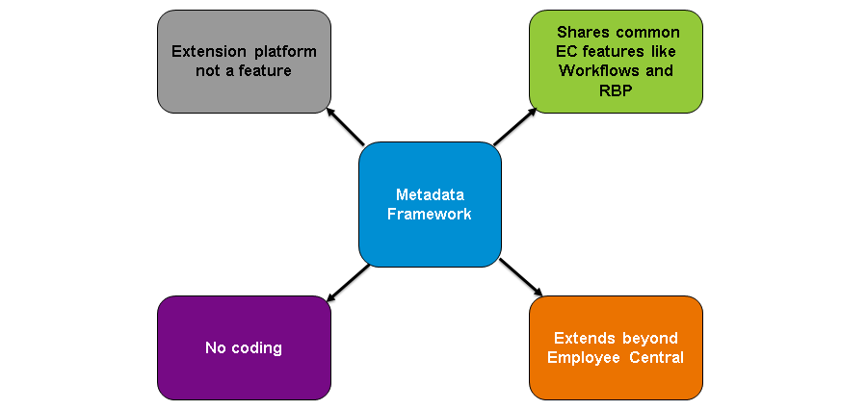

**Configuring objects in MDF**

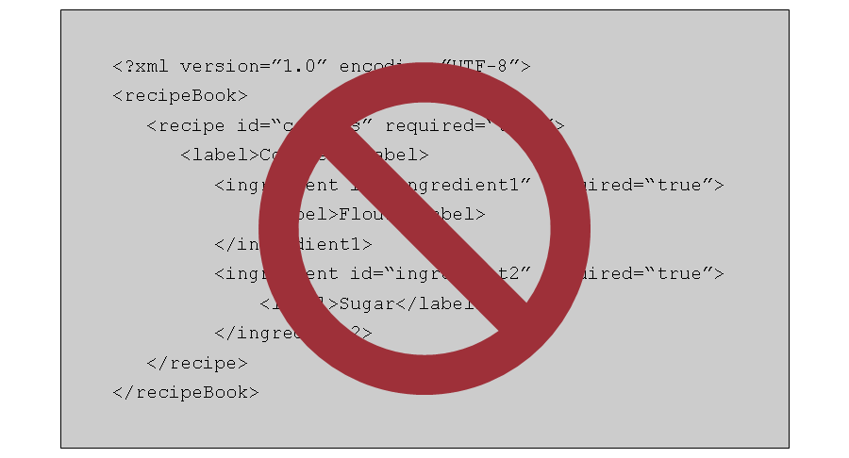

When configuring objects in MDF, there is no XML code. Everything is configured within the instance.

**The Medadata Framework**

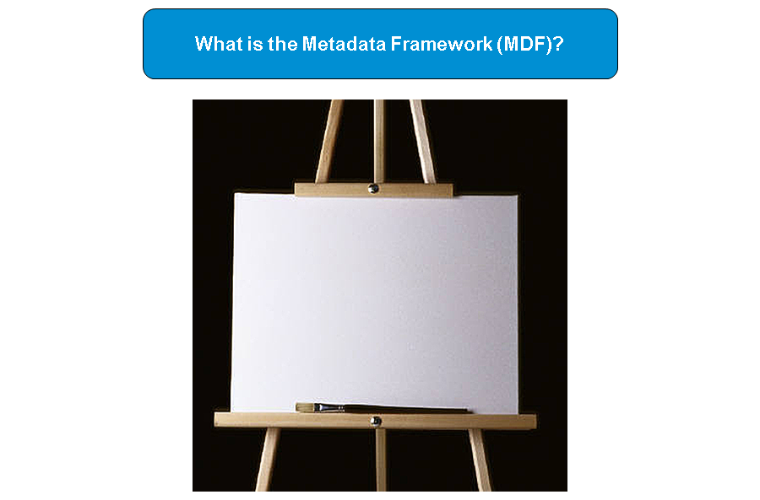

The Metadata Framework is like a blank canvas. You take the requirements you have and you build it. There are a generic set of components available for all MDF objects. These components can be used again and again to fill the requirements you have for that object.

MDF giống như là một từ giấy trắng. Bạn sử dụng những requirements để build ứng dụng. Có các set components available cho các MDF objects, components này có thể dùng đi dùng lại.

However, you can only work with the given size of the canvas. Although MDF objects are highly configurable, there are some restrictions.

**Components of MDF**

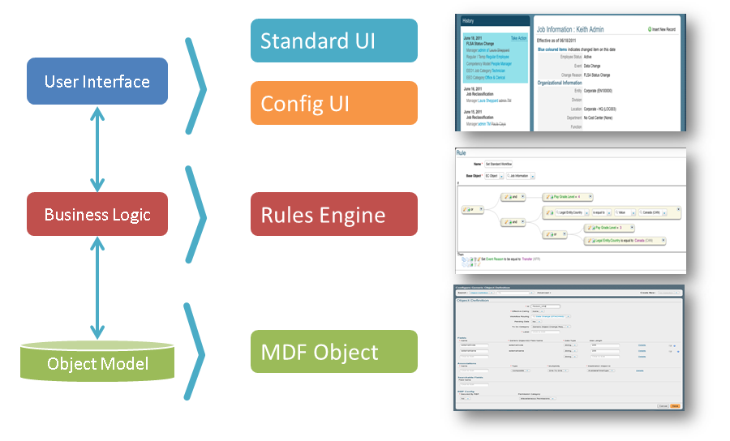

MDF bao gồm nhiều layer. MDF cung cấp các mờ-ce-níc (cơ chế) generic, cấu hình được, mở rộng được để đạt được all layers mà mọi app đều cần. Thông qua cơ chế hoạt động này, MDF promote sự ổn định trong vận hành, look, feel. MDF tránh sử dụng code nhiều và cung cấp nền tảng tuyệt cú để tạo các applications.

**MDF: Multiple Uses (Nhiều ứng dụng)**

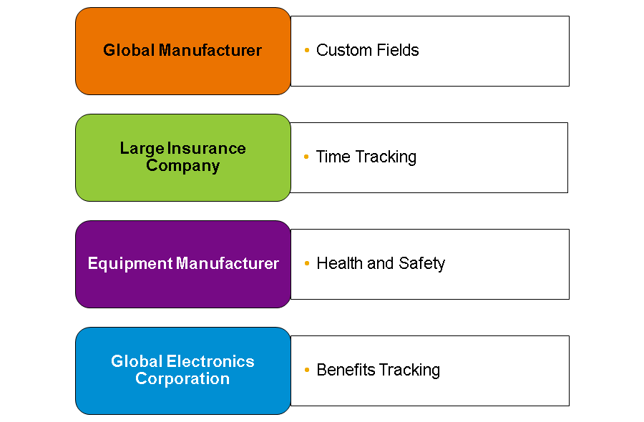

MDF has multiple uses, including the following examples:

***Custom Fields***

Custom fields can be created that reference MDF objects. This is good for fulfilling unique organizational unit requirements. Propagations, workflows, and rules connected to the MDF object will integrate with this custom field.

***Time Tracking***

EC can support time tracking through MDF objects, eliminating the need to buy and implement an expensive and complex time and labor system.

***Health and Safety***

Along the same line, MDF can also track incidents and responses related to equipment and warehouses. You can use analytics to fulfill any reporting requirements needed, as well as have country-specific responses and equipment, aiding the health and safety of employees.

***Benefits Tracking***

MDF can also be used to track benefits. It can communicate with EC to determine eligibility (đủ điều kiện) and create custom objects to ***store benefits data***.

**MDF Limitations**

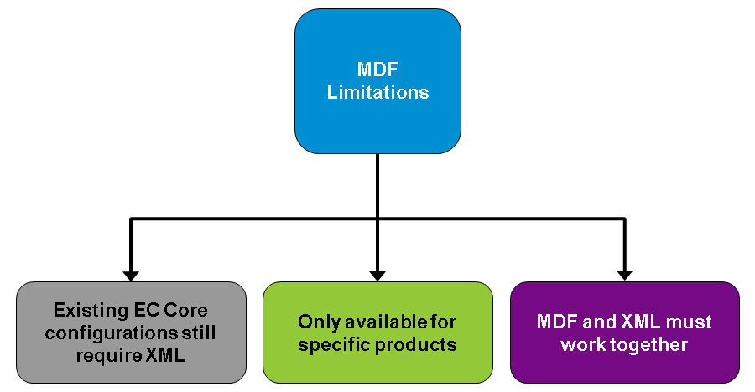

*Configuring items through XML can often cause mistakes in the system, due to the sensitivity of XML coding.*

It is very easy to make one mistake that will affect the entire data model.

***Eventually, the goal is to replace XML coding with MDF for all configurations within the instance.***

However, there are limitations that require us to have knowledge of both systems. ***Many customers are still on legacy systems that require XML for configuration***.

Also, there are still applications that are not configured for MDF.

In order to use MDF capabilities with existing HRIS elements and fields, some additional XML writing must be added to the data models.

## 7.2 Customizing an MDF Object Using Configurable UI:

* *Identify the functions and use cases of Configurable UI*
* *Define the Configurable UI elements and customization process*
* *Identify the available Configurable UI tools*
* *Add a custom UI to the employee files*
* *Create an object for employee assets*

Admin Center -> Configure Object Definitions

**Configurable UI Overview**

Configurable UI allows you to change the visual display of Meta-Data Framework (MDF) objects. The figure, Configurable UI Overview, shows the ***Configuable UI features***.

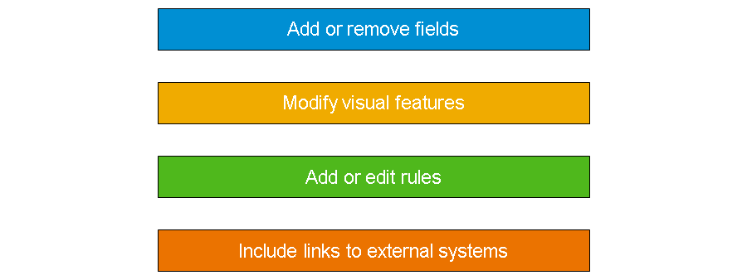

**MDF Object Transformation**

You can ***transform the look and feel of an MDF object***. The figure, Transform MDF Objects, is an example of a standard MDF Object and a customized UI for the same MDF object. For the customized object, the layout is ***streamlined*** and the sections are made ***collapsible***.

**Transform MDF Objects**

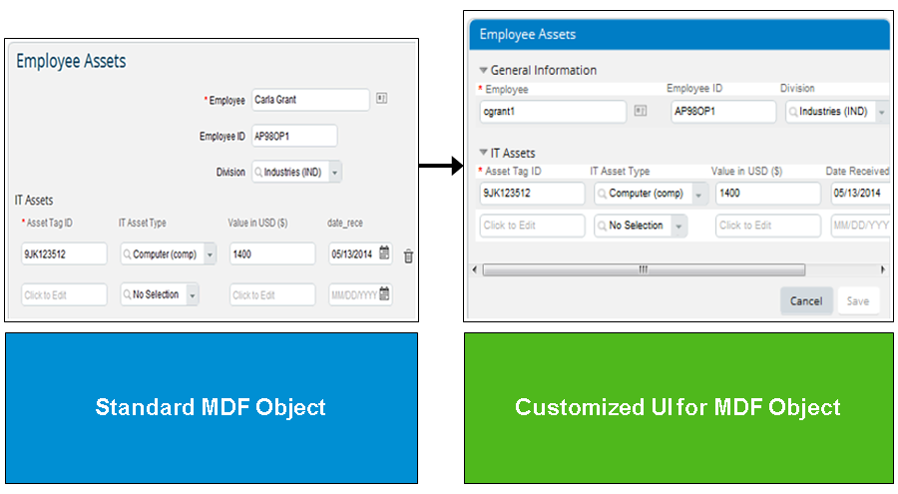

**Use Cases for Configurable UI**

The following list outlines a few of the many reasons to use Configurable UI:

* To extend from the default MDF objects to a custom look
* To increase user-friendliness
* To increase flexibility

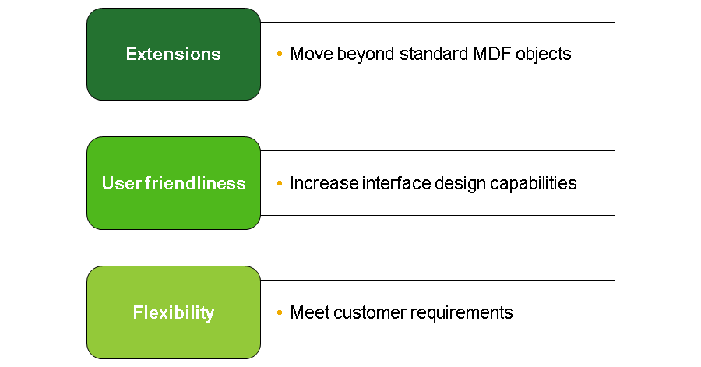

**Configurable UI Requirements**

To use Configurable UI, complete the following steps:

1. Create a new MDF object definition.
2. Add in any custom fields for the object.
3. Save the object definition.

If you want to display the Configurable UI on the employee files, such as*Employee Asset Portlet*, you must set the data type of the *externalCode*field to *User*.

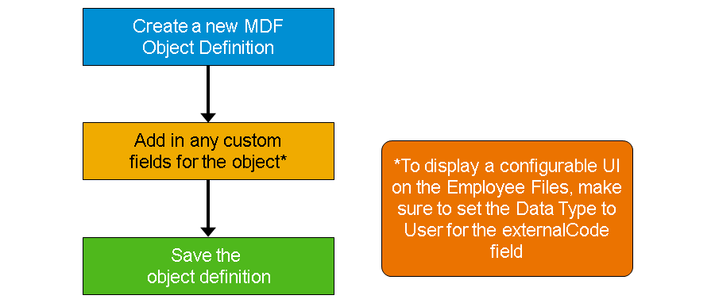

**UI Hierarchy**

*Within Configuration UI, there is a defined hierarchy. Configurable UI allows you to set properties at each level. As shown in the figure, UI Hierarchy, at the top is the MDF object; within the object are groups; and groups can contain fields and links. Fields and links can also exist outside of groups.*

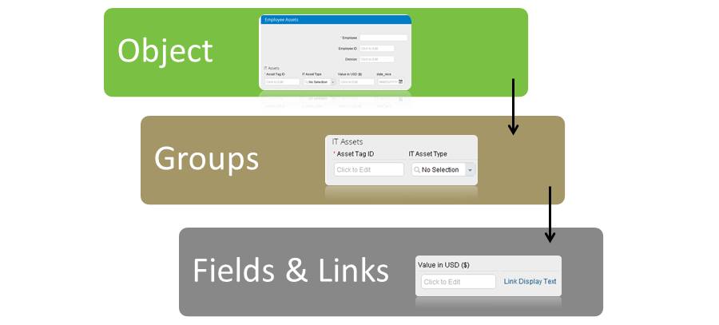

**Resolver**

Another important concept for Configurable UI is resolver. ***Resolver is a way to connect a group or field to one or more fields within an MDF object***. ***The resolver acts as a link between a field on the Configurable UI and the properties of a field in the MDF object***.

Additionally, ***data entered into the field on the Configurable UI is stored as if it were the field in the MDF Object.***

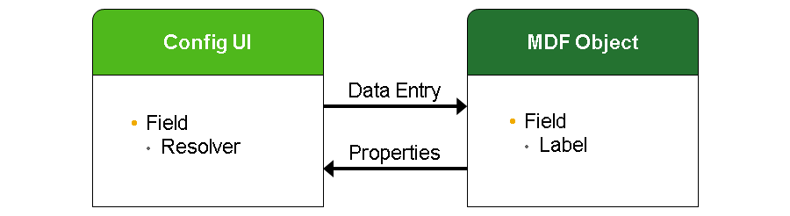

**Rosolver Example**

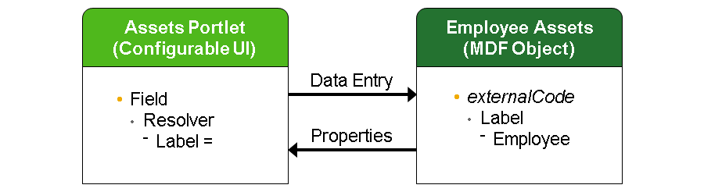

The best way to see how resolver works is through an example. On the left of the figure, Resolver Example, is the *Assets*portlet built from the Configurable UI. On the right is an MDF object for Employee Assets.

To build the *Assets* portlet, we have created a field and used resolver to point to the *externalCode* of the MDF object. By making this connection, the system pulls the field properties, including the label, Employee, onto the *Asset*portlet.

This means that the field appears with a label of *Employee*. Also, when data is entered into the field on the *Assets* portlet, it will be stored in the *Employee* field of the Employee Assets MDF Object.

**Configurable UI Access and Functions**

To access Configurable UI, navigate to *Manage Configuration UI*. On the *Search* selector, you can select and edit existing configurations or create new custom layouts for objects.

**Accessing Configurable UI**

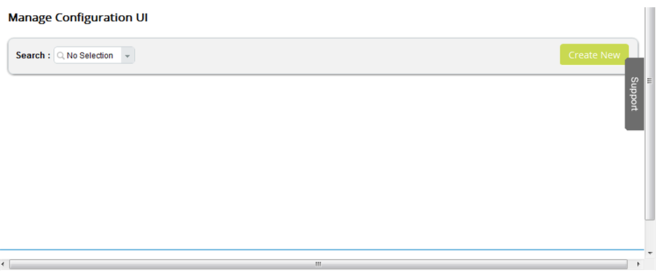

**Base Object**

*For every Configurable UI, you must select a base object*. ***The base object is a reference to the MDF object definition you created***. *When you create a new Configurable UI, the system displays the default layout of the object. From the default layout you can configure the object to meet the customer requirements.*

The figure, Base Object, illustrates the steps required to display a base object for configuration, as follows:

1. Provide an ID
2. Select the MDF object to configure, that is *Base Object*

Once this is done, the system displays the current object in the #3 section of the screen, as shown in the figure.

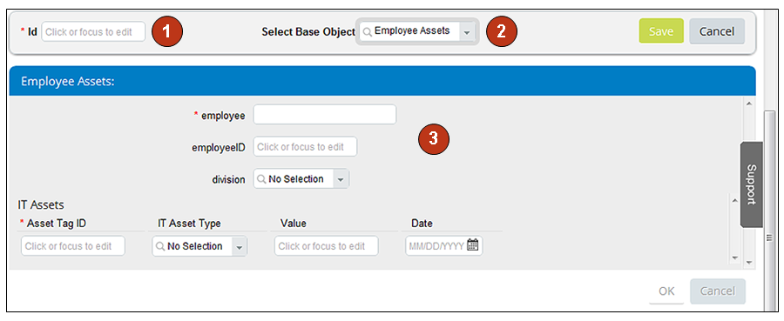

**Object Configuration**

To begin configuring the object, you can use one of the following options:

* ***Title and Object Rules Toolbar***
  + This toolbar allows you to add UI rules to the object as well as edit the object title.
* ***Configure Object Toolbar***
  + The Configure Object Toolbar allows you to add fields, links, groups, as well as edit the properties for the object.

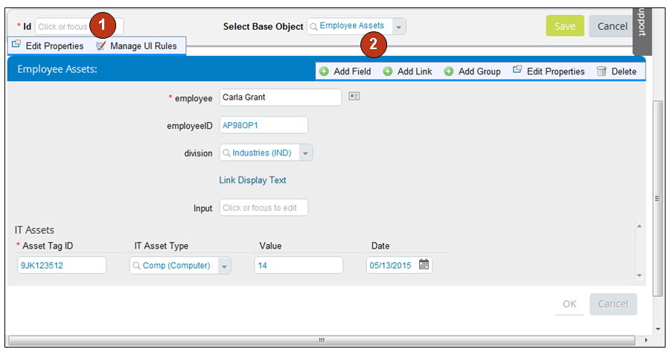

**Title and Object Rules Toolbar**

The Title and Object Rules Toolbar allows you to add UI rules to the object as well as edit the title of the object, as follows:

* Edit Properties
  + Configure Object Title settings
* Manage UI Rules
  + Add new business rules to the object

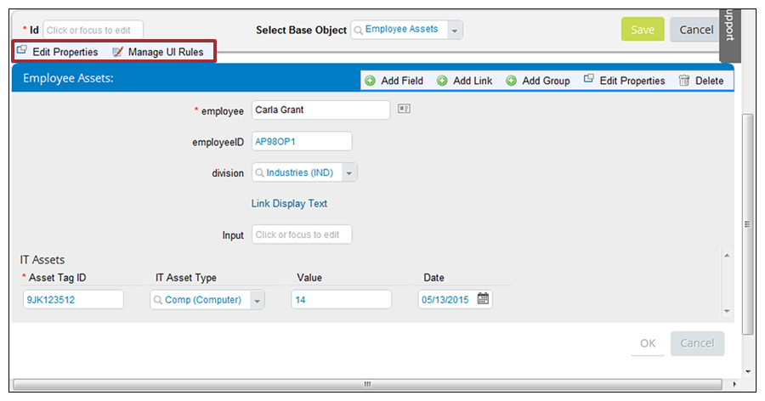

**Object Toolbar Configuration**

The Configure Object Toolbar allows you to add fields, links, and groups, as well as edit the properties for the object, as follows:

* Add Field
  + Insert new field onto object
* Add Link
  + Insert clickable hyperlink onto object
* Add Group
  + Insert new area to group containing fields and links
* Edit Properties
  + Set object display settings

**Configure Object Toolbar**

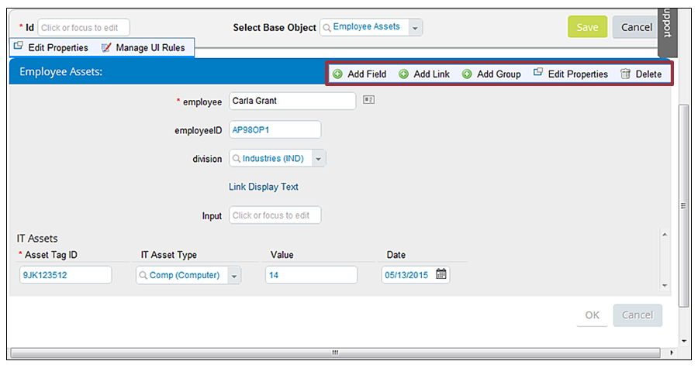

**Object Layout Options**

Within the object and within a group, you can change the layout option. There are three layout options: Form, Flow, and Grid.

**Form** displays fields from top to bottom in the middle of the object.

**Flow** displays fields in a row and attempts to continue the row of fields where possible. When the layout runs out of run, a new row appears below

**Grid** displays fields in a row but only displays the number of fields specified for the grid.

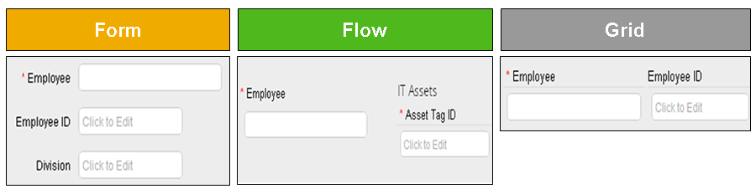  
**Group Configuration**

When configuring a group, you can hover over the group to see the Configure Group Toolbar. On the toolbar, click to add fields, links, groups, and *Edit Properties*. The edit properties option is similar to object properties except that *Edit Properties* offer an additional option to hide nested groups. In the figure, Configuring a Group, you can see the difference between Hide Nested Group set to Yes and Hide Nested Group set to No.

**Configuring a Group**

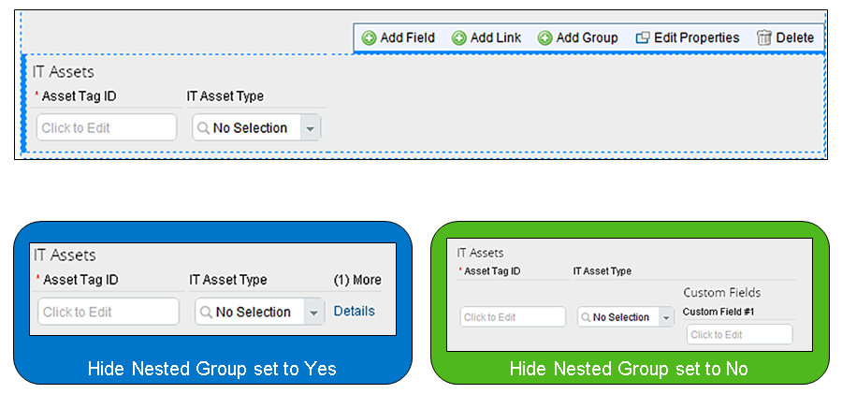

**Field Configuration**

To configure an individual field, hover over the field. You can then select *Edit Properties* or *Delete Field*.

Hover over a field to see the following options:

* Edit Properties
  + Field properties are similar to Group properties.
* Delete Field
  + There is an additional option to Hide Nested Group.

**Configuring a Field**

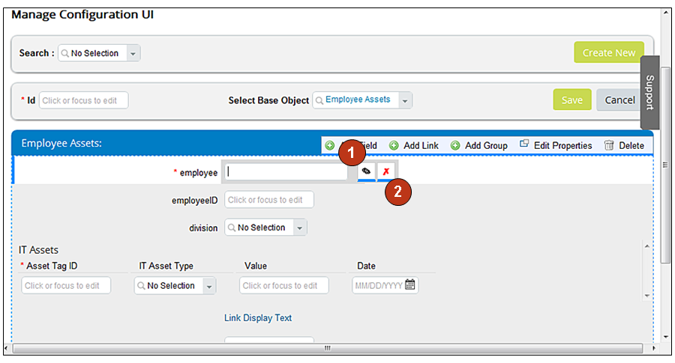

**Group and Field Arrangements**

You can also drag and drop fields and groups to rearrange the layout of the object. First, click the field or group and drag it to the desired location. As soon as the green shading appears, release your mouse to move the field or group. The new location of the field or group displays.

**Arranging Groups and Fields**

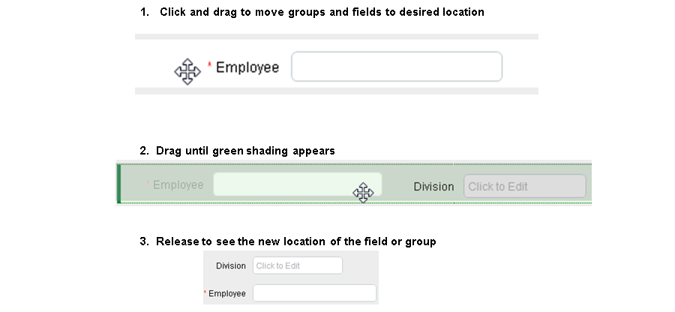

**Custom UI for Employee Files Process**

The figure, Custom UI for Employee File Basic Process, outlines the basic ordered steps to setting up a custom UI to add to the Employee Files.

**Custom UI for Employee File Basic Process**

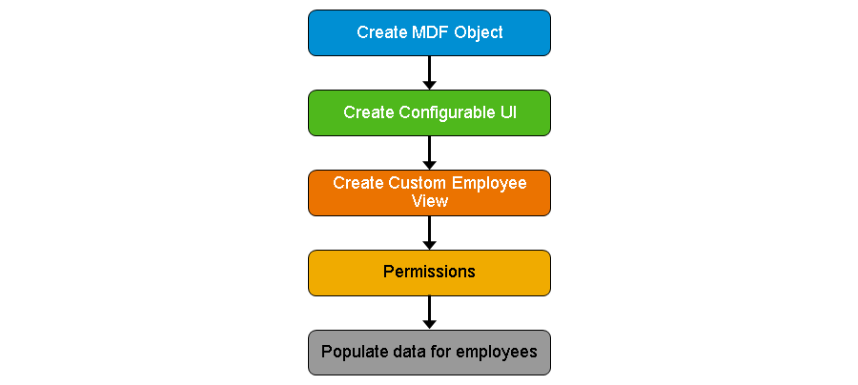

**MDF Object Creation**

To display a Configurable UI on the Employee Files, complete the following process:

1. Create a new MDF object definition
2. Set the Data Type to User for the *externalCode* field
3. Add in any custom fields for the object
4. Save the object definition

The process of creating an MDF object requires that you set the data type for the *externalCode* field to *User*. This requirement binds the custom UI and MDF object to each employee in the system. In this way, all employees have a set of data on their Employee Files.

**Create MDF Object**

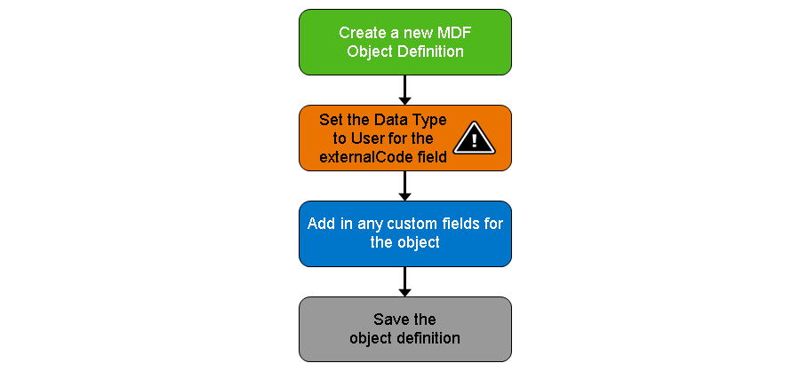

**Configurable UI Creation**

To create the Configurable UI for the MDF object, complete the following process steps as outlined in the figure, Create Configurable UI.

**Create Configurable UI**

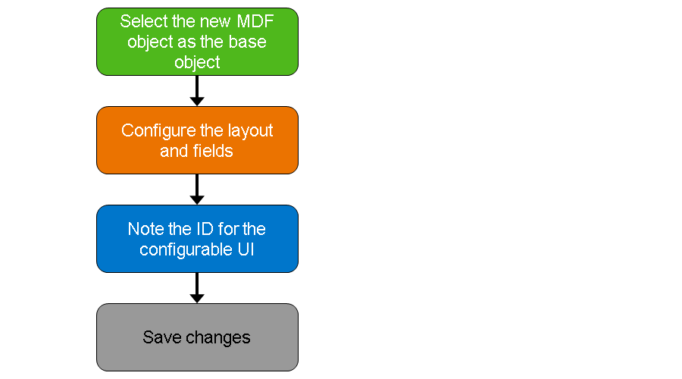

**Employee View Creation**

To add the object to the People Profile, first create a new employee view. Navigate to *Admin Center* and complete the following steps:

1. Choose *Employee Files* → *Configure People Profile*.
2. Navigate to *Custom Blocks > Live Profile MDF Information*.
3. Drag Live Profile MDF Information block to preferred area on People Profile.
4. Select th e appropriate Configuration UI.
5. Save the new layout.

**Create Employee View**

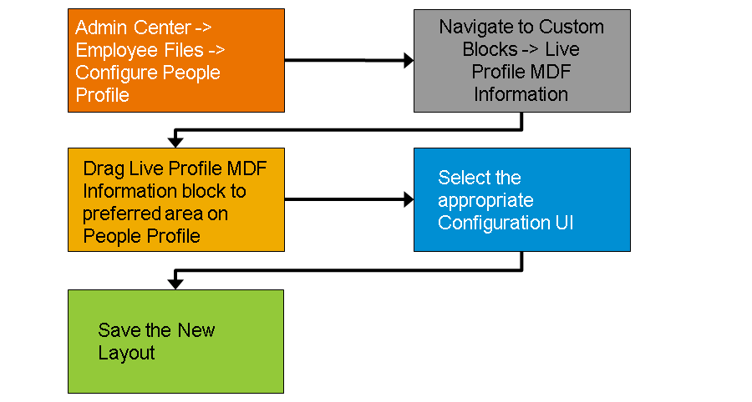

**Permission Roles**

*Once you have set up the new employee view, update the following permission roles for viewing in RBPs, as necessary:*

* *Employee Views*
* *Miscellaneous permissions (if field level permissions are required)*

**Data Population for Employees**

*Lastly, you will want to populate data for the employees. You can either complete this manually through the Manage Data Section or by importing the data for the employees.*

*To populate data manually, navigate to Manage Data.*

*Alternatively, to import data, navigate to Import Export Data.*

*You must populate the initial data for employees before viewing it on Employee Files.*

**Manage Data Population**

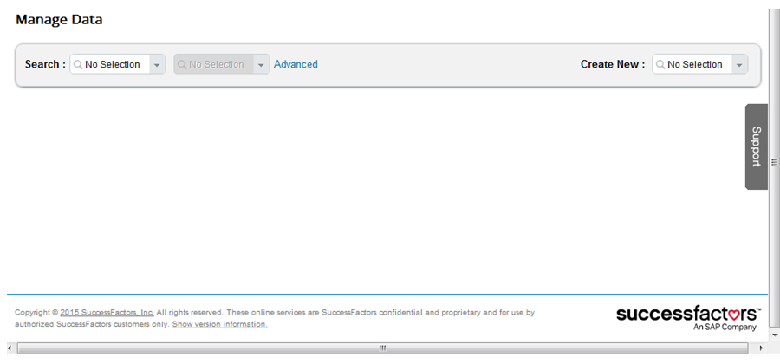

**Customer Scenario**

*Here is the scenario: the customer wants to track assets that are held by employees. The general requirements are that IT assets such as computers, smartphones, tablets, and so on, are stored within EC for tracking and IT should be able to run audit reports and review distributed assets. The additional requirements are that the assets display on the respective employee file and the sections of data collapse and expand to show additional information.*

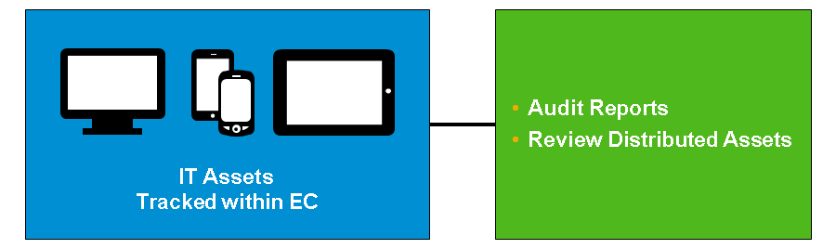

**MDF Object Definition**

Using the requirements, you can create a basic MDF object with the default configuration, as shown in the figure, MDF Object. This object includes fields, an association to another object (IT Assets), as well as a custom picklist for IT Asset Type.

**MDF Object**

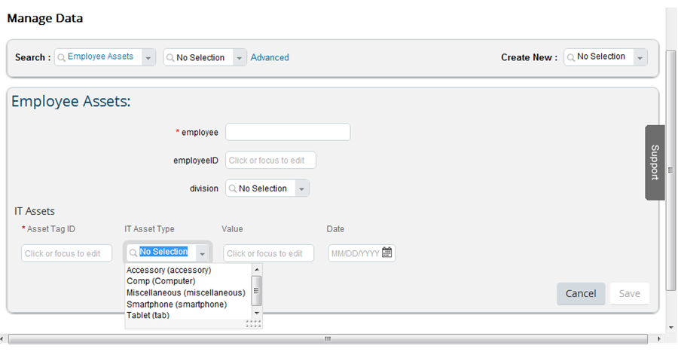

**Configurable UI Customization Process**

The default configuration does not expand and collapse according to the additional requirements. To meet these requirements, create a custom UI.

**Config UI Customization**

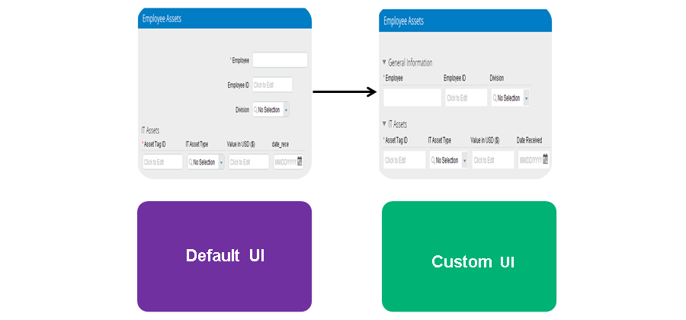

**Steps to Customize the UI**

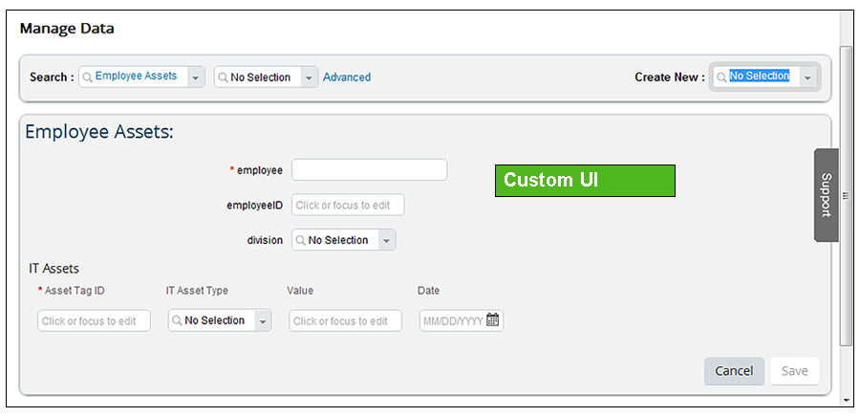

To customize the UI, complete the following process:

1. Add a new group.
2. Move the *Employee*, *Employee ID*, and*Division* fields to the new group.
3. Edit the *Group Properties*, as follows:
   1. Set *Layout* to *Grid*.
   2. Set *Collapsible* to *Yes*.
   3. Set *Default Collapsed* to *No*.
   4. Set  *Title* to *General Information*.
4. Edit *IT Assets Group Properties*.
   1. Set *Layout* to *Grid*.
   2. Set *Collapsible* to *Yes*.
   3. Set *Default Collapsed* to *No*.
5. Delete any additional fields.
6. Move *General Information* above *IT Assets*.
7. Save.

**Employee Files Display**

To display the custom UI on the employee files, complete the remaining steps in Custom UI for Employee File Basic Process, which includes: creating the employee view, updating the permissions, and populating data.

**Display on Employee Files**

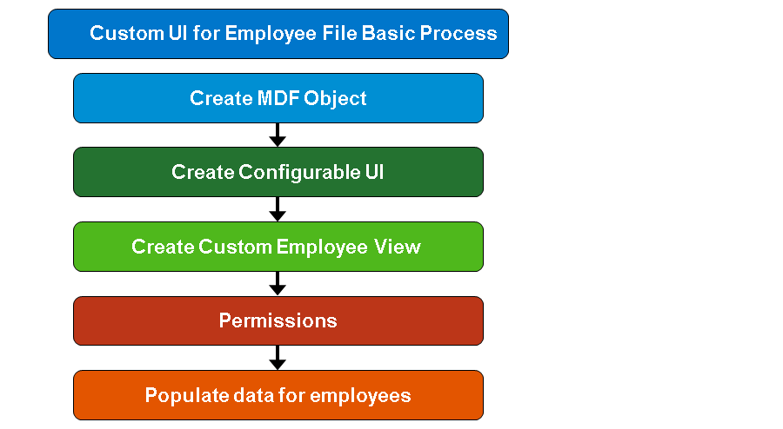

**Employee Files Final Result**

The final result is an *Employee Assets*portlet that meets the general and additional requirements by including the collapsible sections with a grid layout for a cleaner look. There is more than one way to meet customer requirements. Final Result on Employee Files, is an example of the process of transforming the requirements into completed configuration.

**Employee Assets**

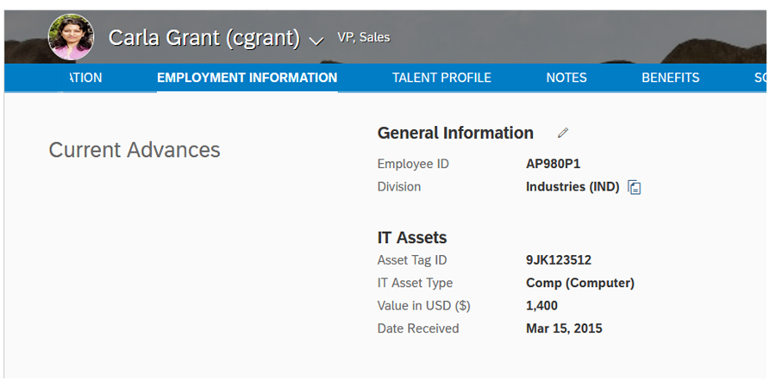

## 5.3 Creating a Configurable Rule Using the Rules Engine:

* Describe the main attributes of the Rules Engine
* Describe the Rules Engine logic types
* Apply rules to the Configurable UI
* Locate rule events
* Assign rules to Human Resource Information System (HRIS) elements and field events
* Create a configurable rule for use in existing EC objects

**Rules Engine**

MDF Rules, such as the following, cung cấp giao diện đồ họa đầy đủ dễ sử dụng để thực hiện các business logic đơn giản:

* Khởi tạo giá trị mặc định for field(s) within an object
* Changing the value of field(s) based on the selection of a value in another field (**propagation**)
* Validating the set of values in the fields before saving an object instance and firing off a validation message in case of an error

Nói về Validate giá trị các trường trước khi save một object instance.

* Creating *Dynamic UI Behavior*: for example, hiding or showing a field or a group of fields

**Rules Engine Overview**

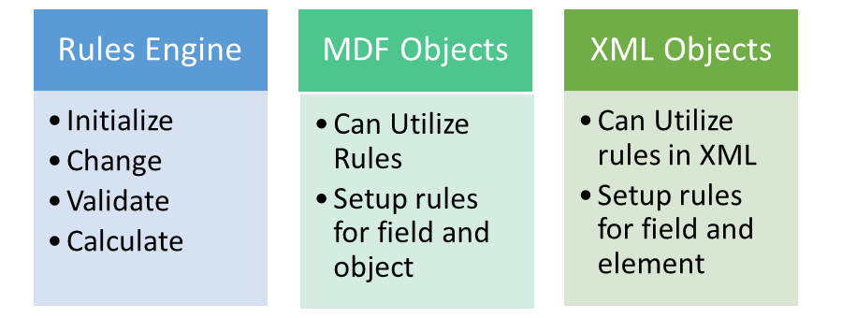

**Rules Engine Uses**

Rules được dùng cho những task sau như là cách để duy trì app logic ổn định khi mà diễn ra một event:

* *Trigger an approval*
* *Trigger an error message or additional information*
* *Auto-fill data*

Rules can provide a way to keep check on data changes (by triggering an approval) or alert the user of an error or warning around adding information.

Time zone information is one example of how rules can also be used to auto-fill field data. In this example the auto-filled data is based on location information.

The Rules Engine allows you create rules using **If**and **Then** logic. These rules can be attached to objects and can provide business logic or validation of data input.

**Rule Logic**

The **If** logic uses “and”/”or” statements to determine when the **Then** logic should be executed. The following list provides examples of when **If**logic is used:

* *If a particular option is chosen from a picklist*
* *If specific text or numbers are entered into a field (or if they are greater than or less than the values stated)*
* *If specific user information is added, such as location*

**If**logic ***can also*** be set to “always true”, which means the **Then** logic is automatically executed when the rule is triggered.

**Additional Rule Logic**

When an **If**condition is not met, the system evaluates **Else If** logic. **Else If**is used when the **If**statement is not true. Examples of when **Else If** is used include the following situations:

* A specific picklist option is NOT chosen
* If certain text or numbers are NOT entered into a field (or if they are greater than or less than the values stated)

**Rule Actions**

The Then logic determines the value to be set or the message to be raised when the If logic condition(s) are met.

There are **three** actions that can be triggered within Then logic, as follows:

***Set***

*This automatically propagates information based on existing information or a specific value chosen.*

***Raise message***

*This brings a popup box up on screen that provides additional information to the user filling in the information, or an error message that something was done incorrectly.*

***Create***

*This creates a child object. Examples include adding a new pay component to an employee, or creating an other child object attached to the parent object.*

***Delete***

*Delete data from the database when a rule is triggered. For example, you can remove a pay component when the employee moves away from London.*

***Execute***

*Carry out specified action when rule is triggered.*

**Additional Rule Actions**

Actions associated with **Else** logic occur when the actions under the **Then** logic are not triggered because the **If**statement is NOT true.

**Rule Example**

The following rule and action is required when creating a new Position Object using MDF:

* The start date for a new position can only be a future date. Create a pop-up message that states “The start date must be a date in the future.”
* The message appears after a Position ID is added.

**Rule Type Picklist**

***Rule types are a way to sort the rules into different groups***. You can create your own rule types. SF suggest you use the rule type to sort the rules according to what they are used for, for example, to differentiate Time Off rules from Position Management rules.

Rule Types are defined in a picklist with the code RuleType.



**Rule Action Options**

We have 5 choices for the rule action: set, raise message, create, delete, and execute. Since we want this rule to trigger a message that pops-up on the screen, so the **Then** action type for this rule will be a *raise message*. Because of this, we need to first create the message that will pop up before creating the rule, as follows:

1. Go to *Employee File* → *Manage Data* and under *Create New*, choose *Message Definition*.
2. For the external code, we will use start date and the text will be the alert content.
3. Click *Save*.

**Rule Action**

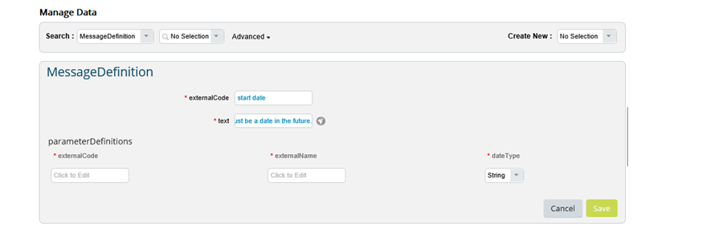

**Rule Creation**

To create the rule, navigate to *Company Settings* → *Configure Business Rules and Choose + To Create New Rule*.

Fill in the rule ID and name, and the rule type that we created. The base object that we choose is very important. This is the most basic object with which we are working. For example, let us say we associated object red with object blue. Object blue is the main object and is the one we choose when creating a record. However, if we want the rule to occur on a field within object red, we choose object red as the base object.

For the position object we do not have any associations, so our base object is going to be position.

**Create Rule**

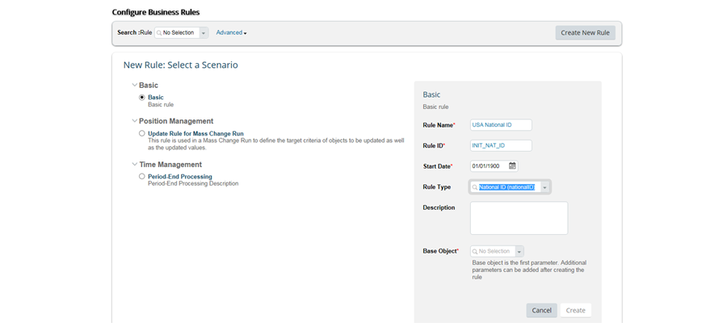

**If Logic**

Now we need to determine what **If** statements need to occur in order for this message to be raised. Since we want the message to be raised anytime a position ID is added, there are no specific requirements needed, therefore we will choose “always true”.

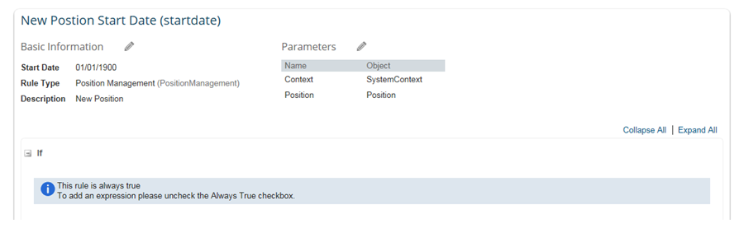

**Then Logic**

Next, we need to add our**Then** statement. Click on the *Pencil*, and then choose *Raise Message* as the output type. For the message, we can choose the message we already created, or *startdate*. For severity, because this is just a friendly reminder before the information is added, we will choose*info*.  Then we want to associate the message to a certain field. Because this message has to do with information we add to the *Start Date* field, we choose *startdate*. Finally, we click *Save*.

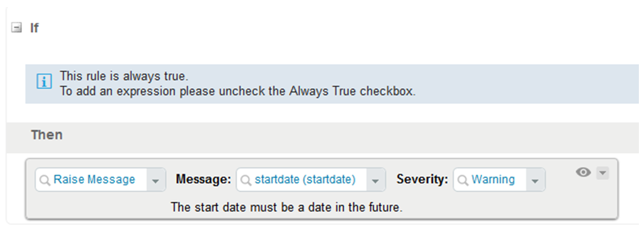

**Rule Events for HRIS Elements**

There are 6 types of rule events associated with HRIS elements and fields. Use the figure, Rule Events, and the Business Rules Implementation Guide, to determine where to assign the rule event.

**Rule Events**

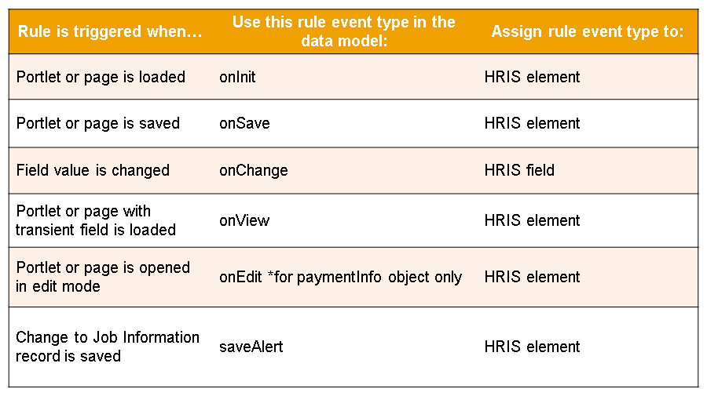

**Rule Event Locations**

The figure, Rule Event Locations, displays a graphical overview of the relationship between events and pages on the user interface where they can be used.

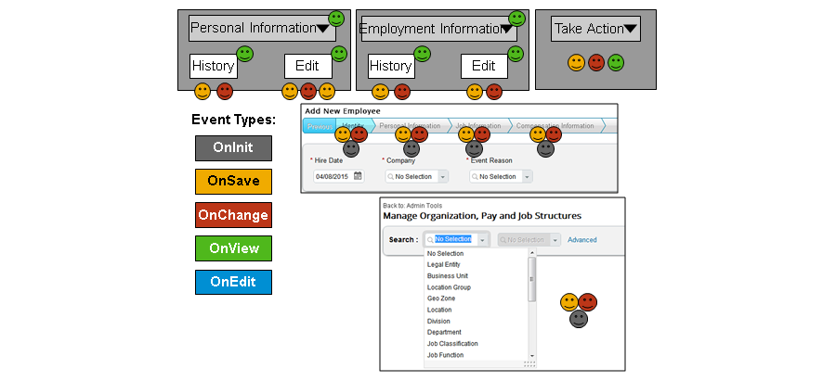

**Assign Rule Events in XML**

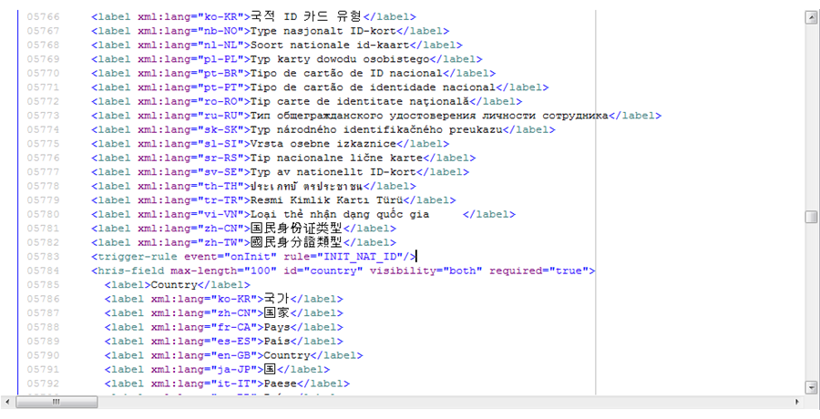

**MDF Rule Events**

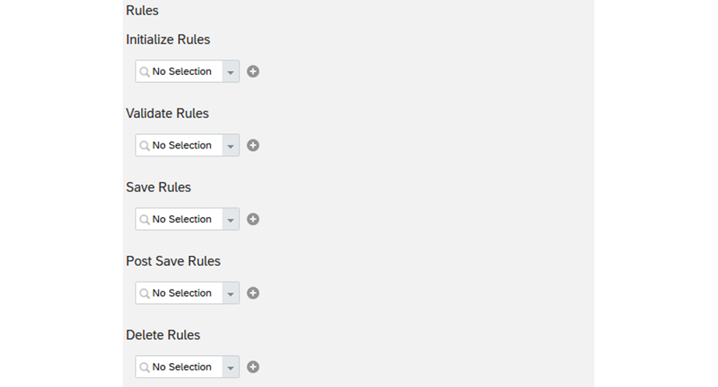

MDF Rule Events are similar to HRIS Element Rule Events. The table describes the options:

|  |  |
| --- | --- |
| **Rule Event** | **Description** |
| initializeRules | Initialization rules ("initializeRules") are triggered in the initialization phase of object creation (an "onInit" event). You can use these rules to initialize fields to default values. OnInit is basically a constructor and no context parameters are provided by onInit. |
| validateRules | Validation rules ("validateRules") are triggered after a change to an object is submitted but before the change is saved (an "onValidate" event). You can use these rules to validate field values. |
| saveRules | Save rules ("saveRules") are triggered when a user tries to save changes to an object (an "onSave" event). You can use these rules to check related field values for correctness. For example, a field could become required as a consequence of a save. |
| postSaveRules | Post-save rules ("postSaveRules") are triggered after changes to an object have been saved (an "onPostSave" event). These rules are used when you want to send an alert message to the user. They are not used to set a field value. To activate the alert and notification feature, you must associate them with a workflow. |
| deleteRules | Deletion rules ("deleteRules") are triggered after an object record is deleted (an "onDelete" event). |
| onChangeRules | Change rules ("onChangeRules ") are used at the field level. Objects cannot be associated with change rules. Change rules are triggered when the value of a particular field is changed. You can use these rules to populate another field after the change. |

**Business Rules Context**

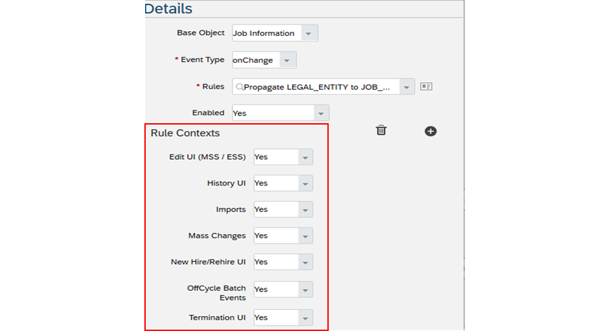

You can add context to onSave and onChange rules in the ***Manage Business Configuration*** to prevent triggering unnecessary rules in a given context, which in turn can improve system performance.

*You do not have to add contexts to rules. If no contexts are set, then the rules are triggered when the IF statement(s) the rule are met. By adding context, you limit the situation where rules are triggered. If you select specific contexts, the rules will be exclusively triggered in the contexts checked.*

You can limit the triggering of rules to the following contexts:

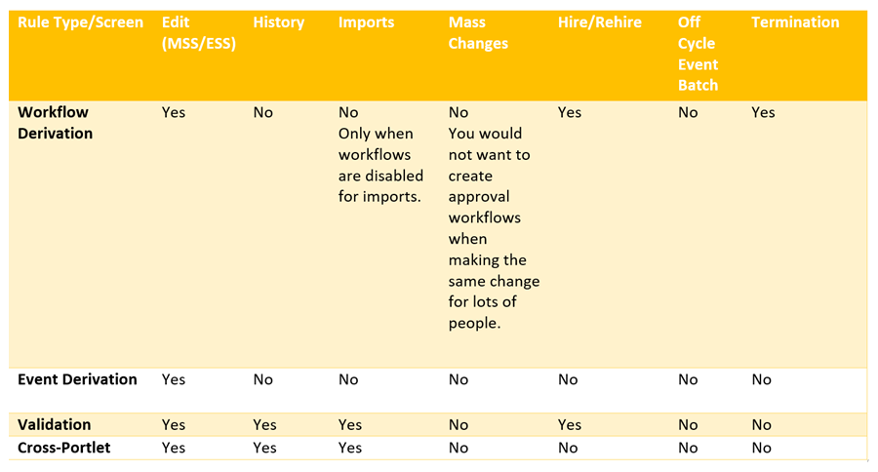

**New Hire Rules**

Rules also allow you to automatically set fields on initiation, or when an object or section is first opened. For example, you can set certain fields to automatically populate in the *Add New Employee* section of the instance.

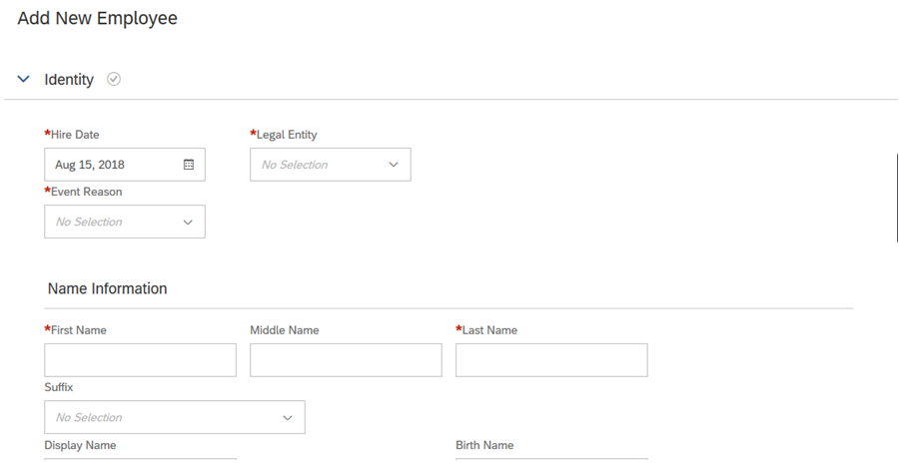

**New Hire Rules Example**

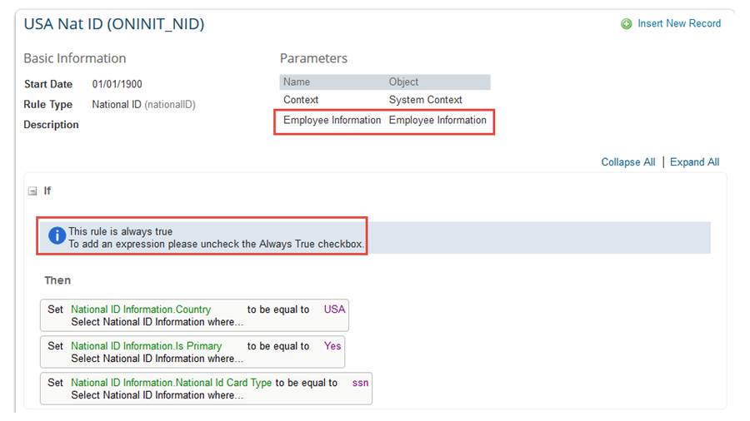

The figure, New Hire Rule Example, shows you how to automatically populate areas, like the national ID, for new hires.

Because this is an on initiation rule, we want it to always trigger and the **Then** settings to be defaulted. Therefore, the **If** section will be marked“always true”. The **Then** section is where we determine our default fields. Choose employee information so the values are ***only to be defaulted when the administrator adds a new employee in the system***. The rule will not take effect on other screens. Next, we choose the area where we want the fields to be defaulted, or national ID. We have set three specific fields: Primary = Yes; Country = USA; and National ID card type = social security number, or the ID which is ssn.

**Rule and Data Model Connection**

Next, we need to connect the rule to the appropriate section. As national ID is not an MDF object we created, but an element in the XML, add an XML line to the appropriate data model.

For the Succession Data Model XML, use the following code:

<hris-element id=“nationalIdCard”>

<trigger-rule events=“onInit rule=“ONINIT_NID”/>”

<hris-field max-length=“100” id=“country” visibility=“both” required=“true”>

To trigger the rule, add <trigger-rule events=“onInit rule=“ONINIT_NID”/>” to the national ID element in that model.

You select the rule event onInit because you want the default values to show up as soon as the administrator opens the ***Add New Employee*** screen, independent of any values that the administrator might add on this page.

**On Initiation Rule**

Once the updated data model is imported to Provisioning, the *Add New Employee* screen will automatically fill in the 3 fields shown in the figure, On Initiation Rule.

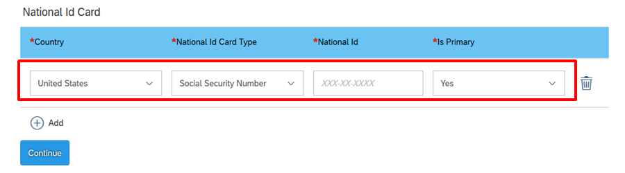

# Unit 8: Position Management

## AGENDA

* Setting Up Position Management
* Company Structure Overview
* Leave of Absence
* Contingent Workers (đội ngũ kế cận)
* Dependents Management (quản lý người phụ thuộc)

## 8.1 Setting Up Position Management:

**Position Management**

Position management allows you to create, maintain, staff, and activate positions in administration tools. It also allows you to display a position hierarchy that can be different from the reporting structure. Currently, Position Management is optional within Employee Central (EC).

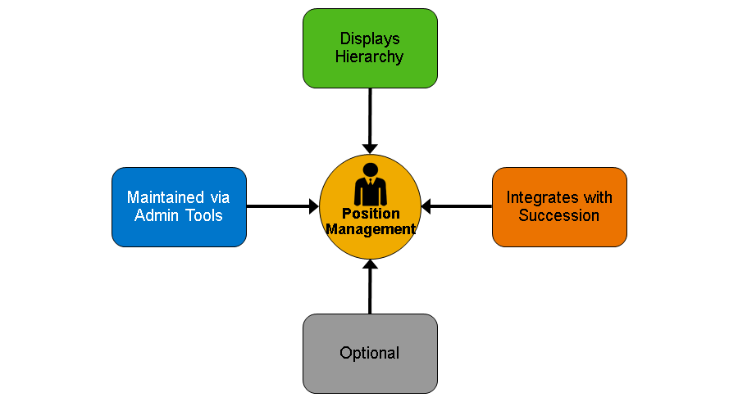

**Position Organization Chart**

In your instance, navigate to Company Info, to see an option in the top left-hand corner to switch to **Position Org Chart**. The Position Org Chart is more focused on the positional structure of the company, and allows you to take several actions on positions. (position org chart tập trung vào cấu trúc cty theo **vị trí**, several actions on positions).

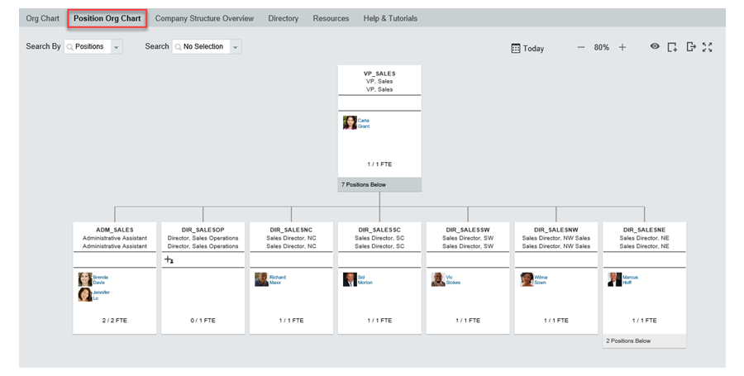

**Position Org Chart Display Options**

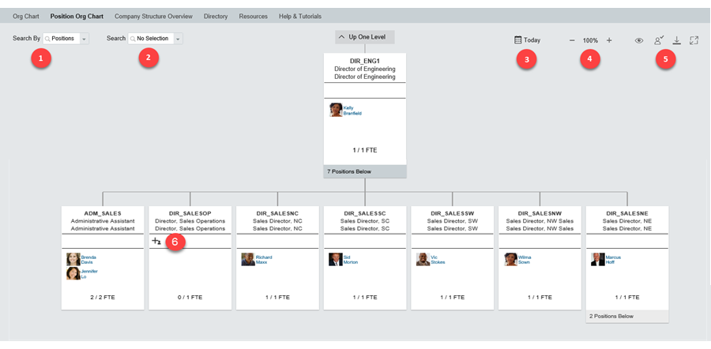

There are several different ways to control the visual aspects of the Positional Org Chart as shown in the figure, Position Org Chart Display Options:

1. Determines the search criteria for the org chart. You have two options, Positions or People
2. If you choose to search by Positions in #1, then this allows you to search the chart by Position Name, Position ID, or any other search-able fields configured on the Position Object If you choose People in #1, this allows you to search the chart by a combination of first name, last name, and/or username
3. Is defaulted to today's date, but allows you move the date to any in the past, present or future to see the Positional Org Chart setup as of that date
4. Allows you to zoom in and out of the org chart to better see all positions on one screen
5. Contains additional visibility options, such as turning on and off the display of child, matrix and inactive positions or hire a new employee. You can also add a new position or hire a new employee directly on this screen or export this display as a pdf or jpeg
6. Is the "to be hired" graphic. You can choose when this graphic displays using the Position Management Settings tool

Please note that all of these capabilities are based on the role based permissions assigned to the user viewing the org chart.

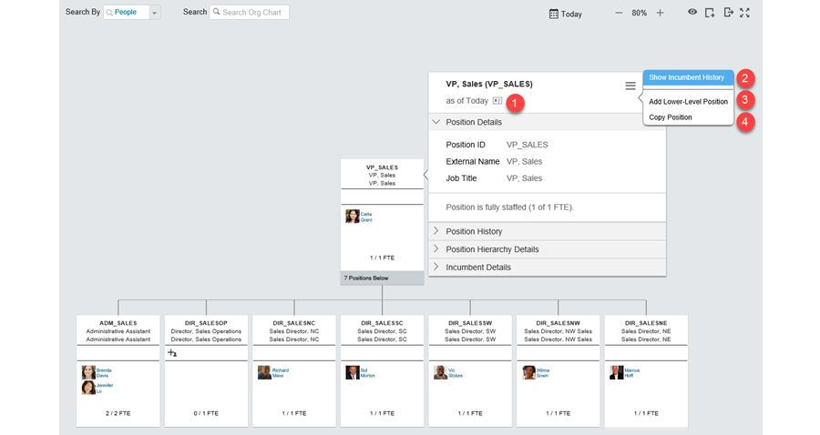

1. In your instance, go to *Admin Center*
2. Navigate to *Company Info -> Org Chart*
3. In the top right-hand corner, switch from the basic or traditional Organization Chart to the Position Organization Chart
4. To display the different areas of the position options, on the left-hand side of the screen, choose *Positions*, *People*, and *Display Options*

Position Management Options



There are several actions that can be taken directly on a Position record, as shown in the figure, Position Management Options:

1. Allows you to view the entire position record. Within there you can change the view date of the position, edit the position, or be navigated to the Manage Positions tool for additional options.
2. Shows the incumbent history over time. You can adjust the date ranges to view which employees held the position during that time.
3. You can add a lower level position directly from this screen. A business rule can be used to determine what fields would copy over from the parent position to the child
4. You can also copy a position on the org chart. When you choose to copy a position, you can state how many copies you want made. All of the copies will have the same parent position and the same field values. The externalCode or Position ID will be automatically generated.

*Configuration UIPosition Org Chart*

**Positional Organization Chart Administration**

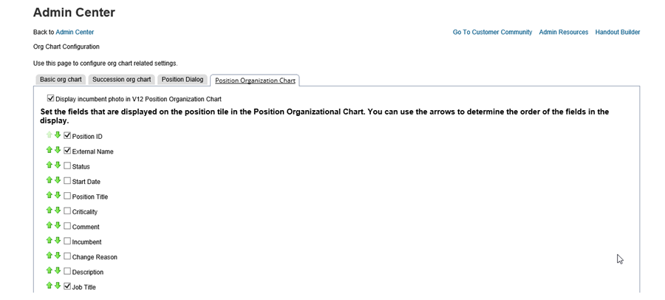

Basic position Org chart configuration can be configured via the Org Chart Configuration tool in the Admin Center. This includes the ability to determine if the photo of the incumbent displays, and the fields that are displayed on the position tile.

The side panel of the Position Org Chart can also be configured in this menu. Sections within the side panel, such as Position History, Hierarchy Details and Global Assignment can be enabled and reordered here.

**Position Management Permission Settings**

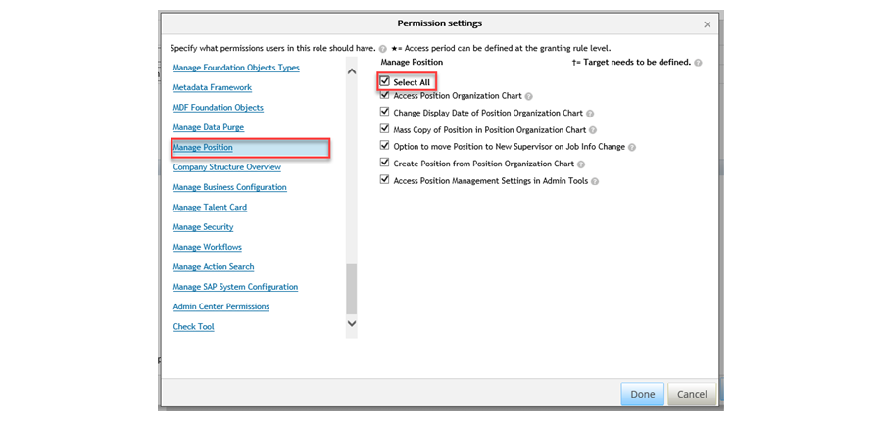

In order to gain access to the position org chart and configure what actions you can take, you need to assign the appropriate permissions in the Manage Position section. ***This is also where you can grant access to the Position Management Settings tool.***

**Position Management Settings Tool**

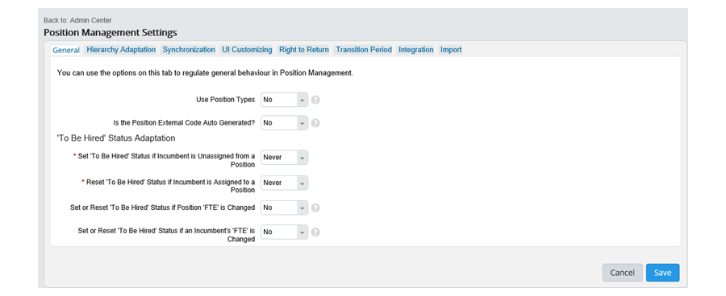

**Position Check Tool**

The Check Tool has now added an option to ***export*** Position Management Settings, Position Object Definition, assigned rules and results of the other checks provided in the check tool in one single file. This is very helpful as it ***creates a technical file of settings and configurations*** for customer support to analyze if there are any issues with the customer’s configurations. => rất hữu ích khi tạo ra một file cài đặt và cấu hình chuyên sâu để customer support phân tích xem nếu có lỗi.

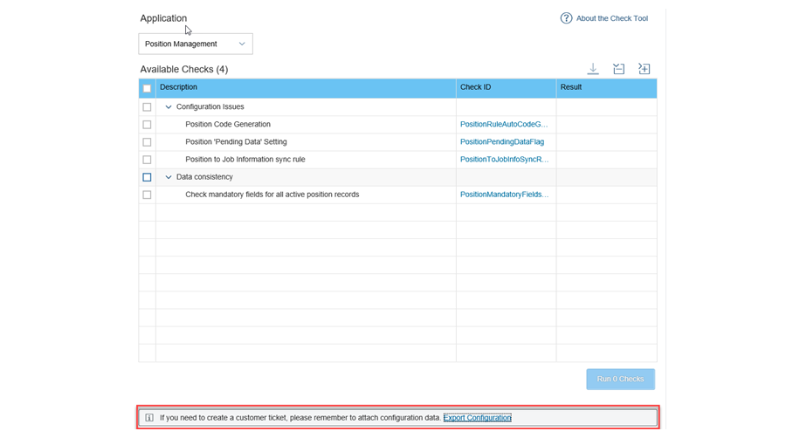

**Position Management Setup**

Enabling Position Management set up is a two-step process. *First, both Position Management and Generic Objects need to be enabled in Provisioning*.

*Second, you must ensure that you have the position field in your Succession Data Model*. To do this, add the position field to the *jobinfo* Human Resource Information System (HRIS) element.

<positionfield></positionfield>

For full instructions please refer to the Position Management Implementation Guide.

**Setting Up Position Management**

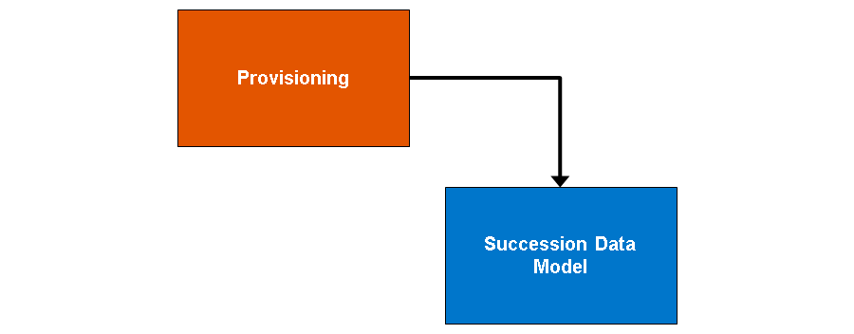

**Position Management Functionality**

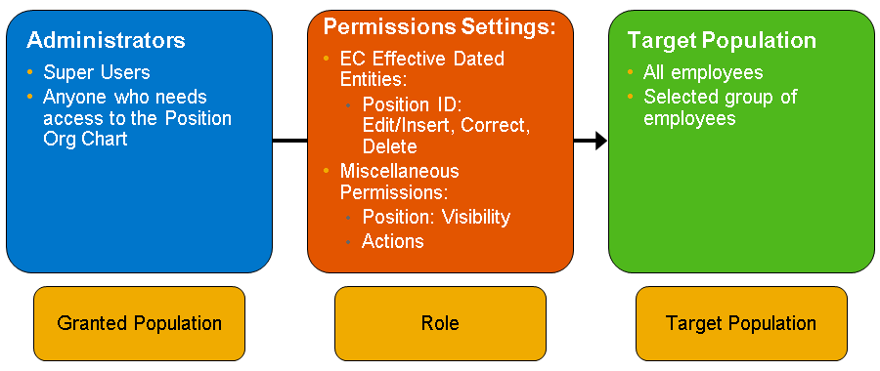

Once you have enabled Position Management in Provisioning, you need to make sure that your administrators and super users are able to access the functionality. There are 2 pieces that you will modify here under Role-Based permissions (RBP). The first, as we see in the figure,

***Setting Up Position Management***, is the ability to view the position on an employee file.

Granting this permission is exactly the same as the traditional RBP model setup, as we have seen before.

**Position Management: Permissions**

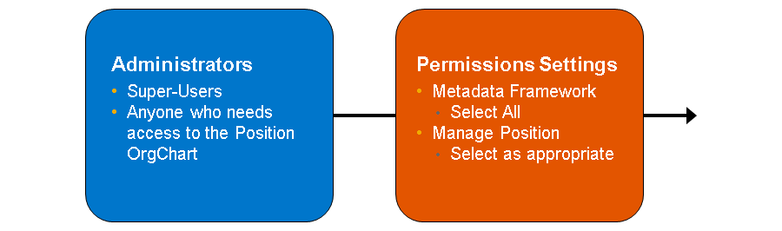

The second part of granting permissions in Position Management still uses the RBP interface; however, these positions do not require a target. When choosing these permissions, refer to the Position Management handbook or to the gray circles in the *Permissions Setting* window for additional details.

**Defining the Position Object**

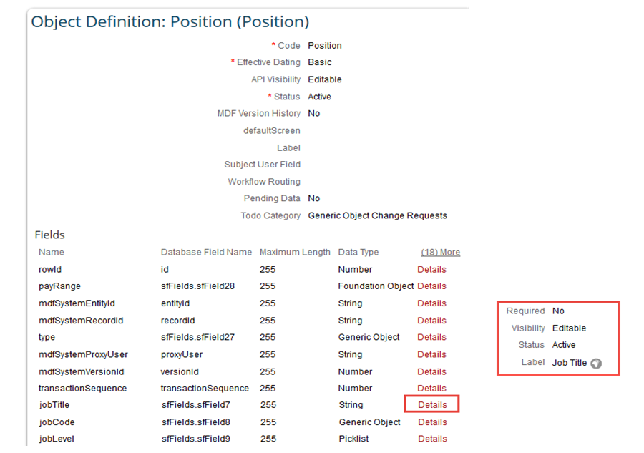

After enabling position management and configuring the permissions, you might want to configure the Position foundation object. This could include:

* Displaying or hiding fields
* Renaming labels
* Populating a new positions fields (either as a default or based on Job Code)
* **Configuring searchable fields**

For full instructions please refer to the Position Management Handbook at SAP Help Portal.

**Position Management *Administration***

You can manage already-existing positions through Admin Center. For Position Management administration, choose *Manage Positions*.

Search along the top left for position, then select the position that you would like to modify.

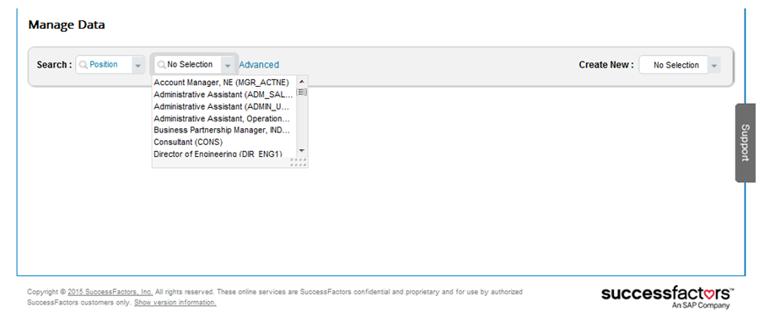

**Position Management Administration 2**

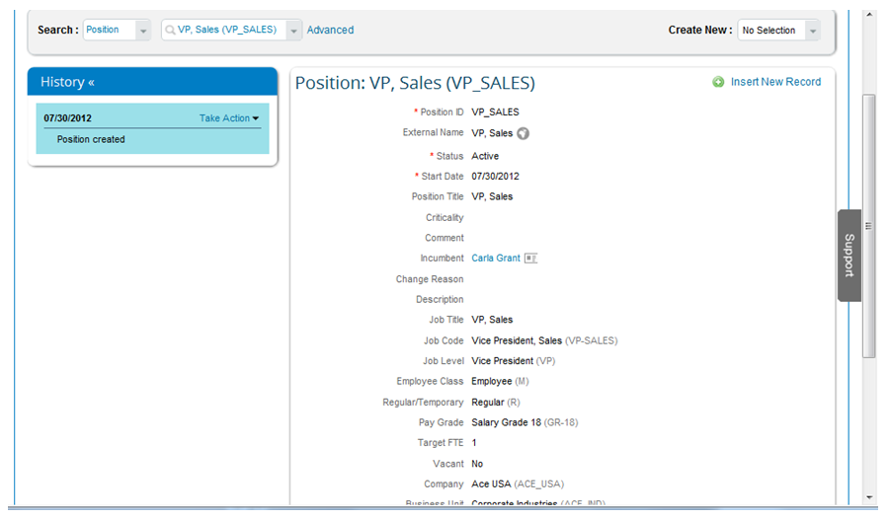

This will be very similar to managing other objects in Employee Central (EC) where an administrator can choose to make corrections or insert new records. As shown in the figure, Position Management Administration 2, these are effective dated entities.

**Position Management Administration 3**

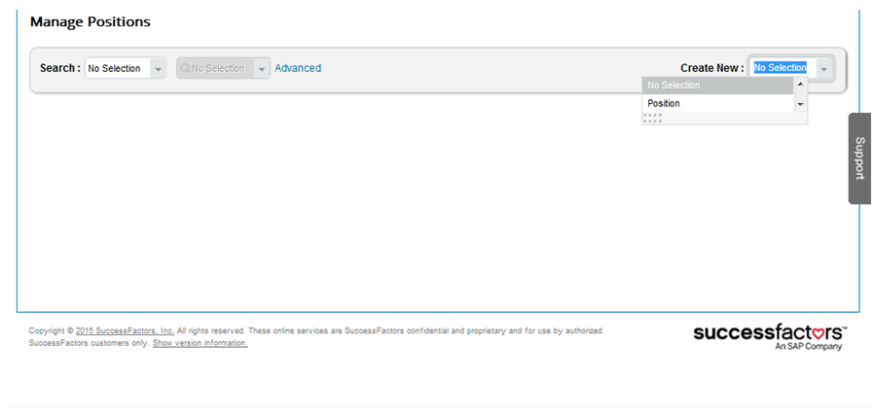

To create a new position, the first position must always be built from Admin tools. Choose *Manage Positions* and, at the right-hand side of the screen, from the *Create New* drop-down menu, select *Position*. You can then enter the information as necessary and click *Save*at the bottom. Subsequent new positions can be created from the Position Org Chart.

**Position Management Administration 4**

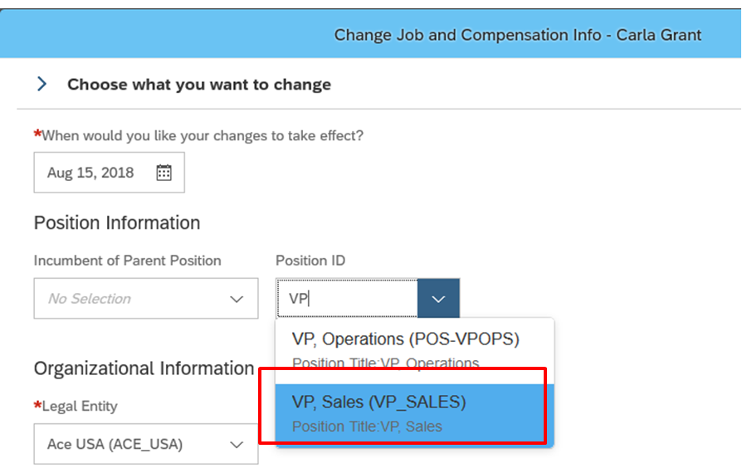

To assign an existing position, navigate to the Job History of an employee and choose to insert a new record or make a correction as appropriate, then choose a position ID from the drop-down.

**Synchronization Between Position and Employee**

As you create positions and fill ***incumbents*** into those positions, maintaining shared fields between an individuals’ job information and the position can become ***cumbersome***. Therefore you might want to configure data synchronization between positions and *jobInfo*. *You can configure the sync in both directions for the common fields they share.*

**Position and JobInfo Sync**

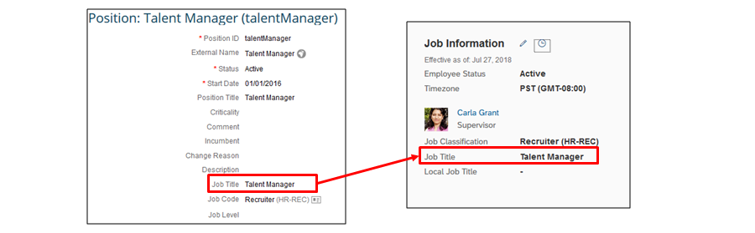

**Synchronization of Position to JobInfo**

Administrators can specify which common fields between **the Position object** and **the jobInfo employment object** are synchronized when changes are made to a Position Record **via** (scenerio) the Position Org Chart or Manage Position tool. A business rule must be created to define which fields will sync between the Position object and the Job Information portlet. You can then decide if the sync process is automatic, or if it allows the user making the change to the position to decide if the sync should occur (***how?***).

Steps for setting up Position Sync: (đồng bộ Position)

1. Create a business rule. Navigate to Configure Business Rules and choose Create New Rule. Select the rule type: Synchronize Position Changes to Incumbents.
2. Determine which fields should sync in the rule (an example is provided in the figure below).
3. In the Synchronization section of the Position Management tool, choose your rule in the Rule for Synchronizing Position to Job Information area.
4. In the Position Organizational Chart Synchronization area, determine if the sync should be automatic or up to the user making the change.

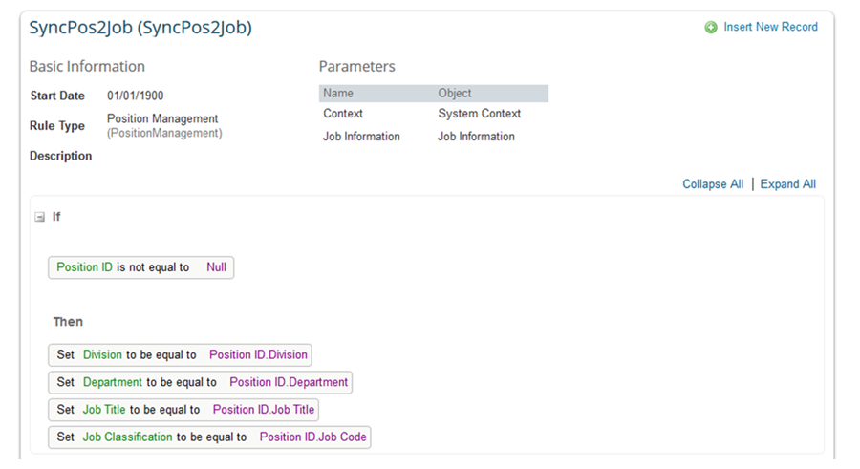

If you want to use this rule also for ***UI propagation***, add the rule as onChange rule to the ***hris-field Position in the Succession Data Model***. An example is provide in Figure: ***UI Propagation Configuration***. This has already been configured in the training instances.

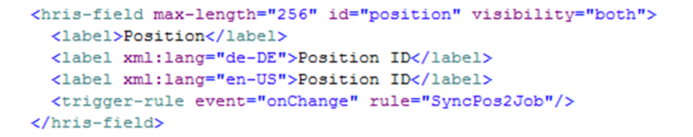

**Synchronization JobInfo to Position**

You can also automatically sync changes from an incumbent's Job Information section out to the Position. This is less commonly used and only recommended for setups with strict 1:1 relationships between employees and positions.

For information on setting up Job Info to Position sync, please see the Position Management Implementation Guide.

**Defined Fields to be Copied from Source Position**

When you create a new position from the position organization chart, you can define which fields are copied from the current position to the new position. To do so, create a business rule with the base object Position. Add a parameter with the code SourcePositionand configure a suitable then statements. Then set the Rule for Defining Copy-Relevant Position Fields in Position Management Settings.

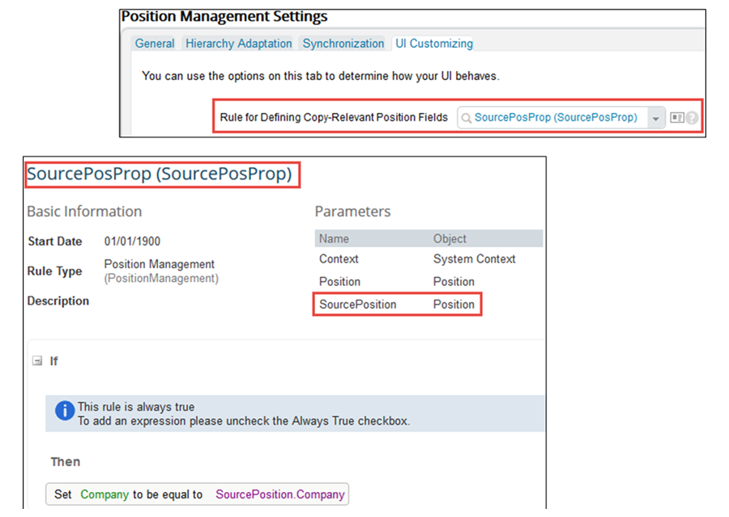

**Automatic Update of *To Be Hired Field***

You can specify that the ***To Be Hired status*** is automatically updated for the position whenever an employee is assigned to the position or unassigned from the position.

When configuring the settings related to assigned/unassigned from a position, you can choose from **never, always, or based upon FTE** Value for the position. You can also specify that the position To Be Hiredstatus is automatically set or reset if the position Target FTE is changed. These are configured to a simple yes / no.

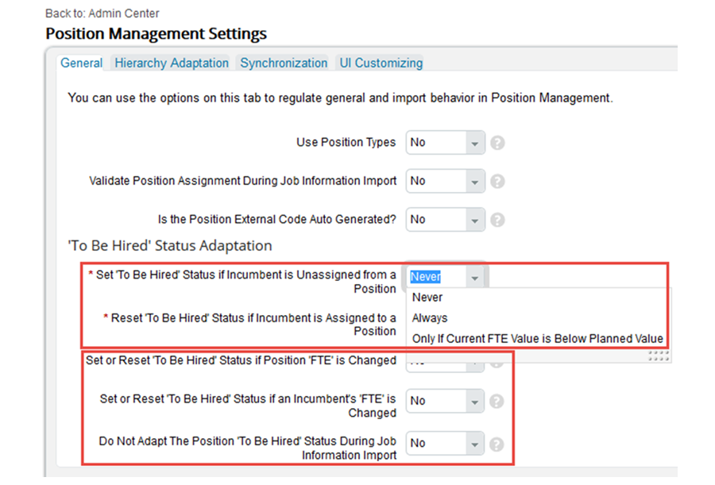

**Moving *assigned* Position to new Supervisor**

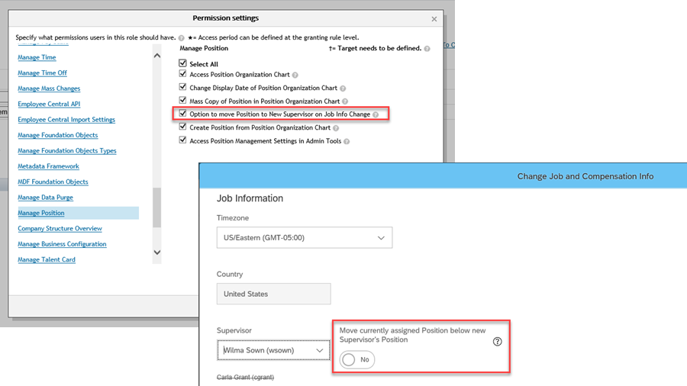

There is a new feature that exists for Position Management to have positions move when the Supervisor field is updated. When updating Job Information by using the Edit or Take Action à Change Job and Compensation buttons, if you change the Supervisor you will see an option to move the assigned Position under that new Supervisor’s Position. This will automatically reflect on the Position Management Org Chart when the feature is set to Yes.

If the Position assigned has multiple incumbents, then by choosing yes, all incumbents will be moved to the new Supervisor. This feature must be enabled in Role Based Permissions in order to see it in the system.  
8.2 Company Structure Overview:

**Company Structure Setup**

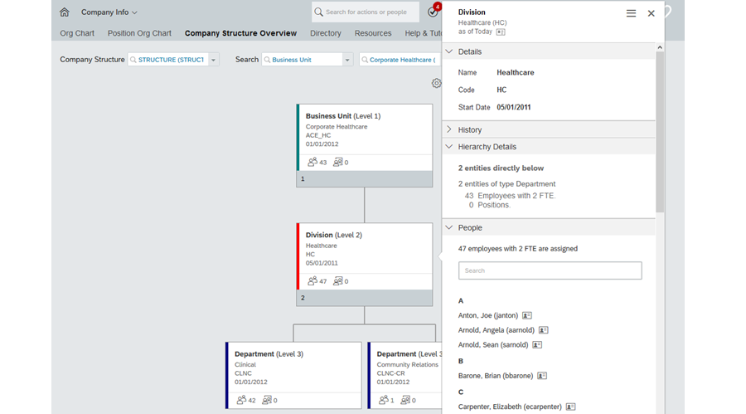

**Enabling Company Structure Overview**

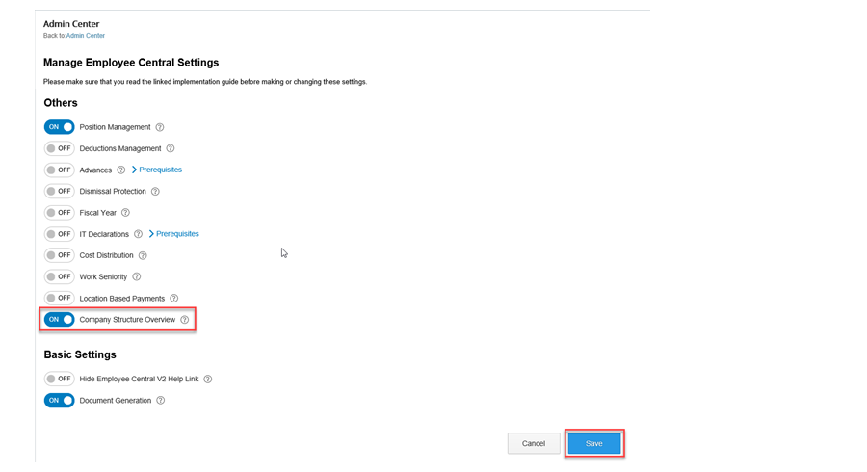

You can enable Company Structure Overview in EC Admin Center via the ‘Manage Employee Central Settings’ tool. Simply navigate to the tool and switch Company Structure Overview to “ON”.

**RBP Configuration**

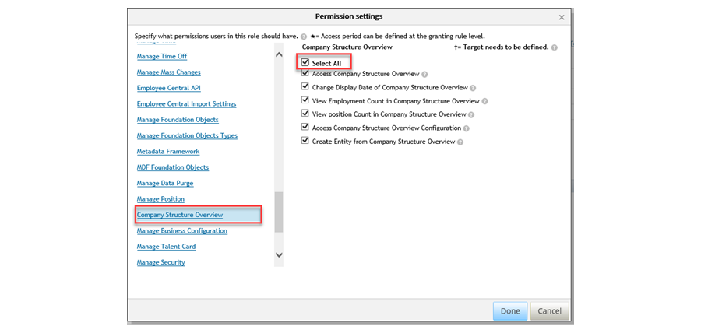

The company structure is secured by role-based permissions (RBP), meaning that you have to specify which users will be allowed to view and edit it. The permissions can be found in the Company Structure Overview section.

**Miscellaneous Permissions**

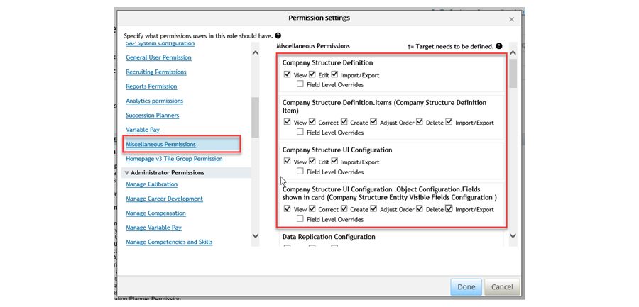

In order to work with the MDF objects that control company structure, you also need to grant permission rights to the objects. These objects can be found in the Miscellaneous Permissions section. If you do not see these objects there, you must go to the object definitions and set the Security section to Yes, and the RBP Category to Miscellaneous Permissions.

**Company Structure Definition**

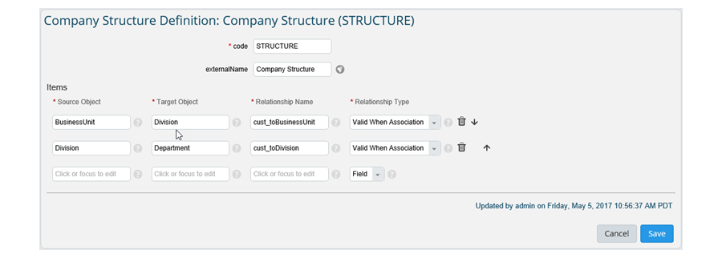

Once you have granted RBP access to the objects, you can create records for them in the ***Manage Data*** tool. Within the Company Structure Definition record, you must recreate your association structures as they exist in your environment.

As mentioned before, the only associations that can be represented are between MDF Foundation Objects. Use the codes of the MDF Foundation Objects for the Source and Target Objects.

*The name of the association is placed in the relationship name field, then the relationship type must be “Valid When Association”*. This will allow your associations to be visually represented in the Company Structure Overview Chart.

**Company Structure UI Configuration**

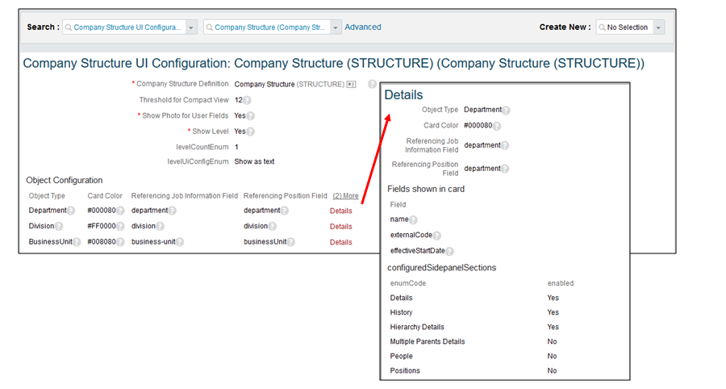

Once you’ve set up your company structure, you can configure the appearance of the org chart and specify exactly how much information should be displayed there. This is done in the Company Structure UI Configuration.For the chart, you can identify if you will display the level of each object record, either as text or as an icon.

For each object you can set:

* Color to differentiate object types.
* Fields about the object records such as Names and Codes.
* Counts of people and positions by identifying the necessary field.
* Sections displayed as part of the side panel when selecting an object record.

**Company Structure Overview Navigation**

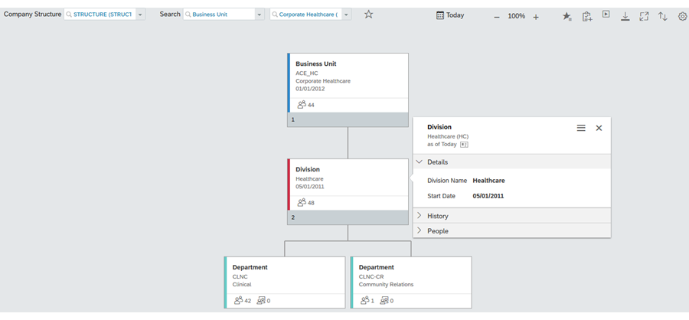

Once you’ve set up your company structure overview, you can navigate through it as an org chart. In the top-right of the chart, you can:

* Choose the date for which you want to see the chart (that is, if you want to see your company structure at some point in the past or future).
* Export the chart in PDF or JPG format.
* Switch to a fullscreen view.
* Set the sort for each object type in the company structure.

On the top left, you determine the Company Structure configuration you want to use. You can then search by any of the foundation objects in your configuration, or you can search by people. Search by People enables HR Admin to search for employees’ assignments. This could be a ‘Head of’ an entity or the organizational assignment based on JobInfo.

In addition, you can see more detailed information for each record. Just click on any icon to navigate to the corresponding section of the side panel.

**Company Structure Configuration**

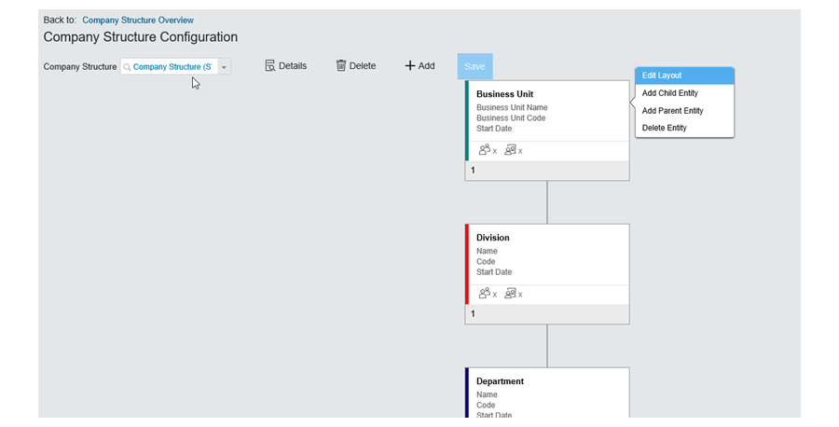

If you click on the Settings (Spoke) button within the Company Structure Overview, you are taken to a UI where you can make adjustments to Company Structures and records. The buttons along the top allow you to edit and delete existing Company Structures, as well as add new ones. If you click on an individual FO Record, you have the ability to edit the layout, delete, or add additional records/entities.

These tools allow the user to make adjustments directly on the visual representation, rather than having to make changes in the Manage Data tool.

**Editing Layout**

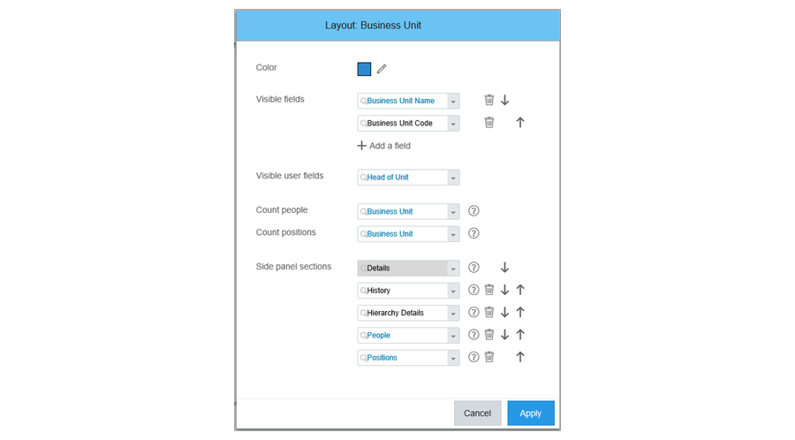

*When editing the Layout directly in the Company Structure Overview org chart, you can set the color for each Foundation Object, set visible fields, connect to the jobInfo and Position fields for real time headcounts, and set additional side panel sections to view for each record.*

**Foundation Object Record Details**

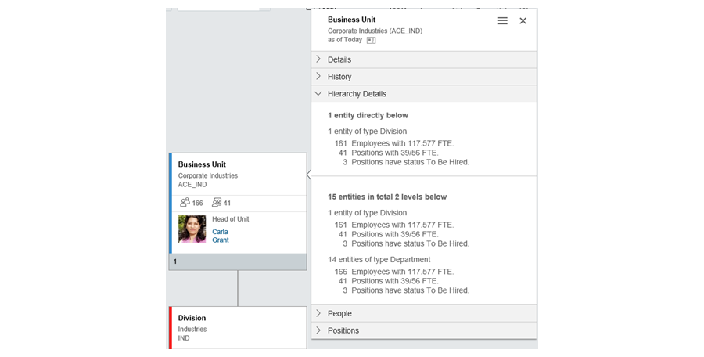

Once you edit the layout, you will see your changes reflected in the Company Structure Overview chart immediately.

**Adding a Child Entity (là gì?)**

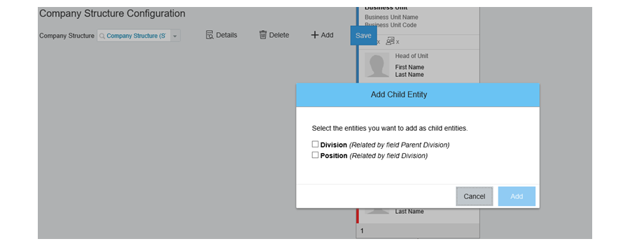

In addition to editing the layout, you can also Add Child Entities from the setup screen. Child Entity options will differ depending on the setup of the Foundation Object, and whether or not Position Management is Enabled.

## 8.3 Leave of Absence: (nghỉ mà định kỳ, period)

Leave of absence (LOA) is a period of often ***extended leave***, such as parental leave or for a sabbatical, that changes the employee’s status. You can integrate LOA management with your Time Off application, allowing ***employees to request LOA in the same way as they would any other absence***. You should note, however, *that LOA is not available in the mobile Time Off feature.*

If you have switched on Time Off, LOA is available for you to configure and use as you require, as part of your **time off management**.

Time off management

If you don’t use Time Off to manage your vacation, PTO, or other absences, but want to use the Time Off functions to request and manage LOA, you can enable this by switching on Time Off for Leave of Absence Only in addition to Time Off.

**Time Off for Leave of Absence only**

If you are only using Time Off for leave of absence (LOA), you need to create a time profile with the external code LEAVE_OF_ABSENCE_PROFILE and then assign your LOA time types to this profile. There’s no need to assign this profile to employees, as it will be picked for every employee automatically.

**Leave of Absence**

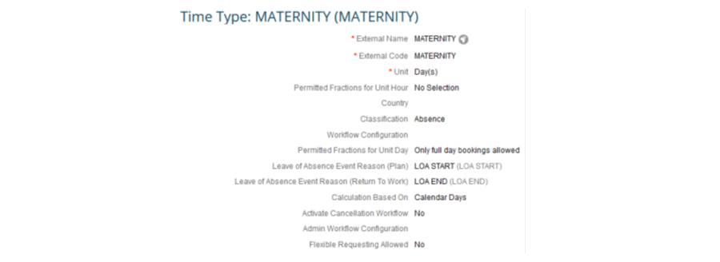

**Leave of Absence (LOA) Options**

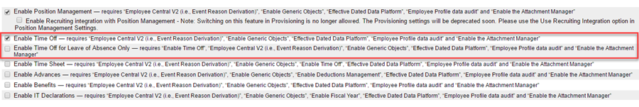

Using LOA only, but with different profiles for different countries:

* Do not create a generic time profile. Instead, create one profile for each country and assign them to users as appropriate.

Using LOA only, but only for certain countries:

* Switch on Time Off, not LOA only. Then create time profiles that use only LOA time types and assign the profiles to those users who should be able to take LOA. In such cases, you also need to create a dummy work schedule and a dummy holiday calendar, and assign them to the users with this LOA only time profile.

Using LOA only for some countries, but full Time Off for other countries:

* Switch on Time Off, not LOA only. Create some time profiles that use only LOA time types and others with full Time Off time types. Then assign the profiles, but be careful - users who should be able to take LOA only should have a time profile that has only LOA time types. In such cases, you also need to create a dummy work schedule and a dummy holiday calendar, and assign them to the users with this LOA only time profile.

## 5.4 Contingent Workers (nhân viên làm việc ngẫu nhiên):

**Enabling Contingent Workers**

Contingent workers deliver services to an organization on a **non-permanent basis**. They are often known as **independent professionals** (chuyên gia không lệ thuộc), **temporary contract workers** (lao động thời vụ), **labor hires** (lao động thuê), **contractors** or **consultants**.

Since contingent worker data is **usually kept out of the core HR system**, companies are not aware of where their workers are located, if they have received training, and how many workers exist as part of their organization.

*This creates a burden on managers of managing contingent workers using multiple systems, different processes and no single access point.*

Using contingent workers management with Employee Central allows you set different data requirements for contingent workers, so you do not need to capture the same data as regular employees. This lesson will cover from how to enable Contingent Workers Management, set up role-based permissions, vendors, work orders, and contingent worker base objects. In addition, there are tools available to import contingent worker, basic identity, organizational, and work order data.

Contingent Workers requires People Profile to be turned on. You can activate Contingent Workers from the Manage Employee Central Settings tool.

**Contingent Worker Field in Employment Details**

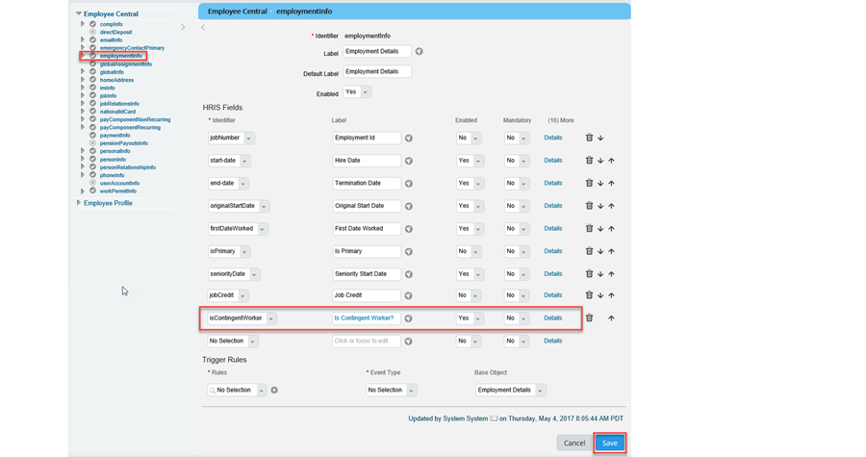

To differentiate between regular employees and contingent workers, a field must be activated in the Employment Details portlet. This will allow you to set different RBP requirements for continent workers vs non contingent workers. This field can be enabled through the Succession Data Model or the Manage Business Configuration tool.

**Contingent Worker Filter in RBP**

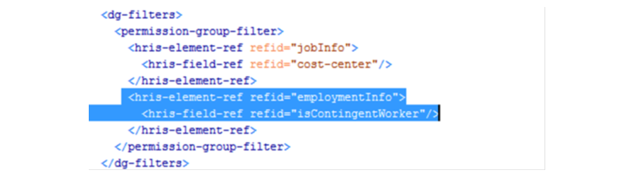

In order to use the new Is Contingent Worker? field as a filter in role-based permission groups, we need to add it as

**a HRIS Element reference/filter within the succession data model.**

This will allow us to create separate groups for contingent workers vs non contingent workers. This element reference has already been added to the THR81 succession data model.

**Regular Employee Permission Group**

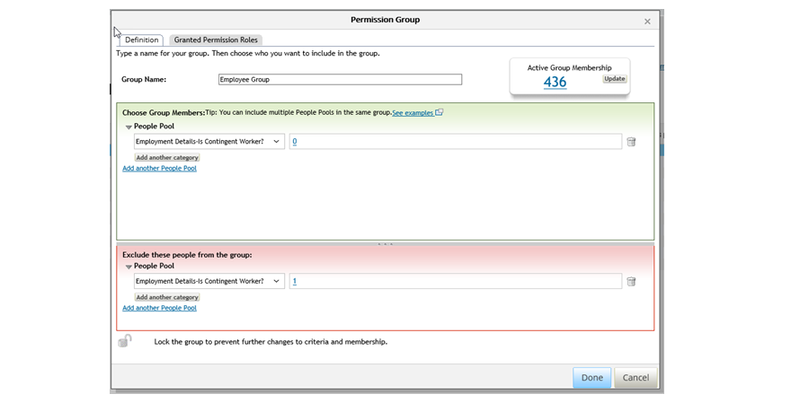

Use the Manage Permission Groups tool to create a group for regular employees. The field Is Contingent Worker will be set to 0, or No, for regular employees. This is the default value for this field.

**Contingent Worker Permission Group**

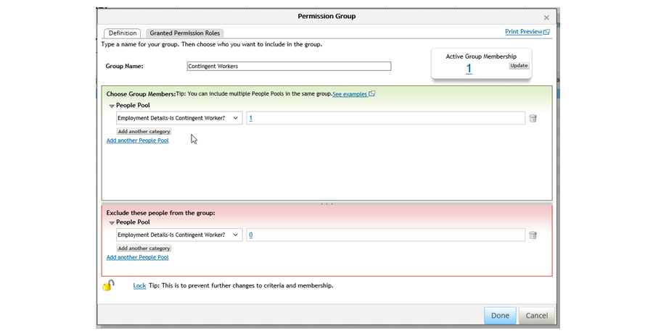

To set up a permission group for Contingent Workers, you want to set the Is Contingent Worker? field to 1, or Yes. You need to have at least one contingent worker in your system before you can set up this group.

**Contingent Worker Events and Event Reasons**

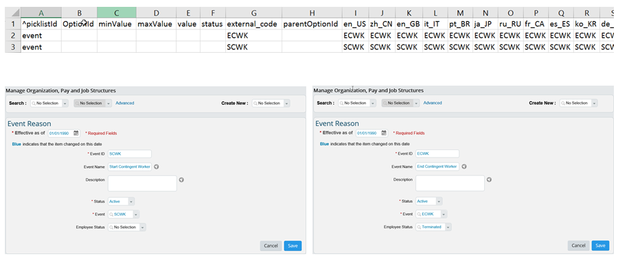

Before new contingent workers can be added to the system, you must set up specific events and event reasons around Starting a Contingent Worker, and Ending a Contingent Worker, as seen in the Figure, Contingent Worker Events and Event Reasons. Any time you add a contingent worker through the Add Contingent Worker tool, it will automatically trigger the Start Contingent Worker Event and Event Reason.

**Vendor Records**

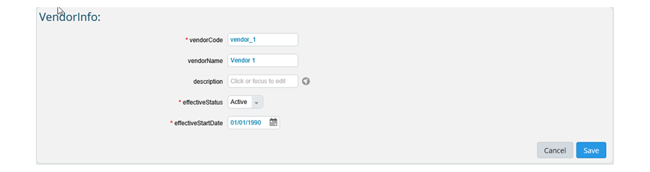

You can set up several Vendor records through the Manage Data tool. Once you have added your vendors, you can set up work orders for each of them. You must have at least one vendor and work order set up before you can add contingent workers.

**Work Order Configuration**

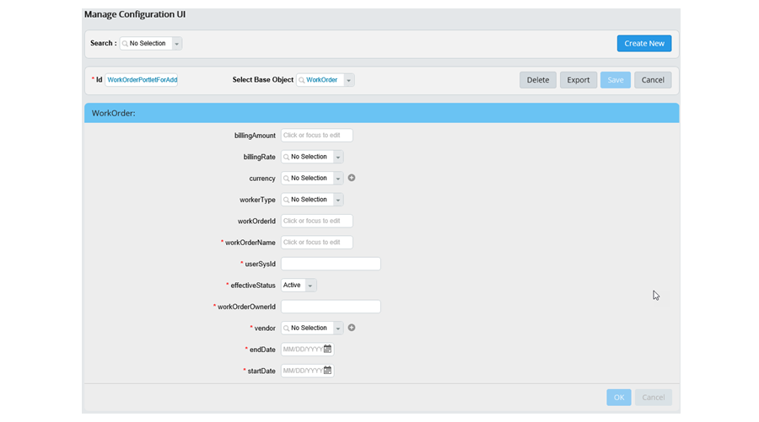

Once you have your vendors built in the system, you can create work orders for contingent workers. You can customize the look and feel of the work order screen through the Manage Configuration UI tool. The work order screen will be part of the Add Contingent Worker tool.

**Importing Contingent Workers**

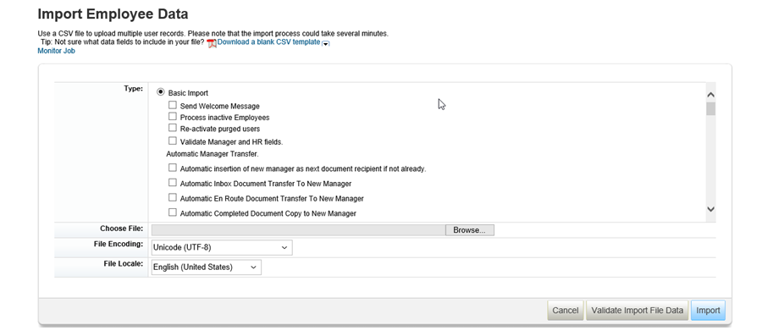

Now that you've configured Contingent Workers for Employee Central, it's time to import all of the data. You can do this by going to the *Import Employee Data*. There are five different types of data you need to import in the following order:

1. Basic Import
2. Employment Details
3. Work Order Import
4. Job History
5. Contact Information

You can import your work order data by using the Import and Export Data tool as available from the Admin Center. To do this, you will need to download the WorkOrder template, fill out the necessary information and import the data.

**Add Contingent Worker Tool**

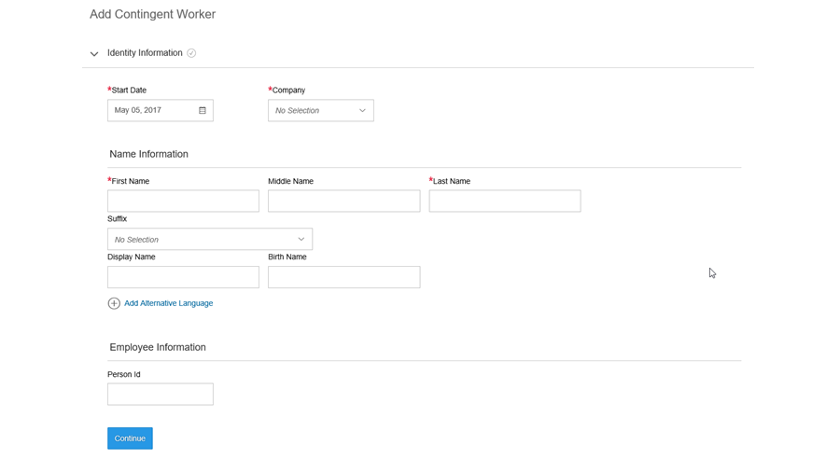

You can also use the Add Contingent Worker tool or wizard to create new contingent workers in the system. This tool works very similarly to the Add New Employees tool, except the Event Reason will automatically be set as Start Contingent Worker. You can also trigger a workflow from this tool if necessary.

The Contingent Worker Wizard consists of four sections:

1. Identity Information
2. Personal Information
3. Contingent Worker Assignment Information (Job Information)
4. Work Order Information

**Customizing the Add Contingent Worker Wizard**

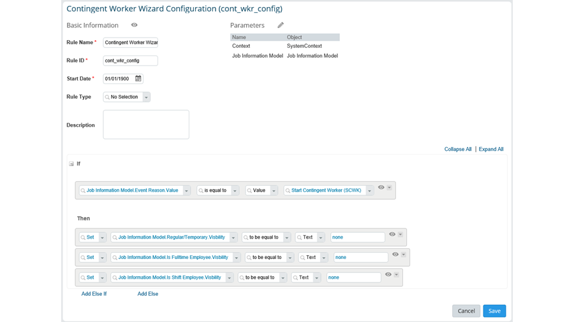

You can customize field visibility for the Contingent Worker Wizard. This can be changed using the Configure Business Rules tool.

The If statement will specify that this configuration is for Contingent Workers only. Using the Then statement, you can hide fields that are typically required for a regular employee hire.

For more information around customizing the Add Contingent Worker wizard, please see the Contingent Workforce Management Implementation Guide.

**Creating and Deleting New UI Config**

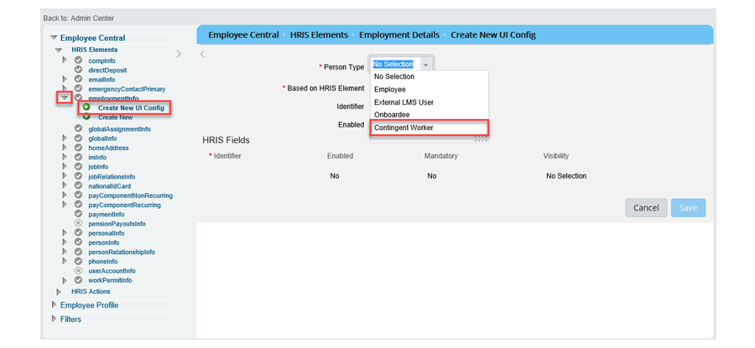

**Deleting your New Configuration UI**

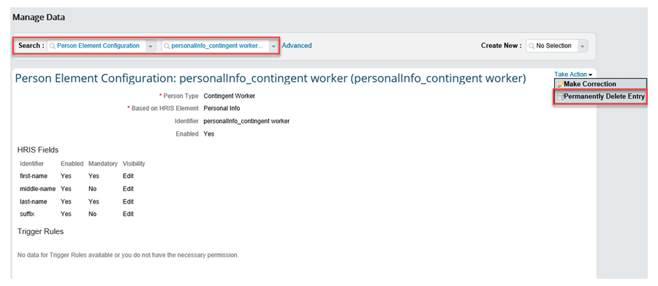

If you need to delete a UI via the Manage Business Configuration tool:

1. Navigate to the Admin Center: *Manage Data*.
2. Search for your configuration.
3. *Click Take Action—>Permanently Delete*.

## 5.5 Dependents Management:

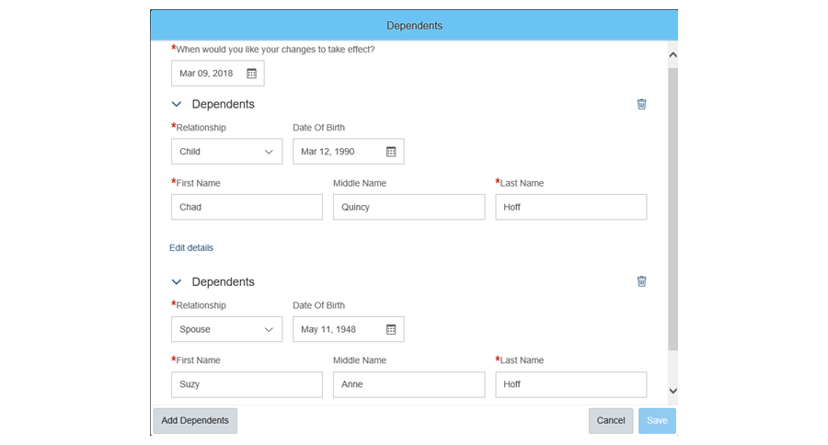

**Navigating to Manage Employee Central Settings Tool**

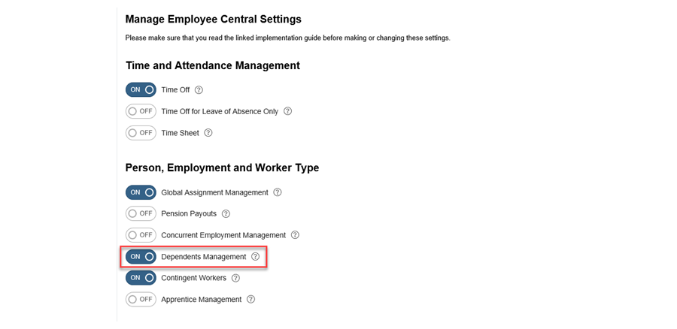

In order to enable Dependents Management in your system, navigate to the Manage Employee Central Settings tool and enable the capability there. Once you’ve turned this feature on, you can configure the fields shown in the Dependents portlet by editing the Succession Data Model in the personRelationshipInfo element. You can add an attachment field here if needed.

**Creating Separate UI for Dependent Portlets**

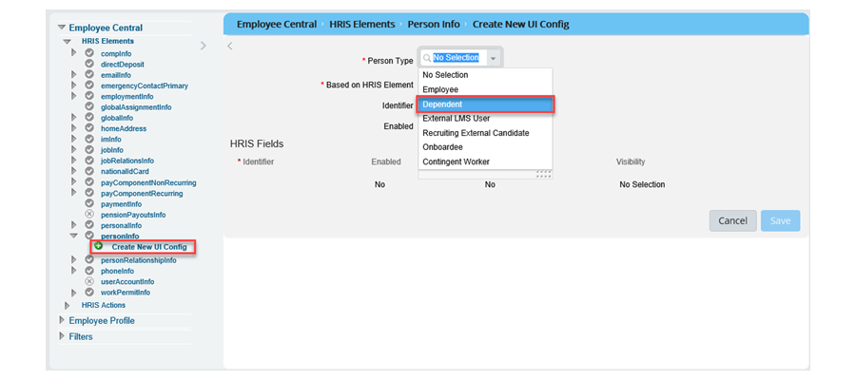

With Dependents management you also have the ability to configure a separate set of fields that will display for Dependents vs Employees. In the past, if it was necessary to capture additional information for dependents, it had to be the same configuration as for regular employees. You can now use the Manage Business Configuration tool (BCUI) to create separate UI’s for dependent portlets. Once you have chosen the required fields, you can then configure the display of the dependent portlet with Configure People Profile. This can be done for the following portlets: *nationalIdcard, personInfo* and *personalInfo*.

In order to do this, you follow the same steps as you would for customization of the Contingent Workers portlet. Instead of choosing Contingent Worker as the person type, instead choose Dependent. You will then be able to change the fields seen in that portlet for the dependent.